MTO 7.1 Examples: Horlacher, Bartók’s “Change of Time”: Coming Unfixed
(Note: audio, video, and other interactive examples are only available online)
http://www.mtosmt.org/issues/mto.01.7.1/mto.01.7.1.horlacher.php

Example 1. “Change of Time”
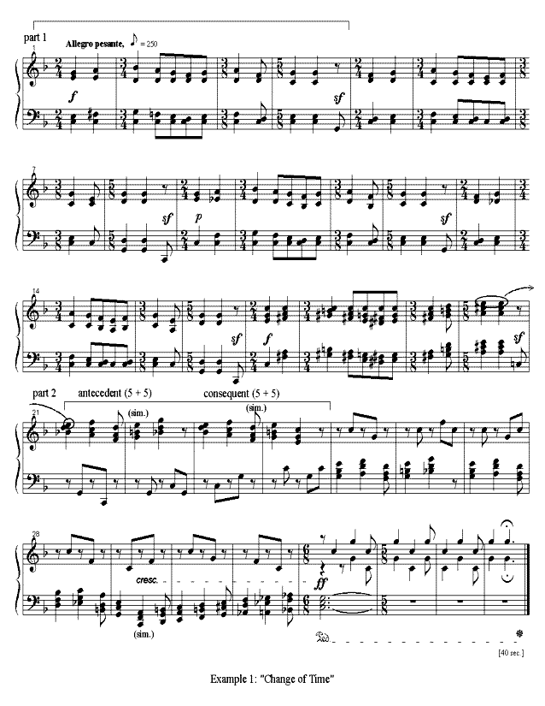

Example 3A. Rebarred in 3/4
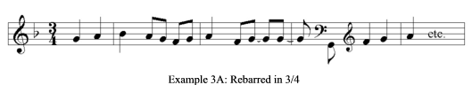

Example 3B. An Altered Grid
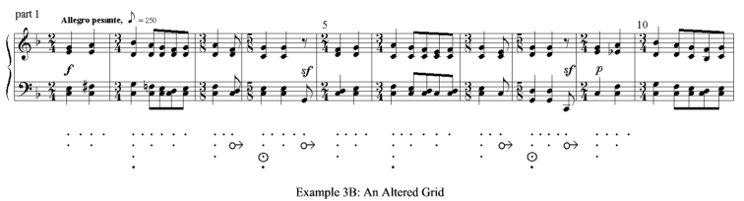

Example 3C. Hypermetrical Hemiola
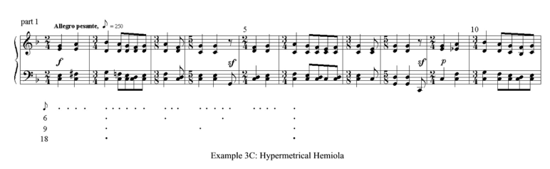

Example 5A. Part 2 Rebarred in Quarter Notes
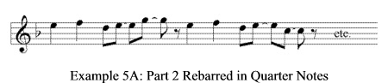

Example 5B. An Altered Grid for Part 2
