MTO 7.1 Examples: Roeder, Pulse Streams and Problems of Grouping
(Note: audio, video, and other interactive examples are only available online)
http://www.mtosmt.org/issues/mto.01.7.1/mto.01.7.1.roeder.php
Figure 1.
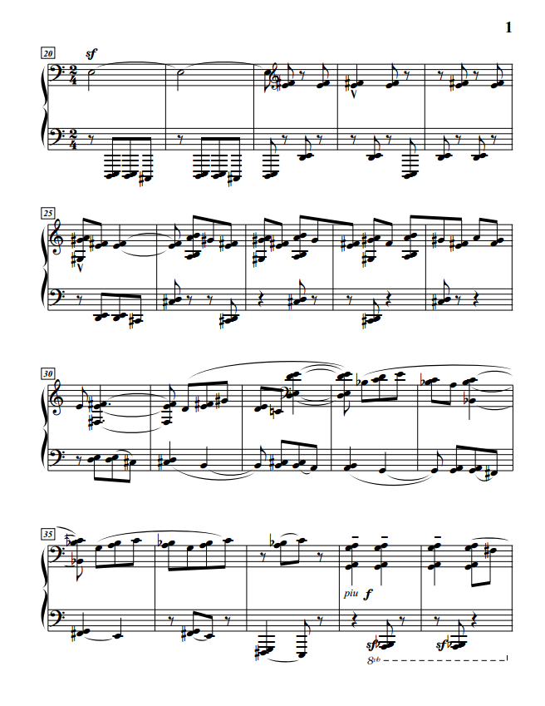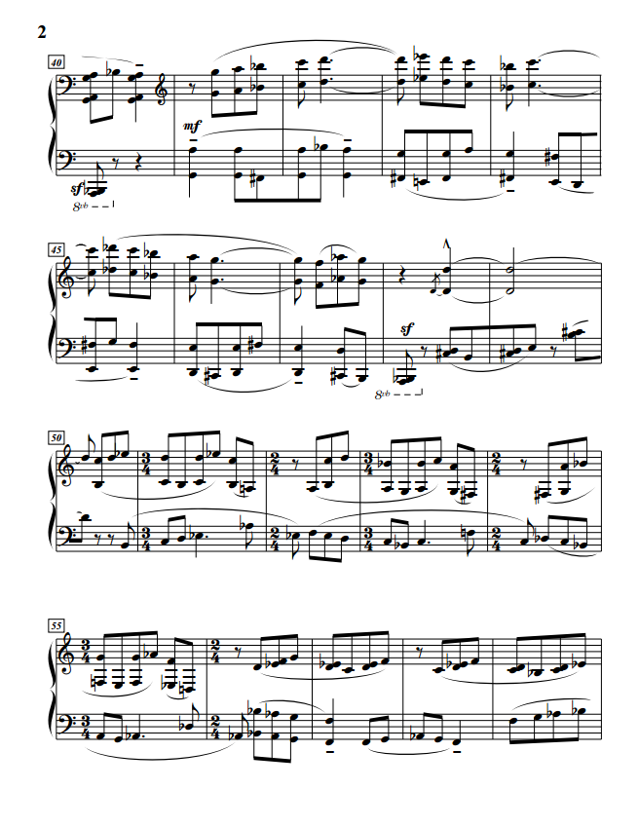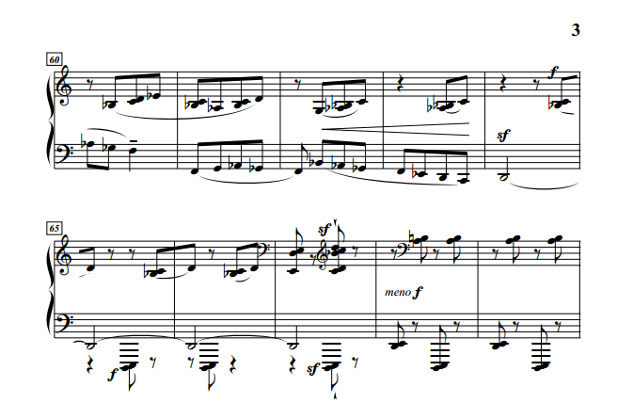
Example II.9.
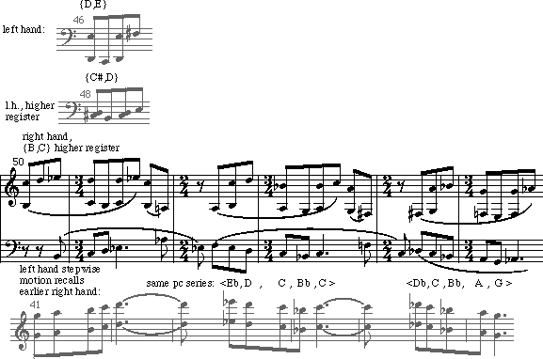
Figure 2.
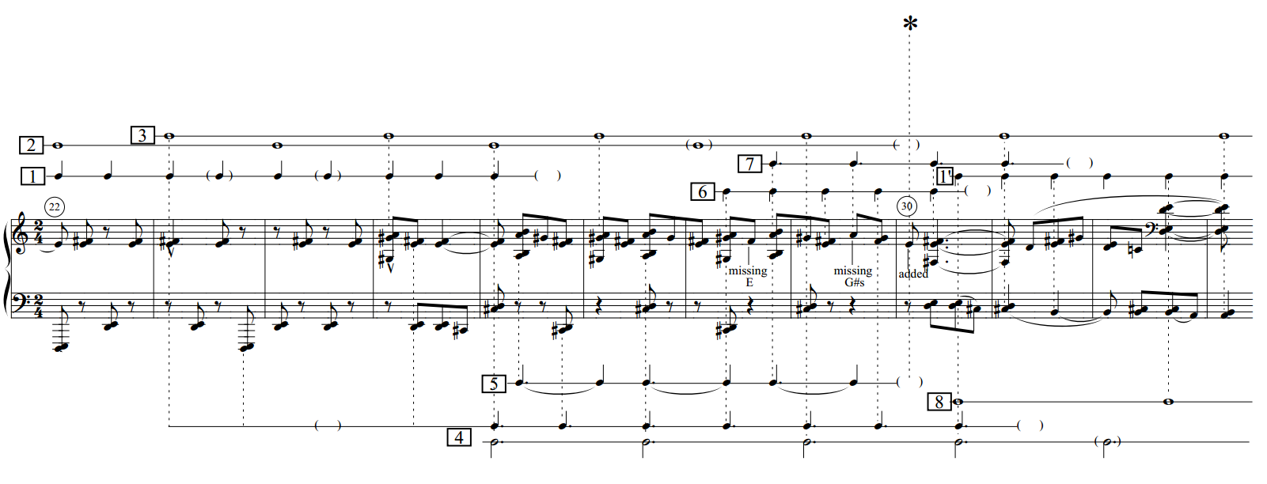
Figure 3. Pulse-stream analysis of mm. 30–43
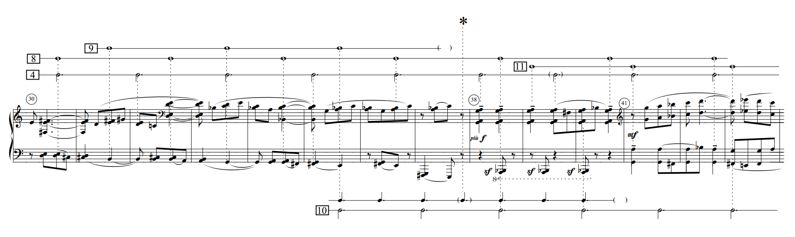
Figure 4. Pulse-stream analysis of mm. 41–53
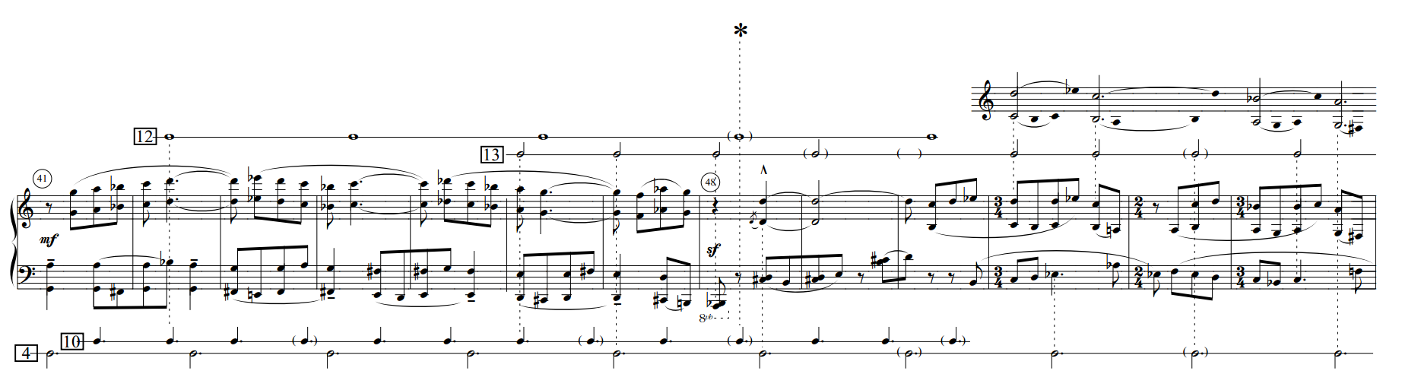
Example VII.2.
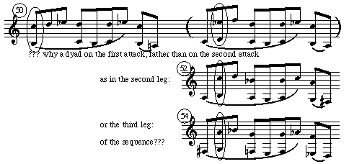

Figure 5. Pulse-stream analysis of mm. 56–68
