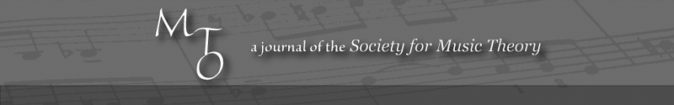
MTO 7.3 Examples: Wannamaker, Structure and Perception in Herma by Iannis Xenakis
(Note: audio, video, and other interactive examples are only available online)
http://www.mtosmt.org/issues/mto.01.7.3/mto.01.7.3.wannamaker.php
Figure 1. Graphical demonstration of equivalence for the two representations of the set F given by Equations 1 and 2 (after Xenakis, Formalized Music)
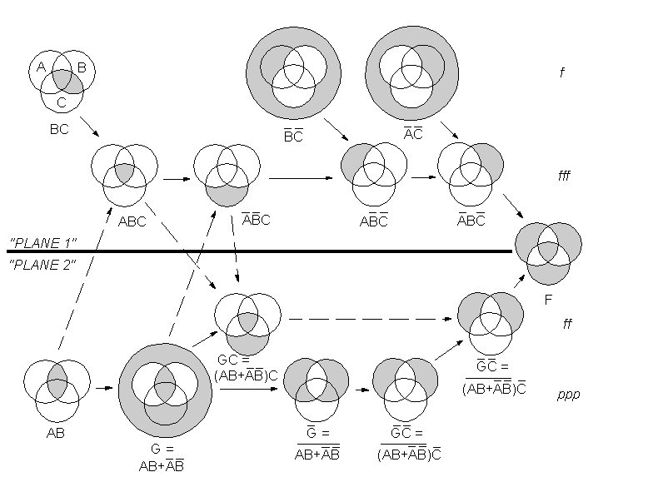

Figure 2. Temporal flow chart for Herma indicating changes in musical parameters, perceived high-level temporal gestalts, and different pitch sets articulated over the course of the work. The dynamic curve is multiple valued where multiple dynamics are marked simultaneously. Times are taken from Yuji Takahashi's Denon recording (Iannis Xenakis, Herma, Yuji Takahashi, piano. Denon 33CO-1052 [1972]. Compact disc.)
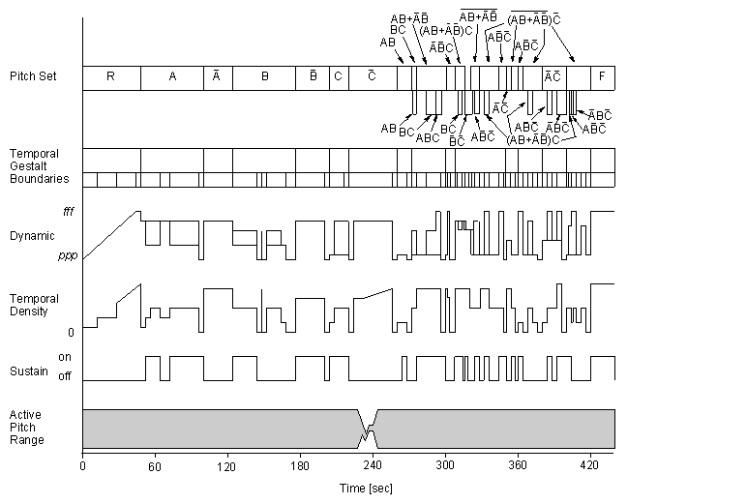

Figure 3. Pitch occurrence frequencies within specific pitch sets articulated in Herma Bullets indicate notes which did not occur in the given section. Shaded areas represent “best-guess” versions of the sets A, B and C and sets algebraically computed from them. As in hexadecimal notation, the decimal numbers 10, 11, 12 . . . are represented by the capital letters A, B, C . . . so that all entries in the table are single characters.
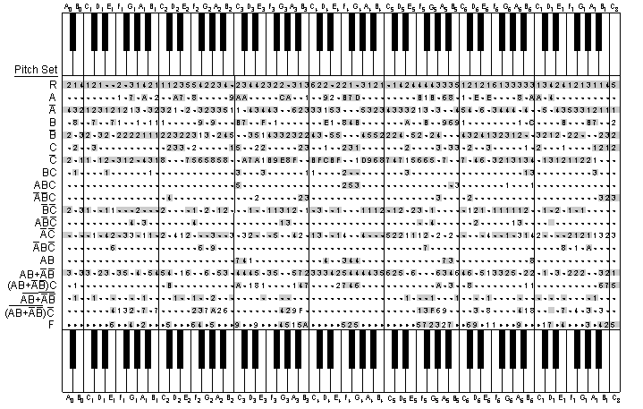

Figure 4. Score excerpt from Herma showing the last four measures of the exposition of set A indicating clangs (circled) and sequences (tied)
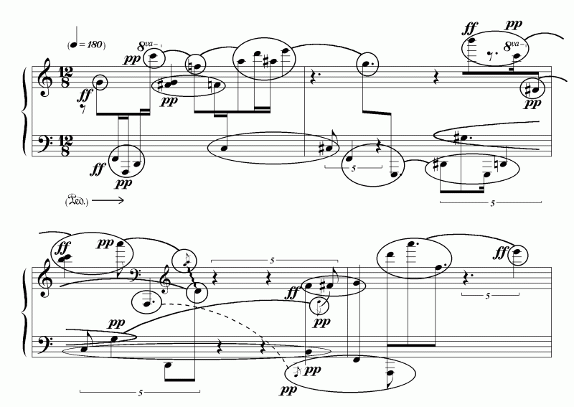

Figure 5. A universal set, R, comprising a set, A, and its complement, AA universal set, R, comprising a set, A, and its complement, A
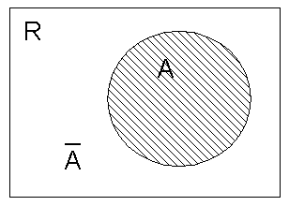

Figure 6. (a) The intersection, AB, of two sets, A and B (b) The union, A+B, of two sets A and B
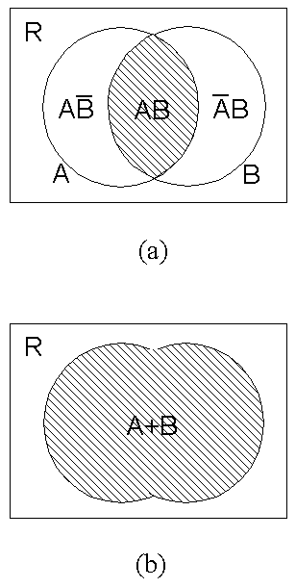

Figure 7. A pair of disjoint sets
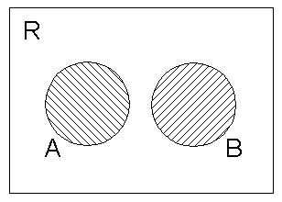

Figure 8. Intersections between three sets, A, B, C, and their complements
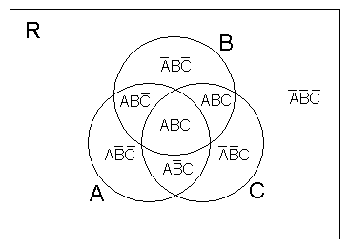

Figure 9. Venn diagram of the target set, F, in Herma
