MTO 7.4 Examples: Huron, What is a Musical Feature?
(Note: audio, video, and other interactive examples are only available online)
http://www.mtosmt.org/issues/mto.01.7.4/mto.01.7.4.huron.php
Table 1. Summary of Terminology Related to Features
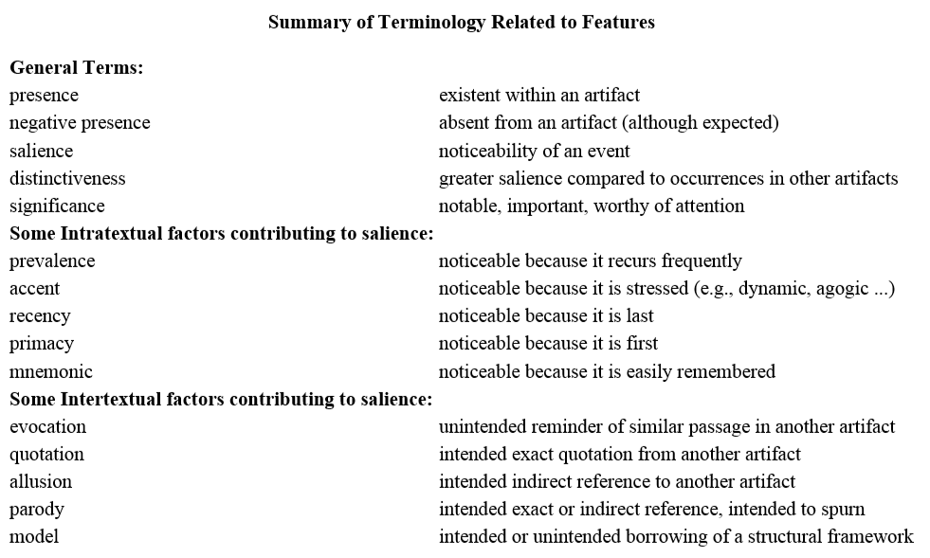

Example 1. Brahms, String Quartet Op. 51, No. 1, mvt.1, mm. 1–6
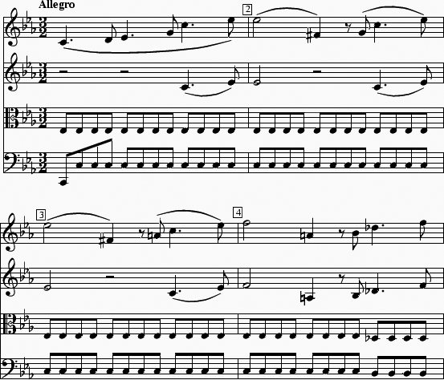

Example 2. Some Sample Sets from Forte’s Motivic Analysis of Brahms Op. 51, No. 1, mvt. 1
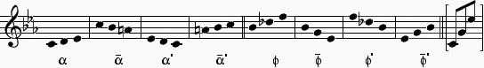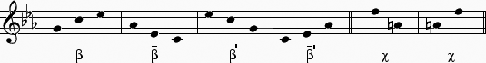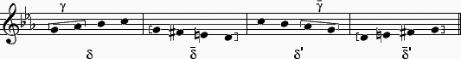

Table 2. Prevalence of “Alpha” Patterns in First Movements of Brahms’s String Quartets
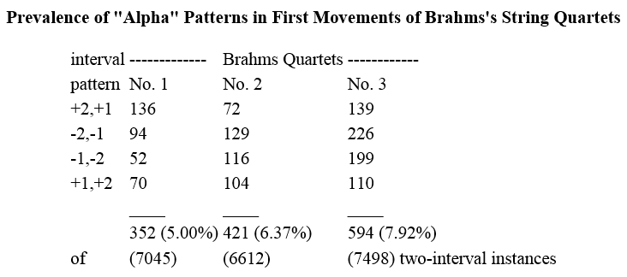

Table 3a. Instances of “Alpha” Patterns Involving Pitch-class Doubling
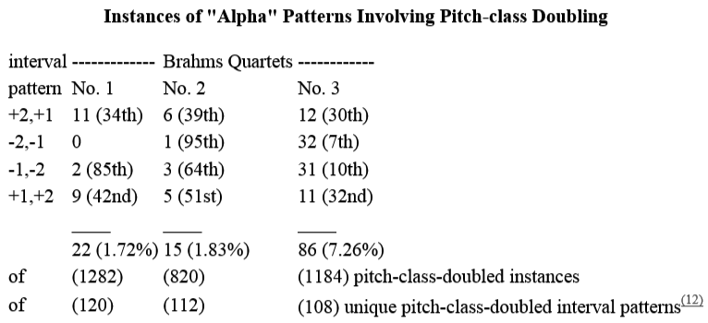

Table 3b. Instances of “Alpha” Patterns Following a Rest
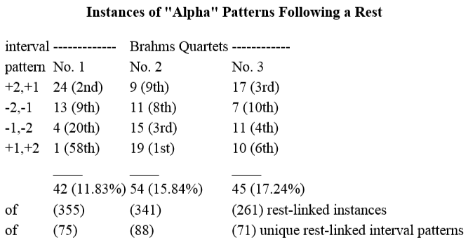

Table 3c. Instances of “Alpha” Patterns Preceding a Rest
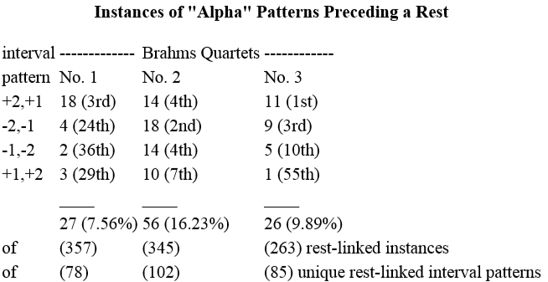

Table 3d. Instances of “Alpha” Patterns Coinciding with Slur or Phrase Onsets
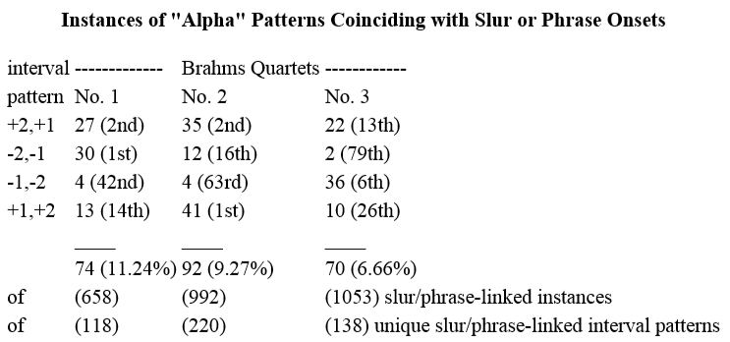

Table 3e. Instances of “Alpha” Patterns Beginning a Measure
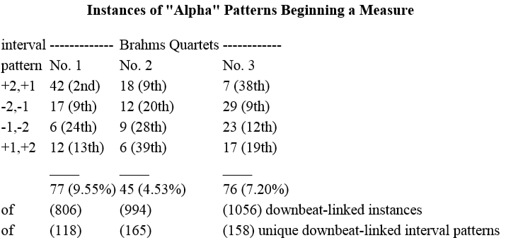

Table 3f. Instances of “Alpha” Patterns in Outer-Most Voices
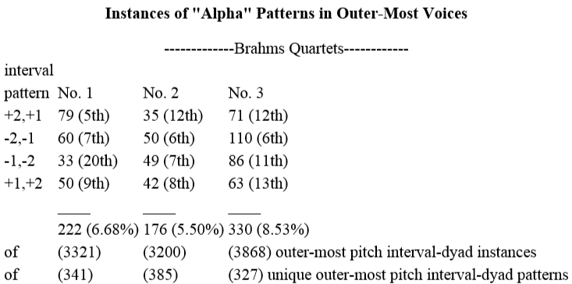

Table 4a. Comparison of the Salience of the (+2,+1) Interval Patterns
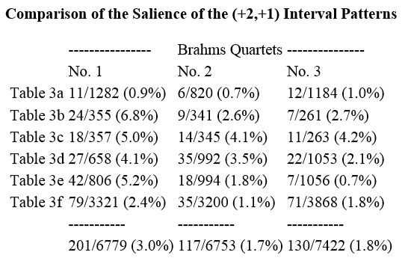

Table 4b. Comparison of the Salience of the (-2,-1) Interval Patterns
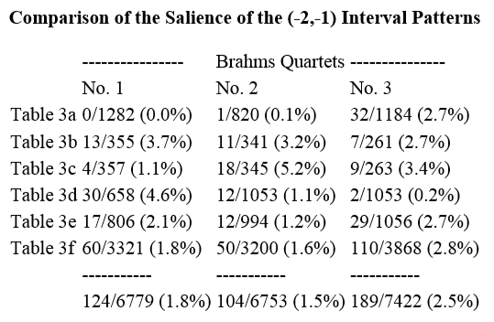

Table 4c. Comparison of the Salience of the (-1,-2) Interval Patterns
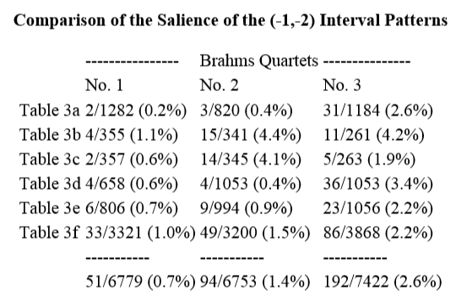

Table 4d. Comparison of the Salience of the (+1,+2) Interval Patterns
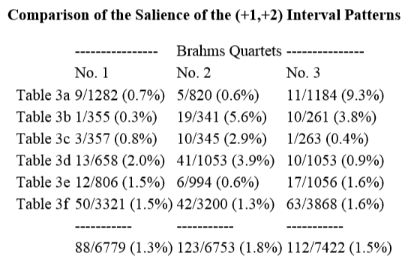

Table 5. Second Order Delta-duration Patterns in Brahms String Quartets
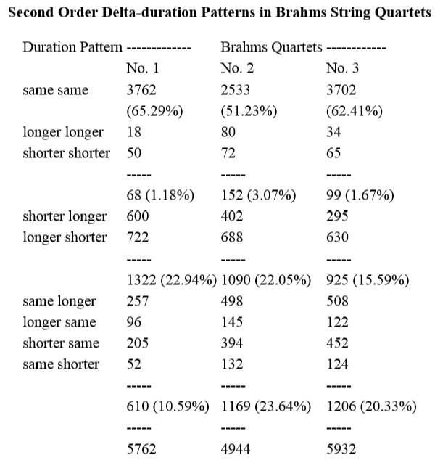

Table 6a. Durational Context of “Alpha” Patterns for Brahms Quartet No. 1 (1st movement)
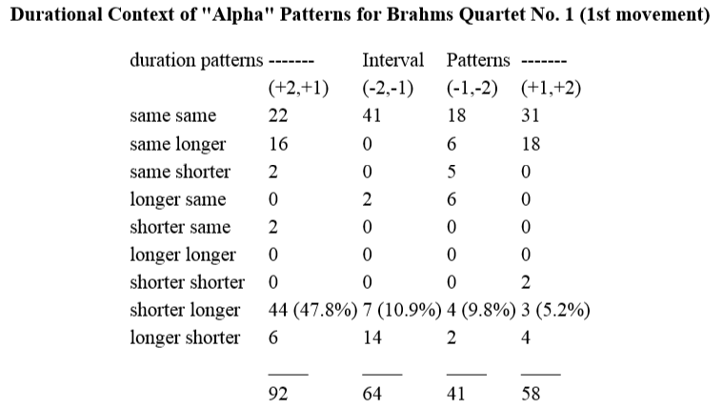

Table 6b. Durational Context of “Alpha” Patterns for Brahms Quartet No. 2 (1st movement)
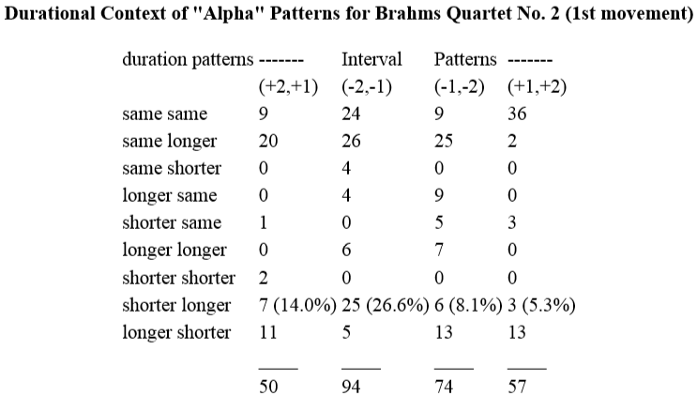

Table 6c. Durational Context of “Alpha” Patterns for Brahms Quartet No. 3 (1st movement)
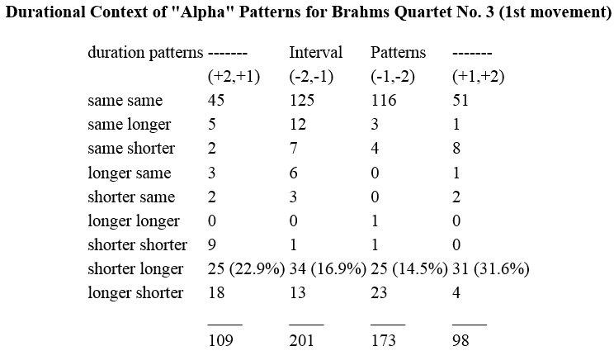

Table 7. Interval Dyad Contexts for ‘Shorter-Longer’ Durational Patterns in Brahms Quartet No. 1 (1st movement)
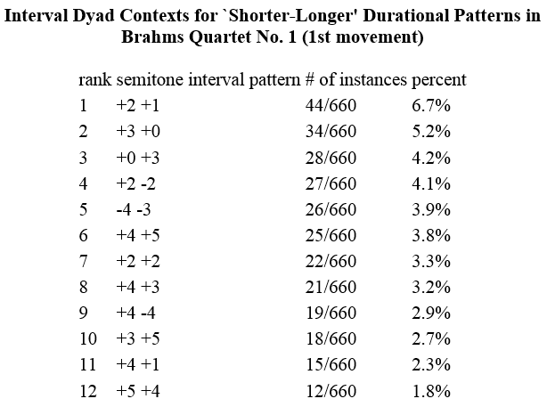

Table 8. Pitch Contour Patterns for Brahms Quartet No. 1 (1st movement)
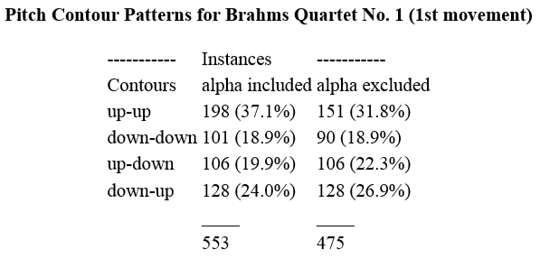

Example 3. Schematic Representation of the Principal Motive in Brahms Op. 51, No. 1, mvt. 1 as Developed Using a Comparative Analysis Method
