MTO 8.2 Examples: Benitez, Simultaneous Contrast and Additive Designs
(Note: audio, video, and other interactive examples are only available online)
http://www.mtosmt.org/issues/mto.02.8.2/mto.02.8.2.benitez.php
Figure 1. Robert Delaunay, Hommage à Blériot (1914)
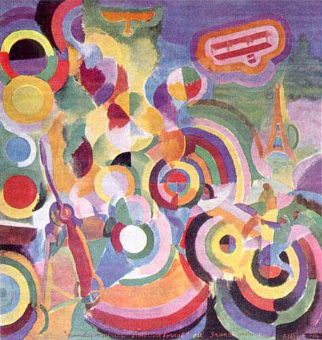

Figure 2. Color Wheel
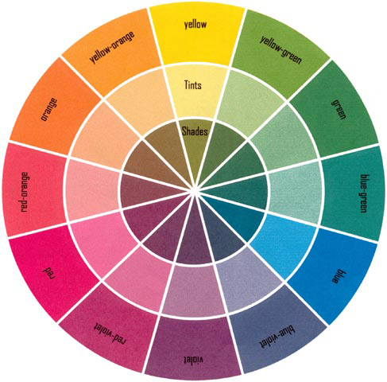

Figure 3. Robert Delaunay, Formes circulaires. Soleil n° 1 (1912–13)
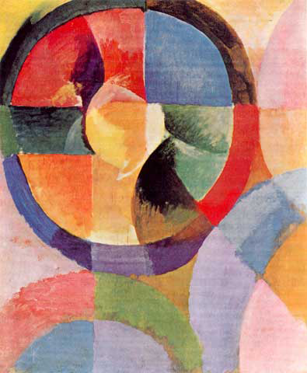

Example 1. The Modes of Limited Transposition
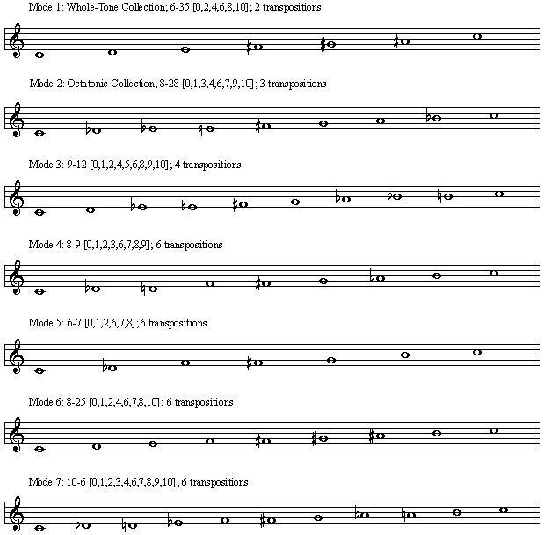

Example 2. Derivation of the Chords of Transposed Inversions on the Same Bass Note from a V9 Chord (see Traité de rythme, 3:86) Reproduced with the kind authorization of Editions Alphonse Leduc, proprietary editor worldwide, Paris, France
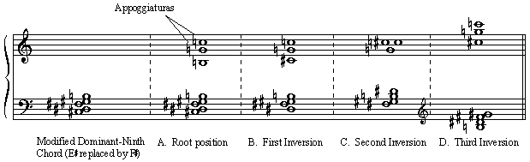

Example 3. Chords of Transposed Inversions on the Same Bass Note
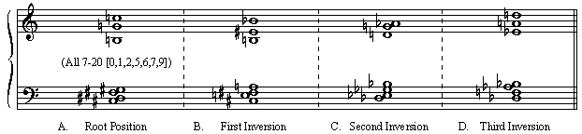

Example 4. Derivation of the Chords of Contracted Resonance from a V9 Chord (see Traité de rythme, 3:87) Reproduced with the kind authorization of Editions Alphonse Leduc, proprietary editor worldwide, Paris, France
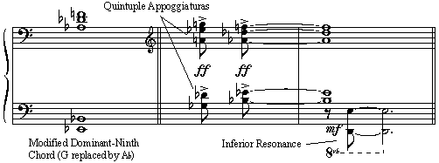

Example 5. Chords of Contracted Resonance
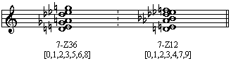

Example 6. Turning Chords
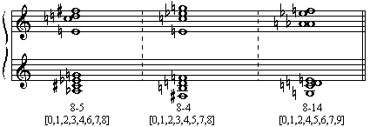

Example for Note 22. Color Associations of Turning Chords, Chronochromie, Strophe I
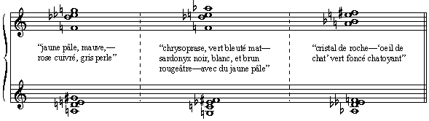

Example 7. Contrasting Additive Design (Pitch/Timbral Opposition): Analytical Reduction, Pitch-Class Complementation, Brother Masseo's Ornithology Lesson, Le Prêche aux oiseaux, R27:1–7
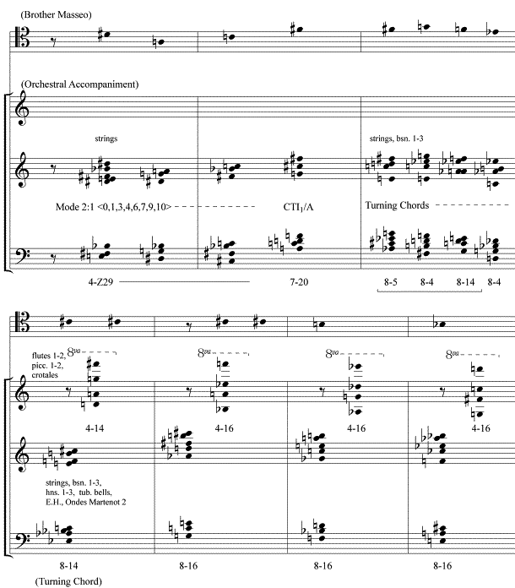

Example 8. Chord of Total Chromaticism, Analytical Reduction, Le Prêche aux oiseaux, R54:5
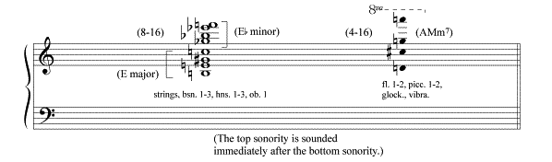

Example 9. Contrasting Additive Design (Pitch/Timbral Opposition): Two Active Parts, Avian Commentary on “Perfect Joy,” La Croix, R66:6–9 Reproduced with the kind authorization of Editions Alphonse Leduc, proprietary editor worldwide, Paris, France
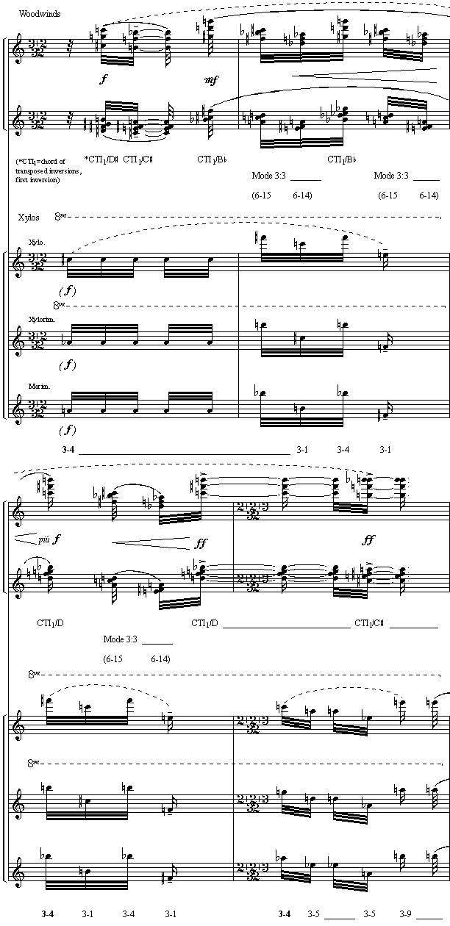
Figure 4. Spatial Arrangement of the Orchestra at the Palais Garnier (1983) (Distances are approximate)
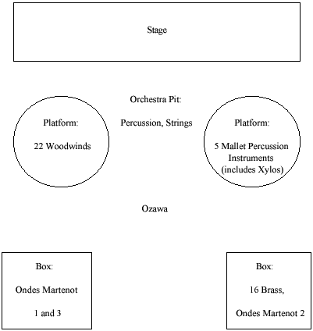

Figure 5. Analogous Additive Design Foreground and Background Pitch Designs linked by Analogous-Color Relationships Background Design, Angel’s Discourse, Le baiser au lépreux, R62:1–12 (Strophe 1), R65:1–12 (Strophe 2), R69:2–18 (Strophe 3), R72:1–24 (Strophe 4)

Example 10. Analogous Additive Design: Foreground Design, Angel’s Discourse, Analytical Reduction of Strophe 1, Le baiser au lépreux, R62:1–12
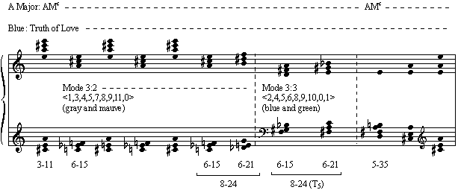

Example 11. Analogous Additive Design: Foreground Design, Angel’s Discourse, Analytical Reduction of Strophe 3, Le baiser au lépreux, R69:2–18
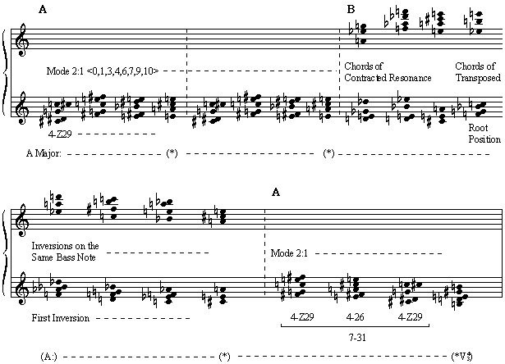
Example 12. Compound Additive Design (Several Simultaneous Textural Layers), Angel’s Celestial Music, L’Ange musicien, R89:1–4 Reproduced with the kind authorization of Editions Alphonse Leduc, proprietary editor worldwide, Paris, France
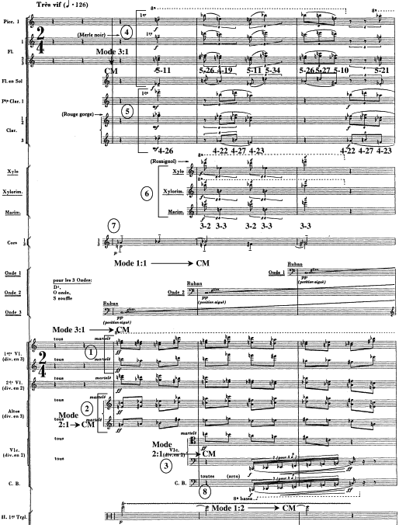

Example 13. Compound Additive Design (Several Simultaneous Textural Layers), Analytical Reduction, Harmonic Content of the Blackbird’s Song, L’Ange musicien, R89:2–4
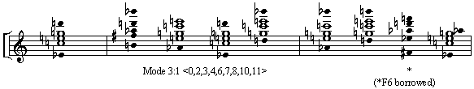

Figure 6. Compound Additive Design Associated with the Angel’s Music, L’Ange musicien, R89:1–16
