MTO 8.3 Examples: Dineen, Figured Bass and Modulation
(Note: audio, video, and other interactive examples are only available online)
http://www.mtosmt.org/issues/mto.02.8.3/mto.02.8.3.dineen.php
Example 1.
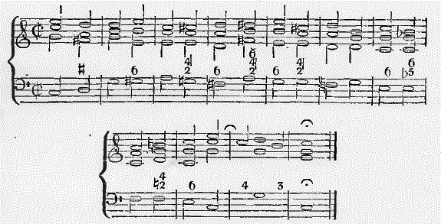

Example 2.
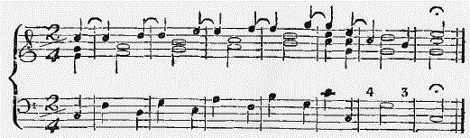

Example 3.
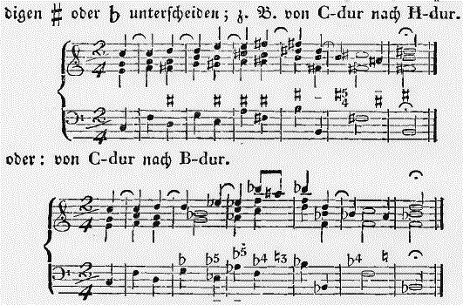

Example 4.
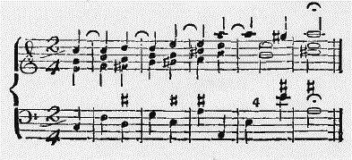

Example 5.
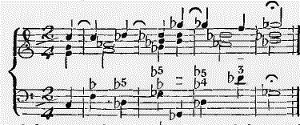

Example 6.
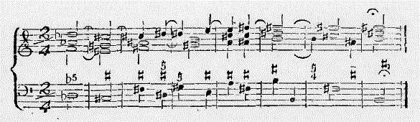

Example 7.
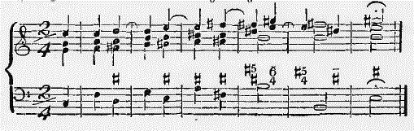

Example 8.
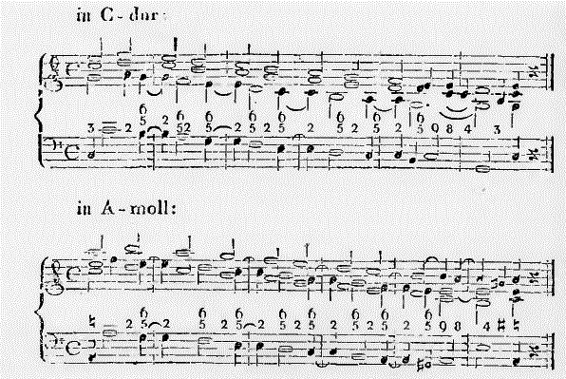

Example 9.
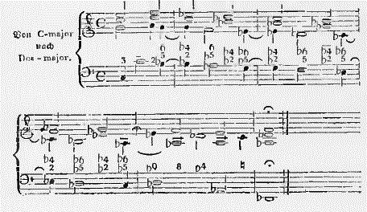

Example 10.
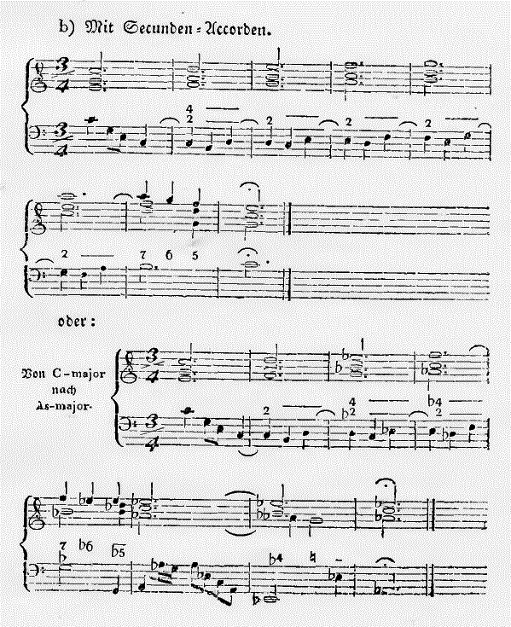

Example 11.
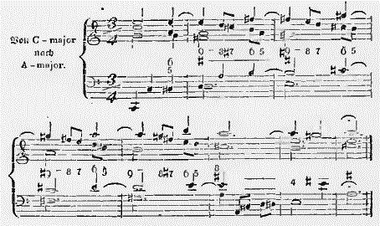

Example 12.
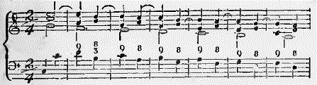
Example 13.
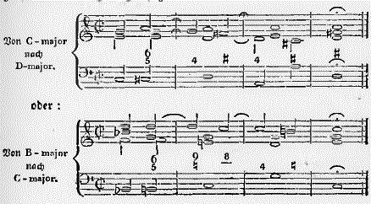

Example 14.
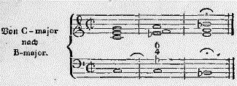

Example 15.
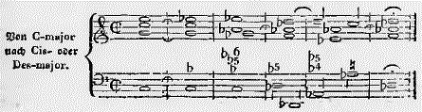

Example 16.
