MTO 10.1 Examples: Wibberley, Syntonic Tuning
(Note: audio, video, and other interactive examples are only available online)
http://www.mtosmt.org/issues/mto.04.10.1/mto.04.10.1.wibberley.php
Figure 1. Finale 3.7.2 main tool palette containing differing Expression Tools
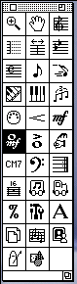

Figure 2. Finale 2000 main tool palette
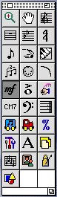

Figure 3. Finale 2003 main tool palette
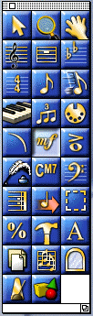

Figure 4. Staff Expression Selection window (version 3.7.2)
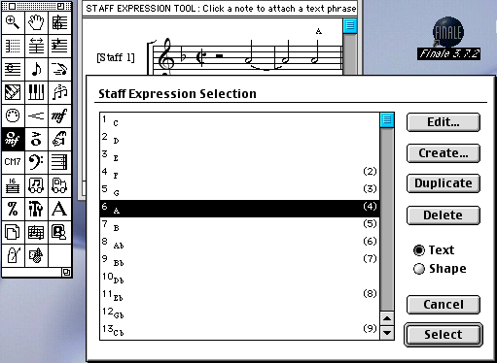

Figure 5. Text Expression Designer window (version 3.7.2)
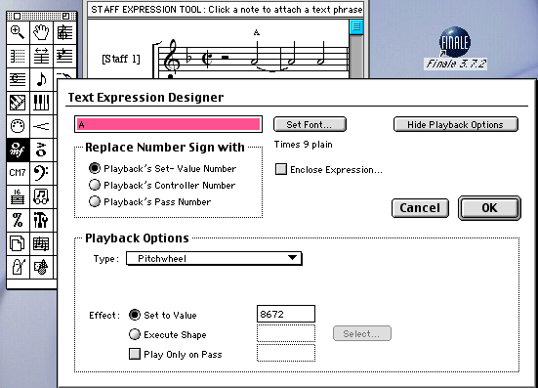
Figure 6. Expression Selection window (Finale 2000)
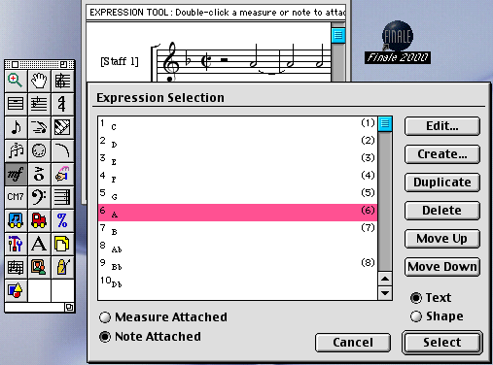

Figure 7. Measure-attached Expression Assignment window (Finale 2000)
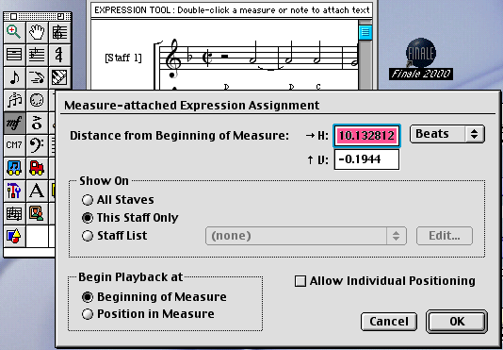

Figure 8. Text Expression Designer window (Finale 2000)
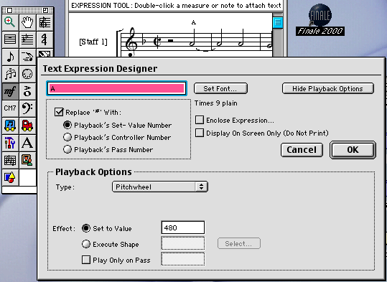

Figure 9. Expression Selection window (Finale 2003)
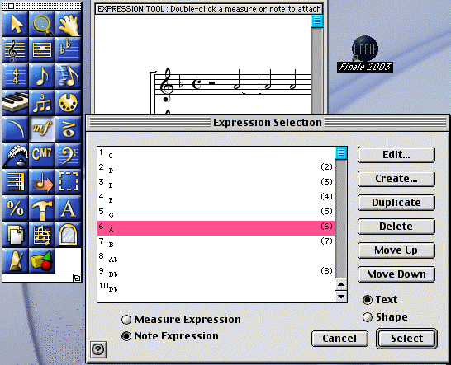
Figure 10. Text Expression Designer (Finale 2003)
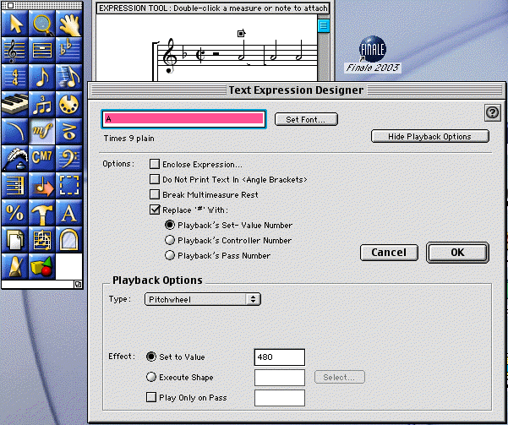

Figure 11. Pythagorean pitchwheel values with comma shifts (older versions)
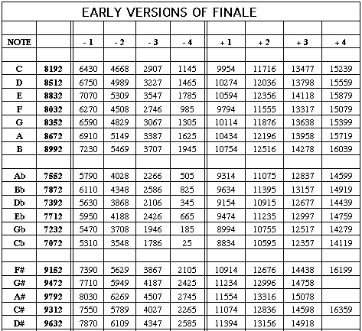

Figure 12. Pythagorean pitchwheel values with comma shifts (later versions)
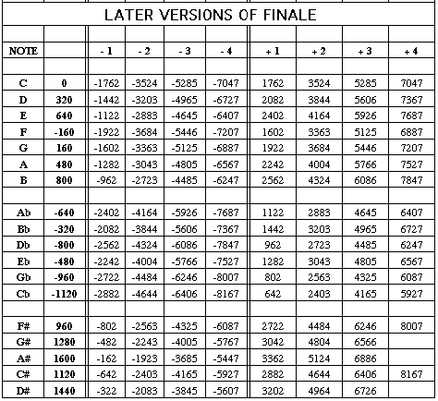

Figure 13. The 19-tet scale
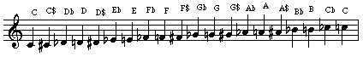

Figure 14. Guillaume Costeley’s spiritual chanson Signeur dieu ta pitié
