MTO 11.4 Examples: Moore, The Persona-Environment Relation in Recorded Song
(Note: audio, video, and other interactive examples are only available online)
http://www.mtosmt.org/issues/mto.05.11.4/mto.05.11.4.moore.php
Example 1. Patsy Cline, “I’m blue again”
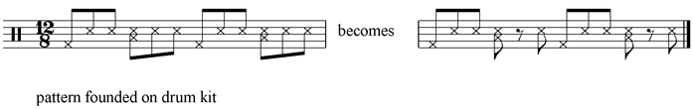

Example 2a. Laïs
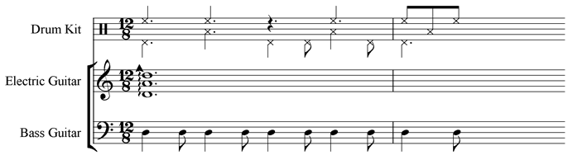

Example 2b. Laïs from 12”
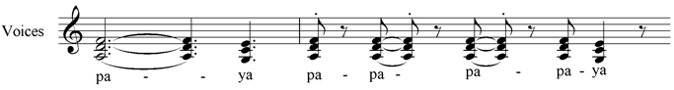

Example 2c. Laïs from 46”
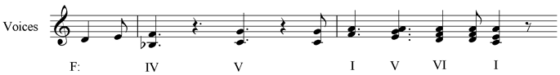

Example 3a. Vanessa Carlton, “Ordinary Day”
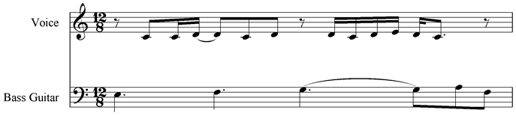

Example 3b. Vanessa Carlton, “Ordinary Day” from 1’46”
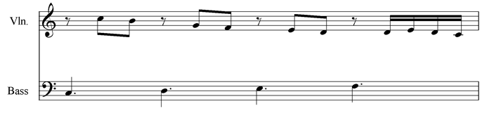
Example 3c. Vanessa Carlton, “Ordinary Day” from 2’1”
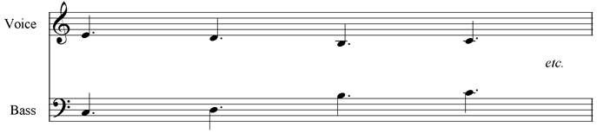

Example 4a. Lorraine Ellison
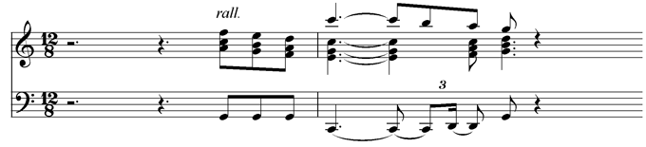

Example 4b. Bette Midler
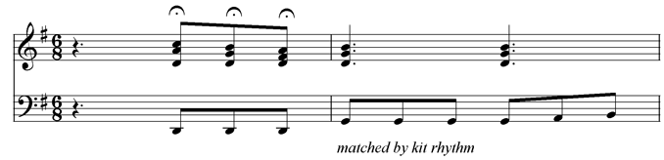

Example 5. Jethro Tull, “Flyingdale flyer” from 29”
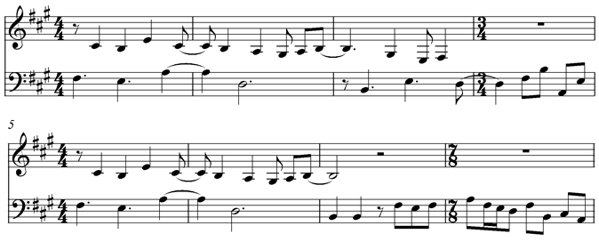

Example 6. Carpenters, “Goodbye to Love”
