MTO 12.3 Examples: Sobaskie, Contextual Drama in Bach
(Note: audio, video, and other interactive examples are only available online)
http://www.mtosmt.org/issues/mto.06.12.3/mto.06.12.3.sobaskie.php

Example 1. J. S. Bach, St. Matthew Passion: Ich bin’s, ich sollte büßen, with analytical overlay
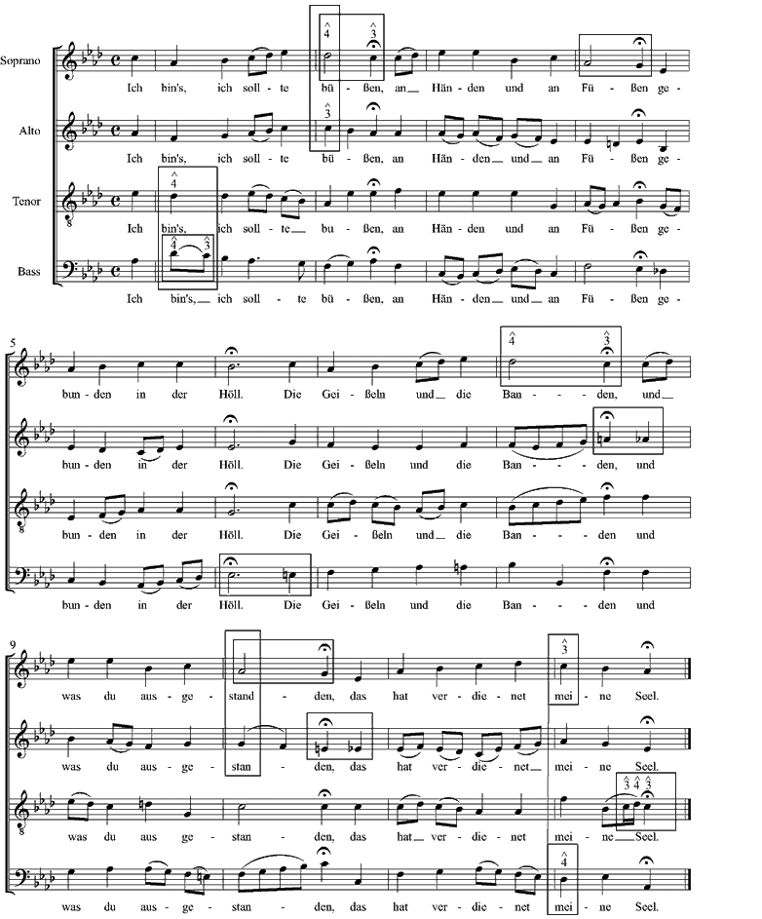
Example 2. Ich bin’s, ich sollte büßen: voice leading summaries of mm. 1-2 and mm. 11-12
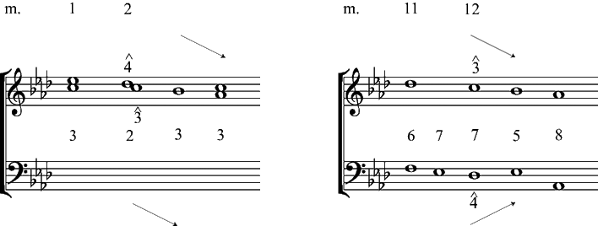

Example 3. Schenker, Free Composition, sketch of Ich bin’s, ich sollte büßen
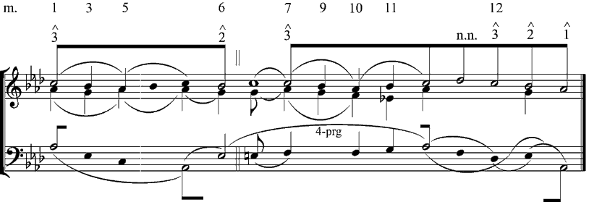

Example 4. J.S. Bach, Well-Tempered Clavier, Vol. I: Prelude in G-sharp minor
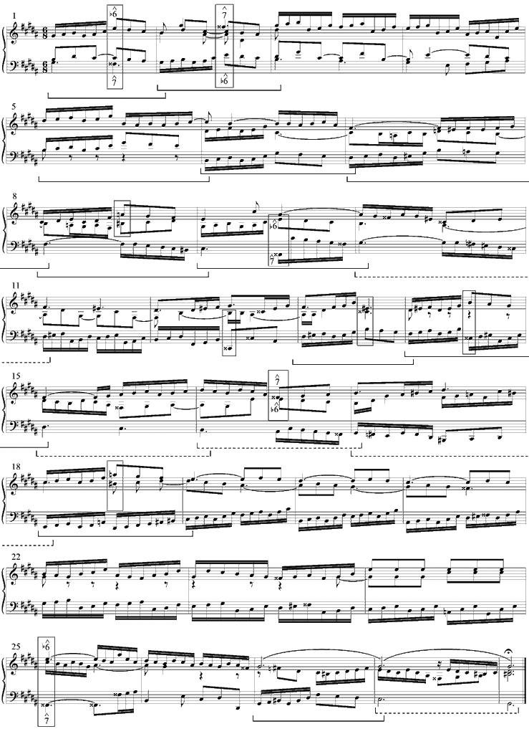
Example 5. Prelude in G-sharp minor: the “musical idea” and its “problem”
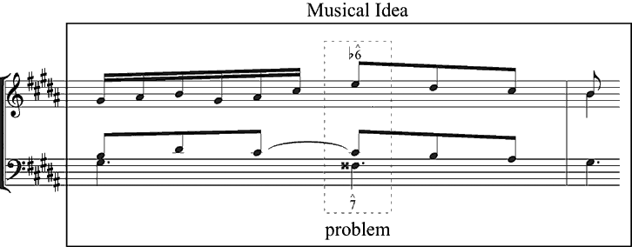

Example 6. G-sharp minor Prelude: “problem” and “climax“ voice leading summaries of mm. 1-2 and mm. 25-26
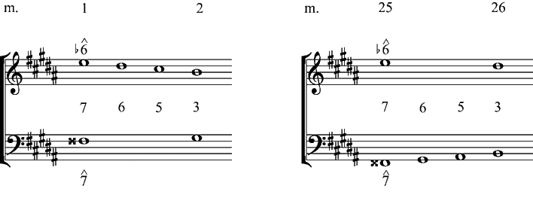

Example 7. Prelude in G-sharp minor: comprehensive voice-leading sketch
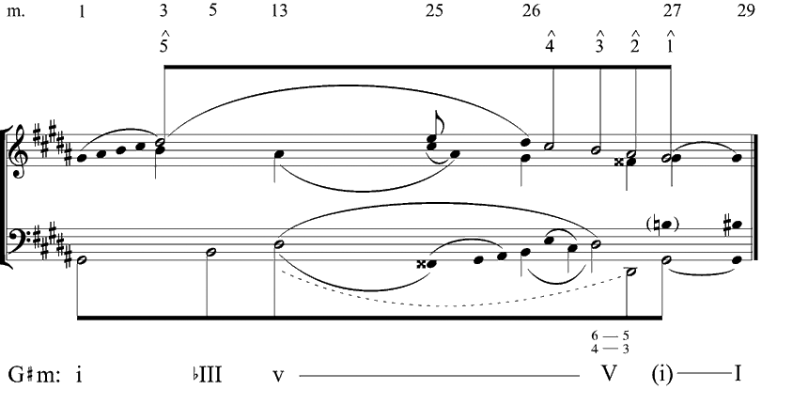

Example 8. Prelude in G-sharp minor: rhythmic reduction of the bass, mm. 15-25
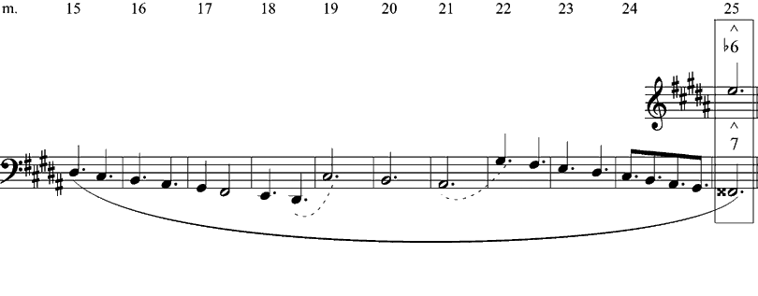

Example 9. J.S. Bach, Well-Tempered Clavier, Vol. I: G-sharp minor Prelude: mm. 26-29
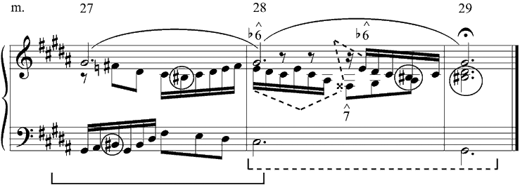

Example 10. G-sharp minor Prelude: voice leading summary of the problem’s “solution” in mm. 28-29
