MTO 14.2 Examples: Adams, Aspects of the Music/Text Relationship in Rap
(Note: audio, video, and other interactive examples are only available online)
http://www.mtosmt.org/issues/mto.08.14.2/mto.08.14.2.adams.php
Example 1. A Tribe Called Quest with Leaders of the New School, “Scenario” (1991), last verse (Rapper: Busta Rhymes)
Watch! As I combine all the juice from the mind
Heel up, wheel up, bring it back, come, rewind Powerful impact- BOOM! from the cannon
Not braggin’, try to read my mind, just imagine
Vocabulary’s necessary
When diggin’ in to my library
Oh my gosh! Oh my gosh!
Eating Ital stew like the one Peter Tosh-a*
Uh! Uh! Uh! All over the track, man
Uh! Pardon me, UH! As I come back,
As I did before I heard you beg your pardon
When I travel to the sun I roll with the squadron
RAWR! RAWR! Like the dungeon dragon
Change your little drawers ’cause your pants are saggin’
Try to step to this I will fit you in a turban
And have you smellin’ ripe like some old stale urine
Choclatey chock-o, the chocolate chicken
The rear cock diesel, butt cheeks they were kickin’
Yo! Bustin’ out before the Busta bustin’ out the rhyme the
Rhythm is in sync (HUH!) the rhymes are on time (TIME!)
Rippin’ up the sound just like a ratio
Observe the vibe but check out the Scenario
* Peter Tosh was an early reggae musician known for his commitment to the legalization of drugs.
“Ital” refers to a type of cooking favored by Rastafarians; the word is derived from “vital.”

Example 2. Graphic Depiction of the Development of Rap
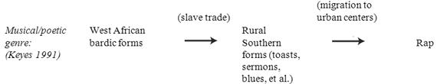

Example 3. A Tribe Called Quest, “Push It Along” (1990), 0:47–1:37 (Rapper: Q-Tip)
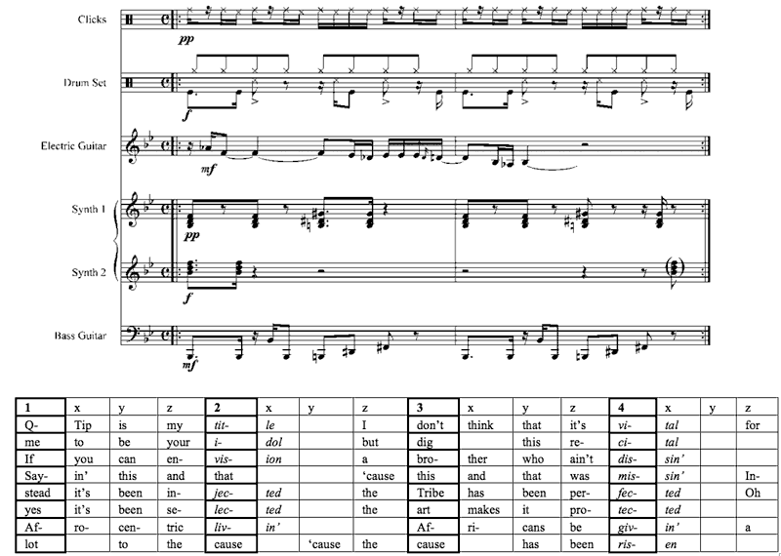

Example 4. Big Boi, “Tomb of the Boom” (2003), chorus (first occurrence, 0:55–1:06)
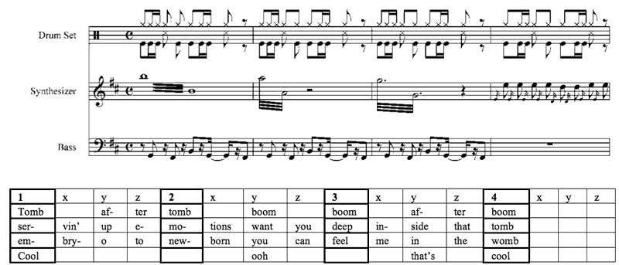

Example 5. A Tribe Called Quest, “Can I Kick It?” (1990), 3:08–3:31 (Rapper: Phife)
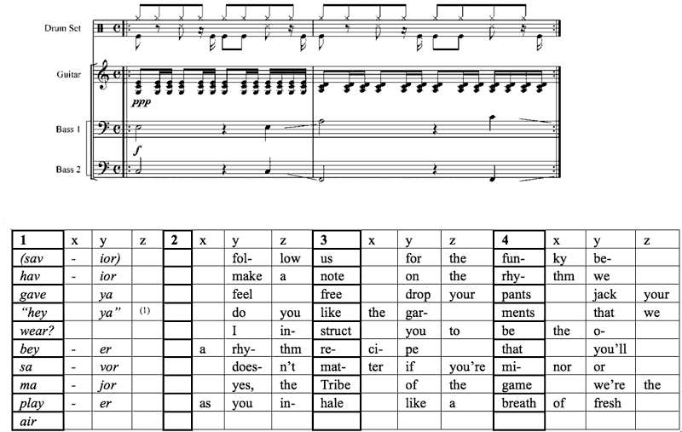
Example 6. Purple Ribbon All-Stars, “Kryptonite” (2005), 1:31–1:51 (Rapper: C-Bone)*
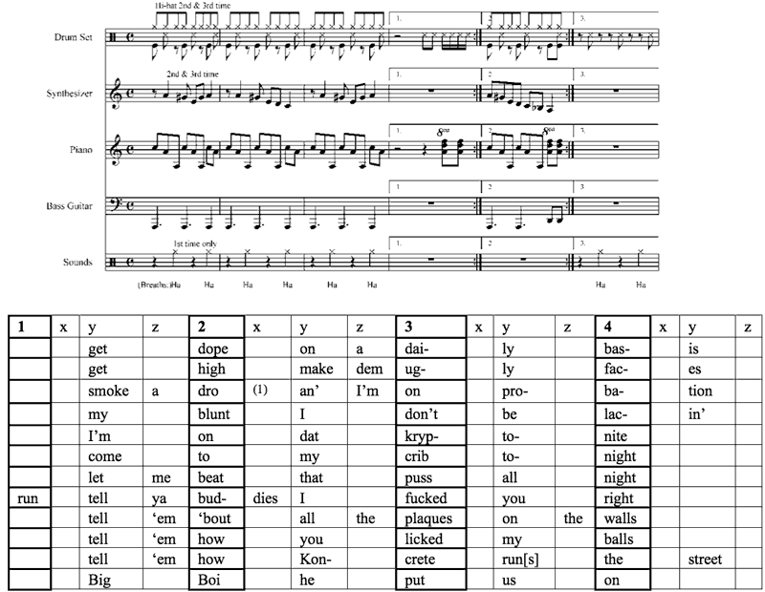

Example 7. OutKast, “The Rooster” (2003), 0:00–0:20
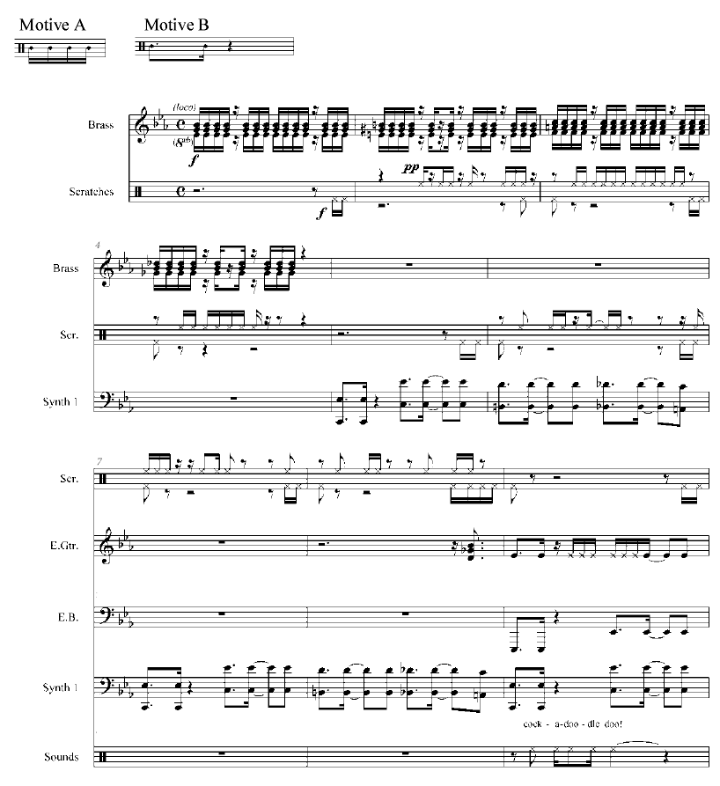

Example 8. OutKast, “The Rooster” (2003), 0:46–1:15 (Rapper: Big Boi)
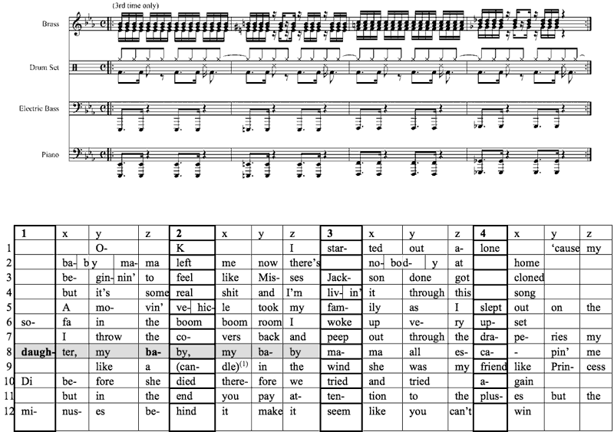

Example 9. OutKast, “The Rooster” (2003), 2:20–2:39 (Rapper: Big Boi)
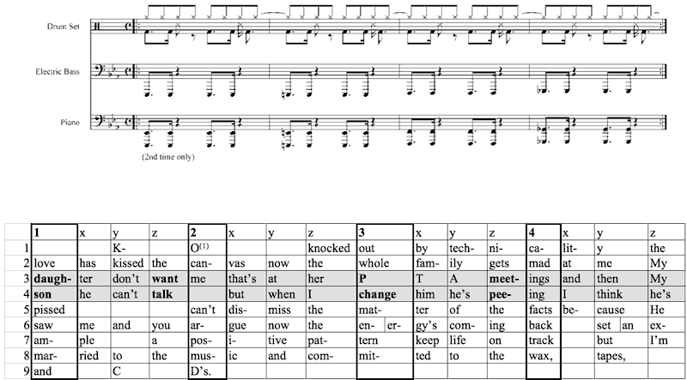

Example 10. A Tribe Called Quest with Leaders of the New School, “Scenario” (1991), 2:56–3:50 (Rapper: Busta Rhymes)
