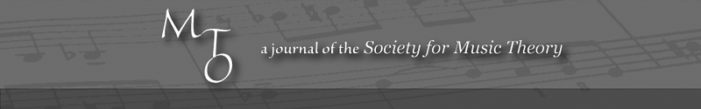
MTO 14.2 Examples: Baragwanath, Approaches to Melody in Puccini
(Note: audio, video, and other interactive examples are only available online)
http://www.mtosmt.org/issues/mto.08.14.2/mto.08.14.2.baragwanath.php
Example 1a. Turandot, Act I, Fig. 42, mm. 1–7: the opening vocal melody of ‘Signore, ascolta’
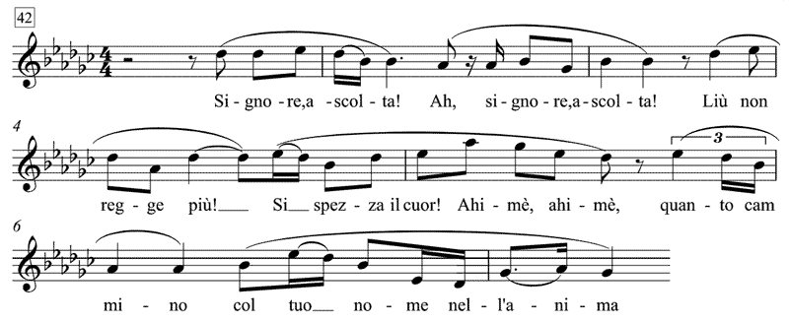

Example 1b. ‘Signore, ascolta’ notated as a contrapuntal melody
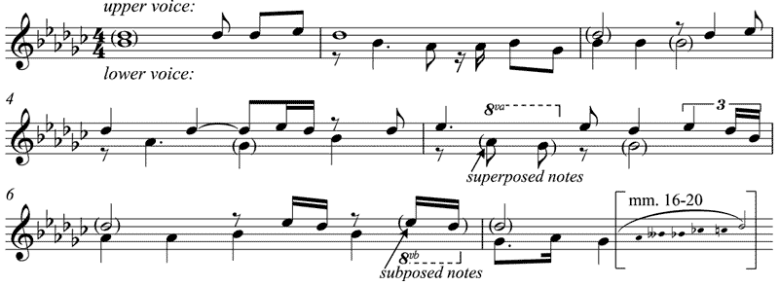
Example 1c. Voice-leading analysis of the first section of ‘Signore, ascolta’
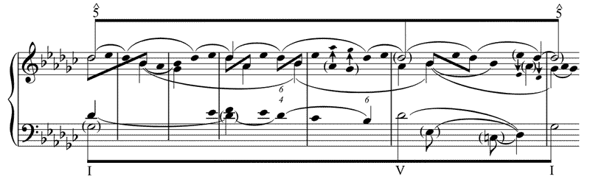
Example 2a. Turandot, Act I, Fig. 42, mm. 16–20: The Closing Section of ‘Signore, ascolta’
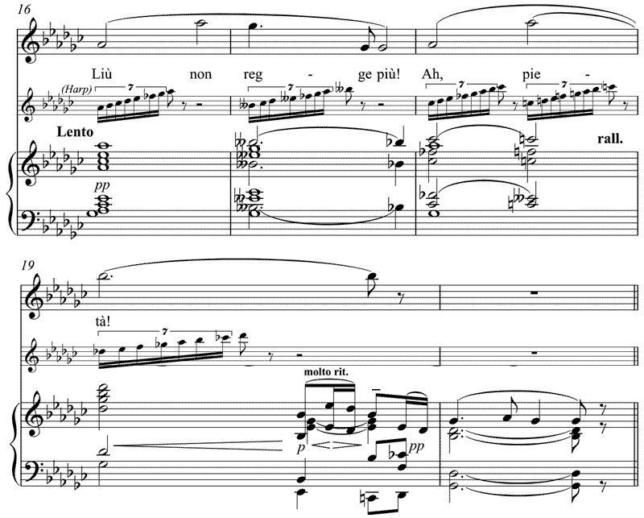

Example 2b. Voice-leading analysis of the closing section of ‘Signore, ascolta’, Act I, Fig. 42, mm. 15–19
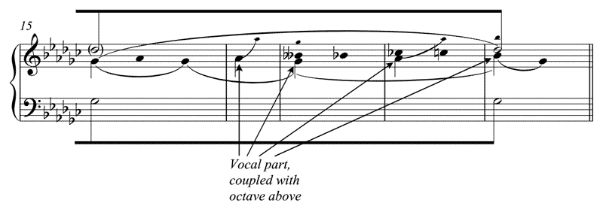

Example 3. Turandot, Act I, Fig. 43, mm. 1–8: The beginning of ‘Non piangere, Liù’
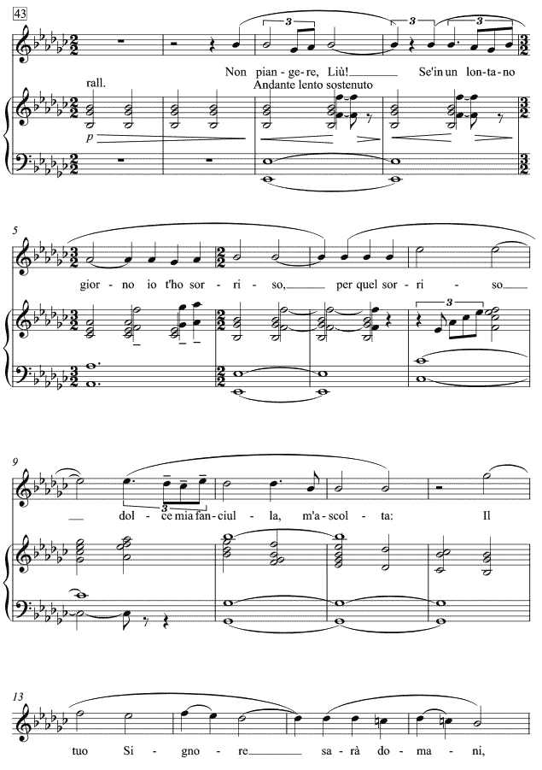

Example 4. Catalini, La Wally, Act I: The beginning of ‘Ebben? Ne andrò’
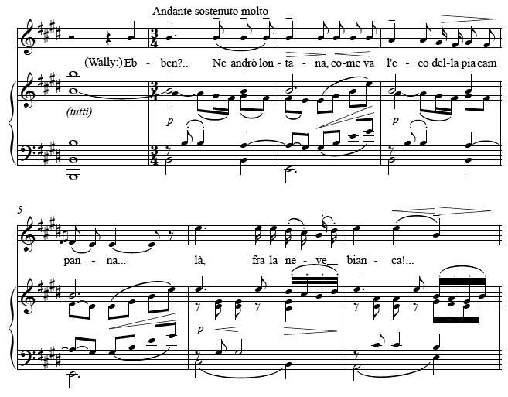

Example 5a. Turandot, Act I, Fig. 45: The final section of ‘Non piangere, Liù’ (vocal part)
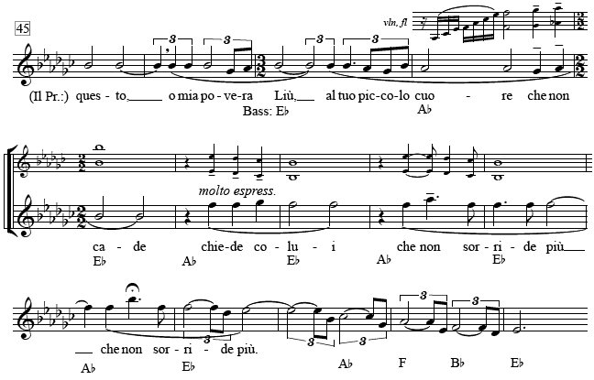

Example 5b. Turandot, Act I, Fig. 45, mm. 3–13: Final section of ‘Non piangere’ (voice-leading graph)
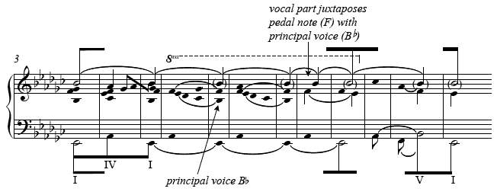

Example 6. Tosca, Act II, Fig. 51–Fig. 52, mm. 1–8: ‘Vissi d'arte’ (voice-leading graph)
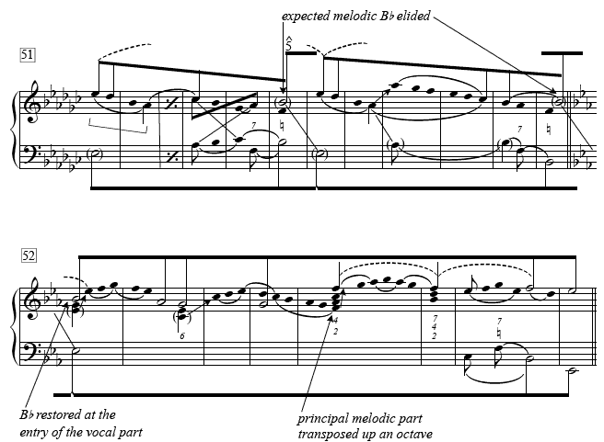

Example 7a. Tosca, Act II, Fig. 52, mm. 8–13: Central Section of ‘Vissi d'arte’ (voice-leading graph)
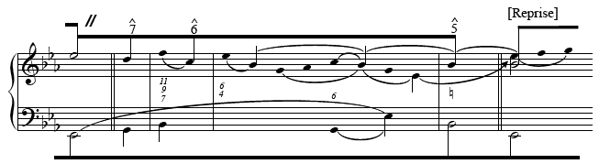

Example 7b. Tosca, Act II, Fig. 52, mm. 19–Fig. 53, m. 3: Cadence of ‘Vissi d'arte’ (voice-leading graph)
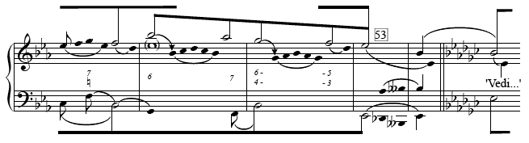

Example 8a. Tosca, Act III, Fig. 11, mm. 1–5: The opening of ‘E lucevan le stelle’ (piano reduction)
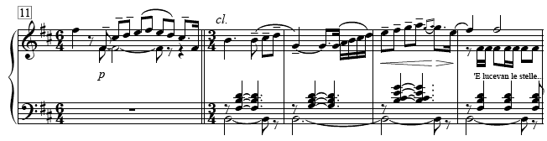

Example 8b. Voice-leading analysis
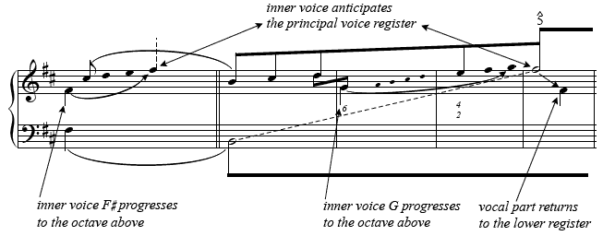

Example 9. Tosca, Act III, Fig. 11, mm. 6–15: ‘E lucevan le stelle’ (voice-leading graph)
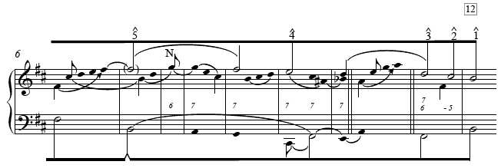

Example 10. Turandot, Act II, Fig. 44: The beginning of the principal section of ‘In questa reggia’
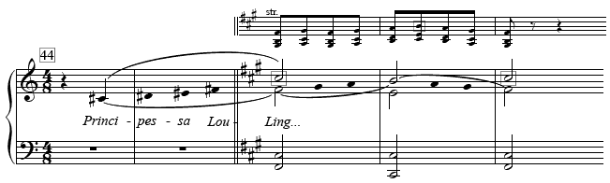

Example 11. Turandot, Act II, Fig. 46, m. 10–Fig. 47: Culmination of ‘In questa reggia’
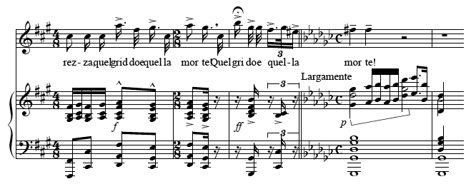
Example 12. Suor Angelica, Fig. 60, mm. 1–6: The opening of Angelica's aria ‘Senza Mamma’
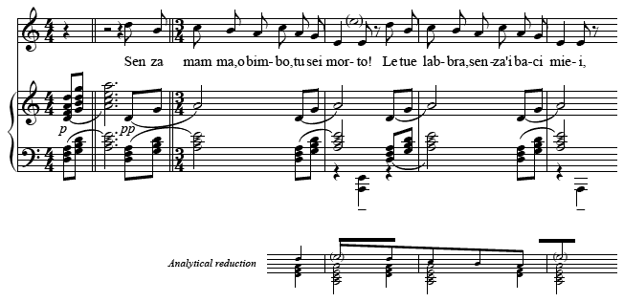

Example 13. Suor Angelica, Fig. 62, mm. 1–10: The varied reprise/closing section of ‘Senza Mamma’
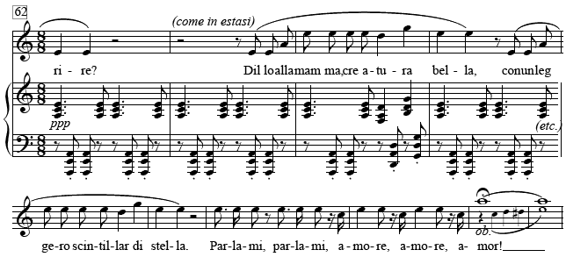

Example 14a. Turandot, Act III, Fig. 4, mm. 1–7: The beginning of ‘Nessun dorma’
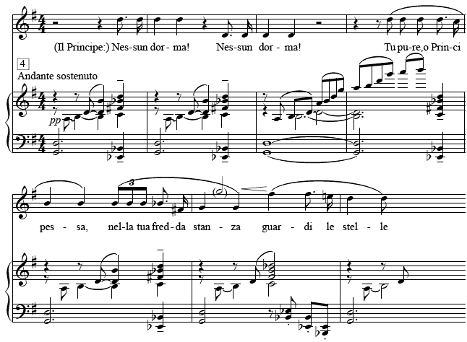

Example 14b. Turandot, Act III, Figs. 4–5: The first section of ‘Nessun dorma’ (voice-leading analysis)
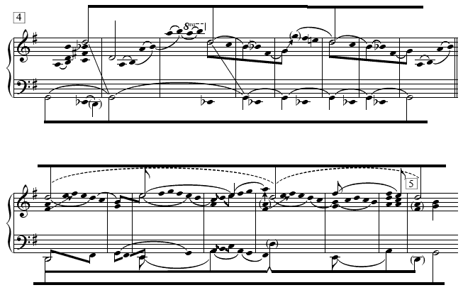

Example 15. Turandot, Act III: The opening section of ‘Tu che di gel’ (voice-leading analysis)
