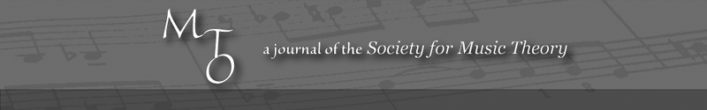
MTO 14.2 Examples: Väisälä, Rhetoric and Justification in Analysis
(Note: audio, video, and other interactive examples are only available online)
http://www.mtosmt.org/issues/mto.08.14.2/mto.08.14.2.vaisala.php

Example 1. Brahms, Piano Quartet No. 3, mm. 1–27, three conceptions of bass line hierarchy
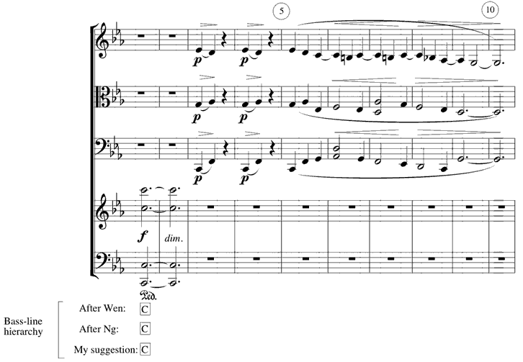
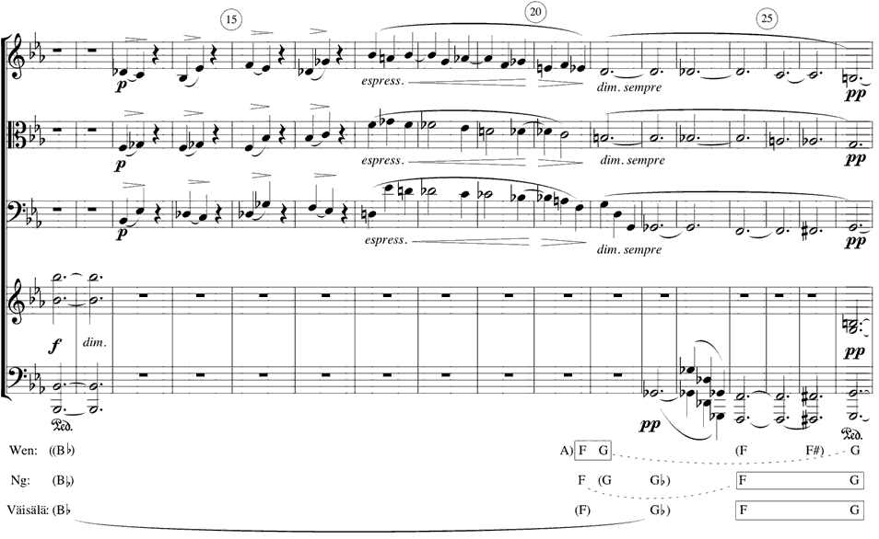

Example 2. Brahms, Piano Quartet No. 3, three readings of harmonic structure
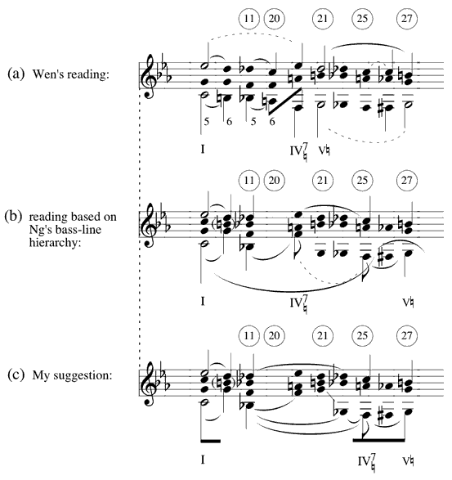

Example 3. Brahms, Piano Quartet No. 3, mm. 1–32, voice-leading sketch
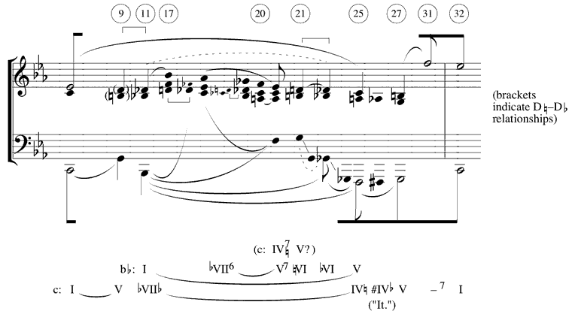

Example 4. Brahms, Piano Quartet No. 3, rhythmic treatment of “parallelistic” progressions
