MTO 14.3 Examples: Capuzzo, Maximally Alpha-Like Operations
(Note: audio, video, and other interactive examples are only available online)
http://www.mtosmt.org/issues/mto.08.14.3/mto.08.14.3.capuzzo.php
Example 1. Dallapiccola, Quattro Liriche de Antonio Machado, III (1948), mm. 80–85
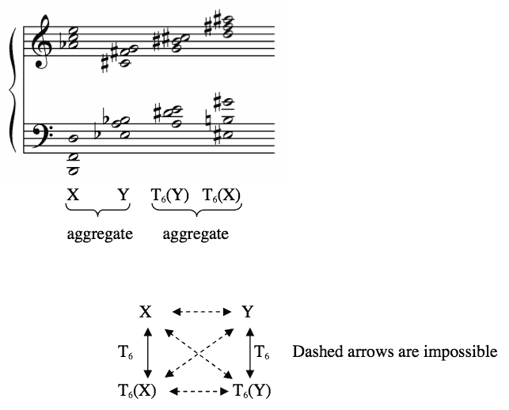

Example 2. Z-related/M-related scs
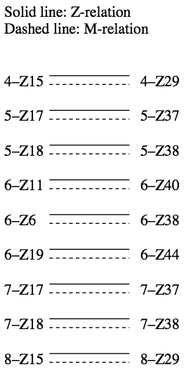

Example 3. Z-related/M-variant scs
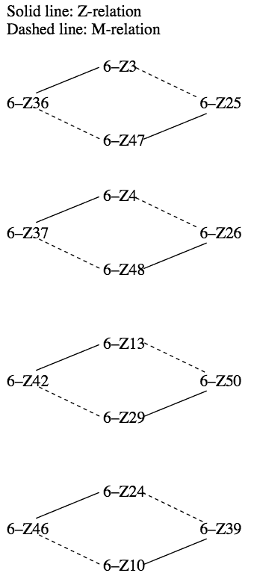

Example 4. Z-related/M-invariant scs
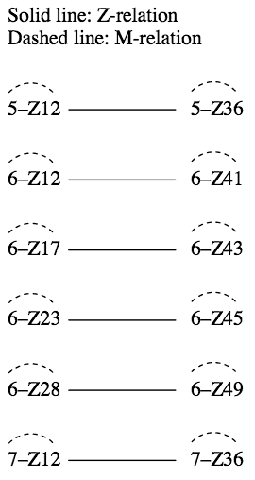

Example 5. Adding α to the Z-related/M-variant scs
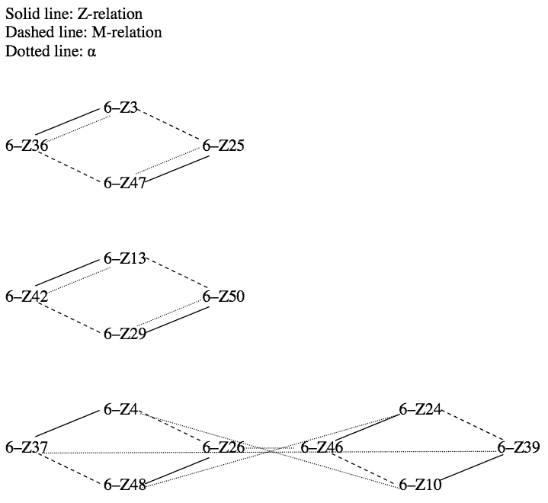

Example 6. Adding α to the Z-related/M-variant scs
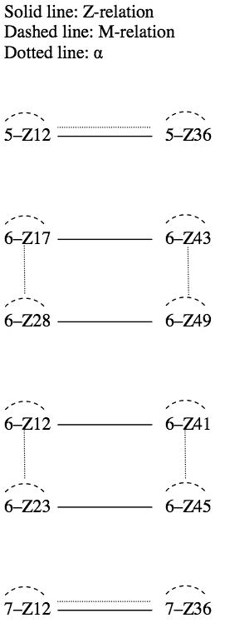

Example 7. Two maximally α–like operations
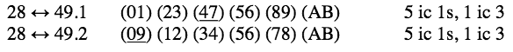

Example 8. Redo of the transformational network in Example 1 using 28 ↔ 49
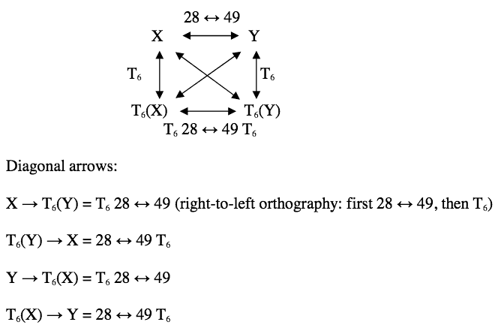

Example 9. Carter, Retrouvailles (2000), mm. 5–10
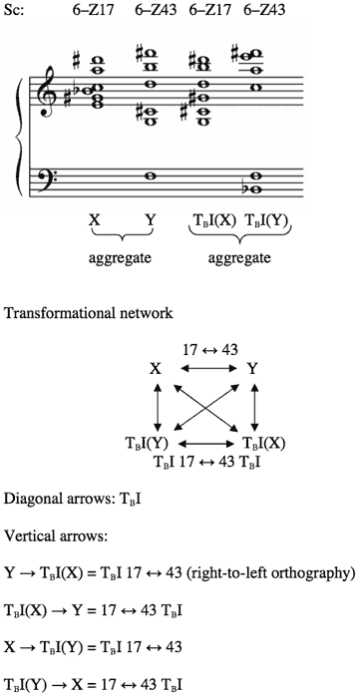

Example 10. Webern, Op. 7, No. 2 (1910)
(Forte 1990, 249)
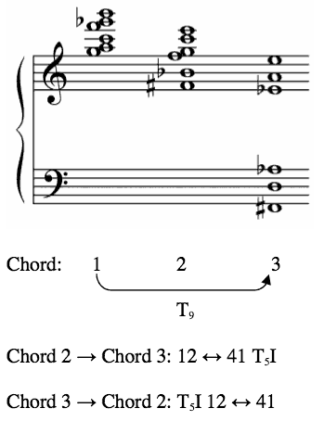

Example 11. Stravinsky, “Sacrificial Dance” from The Rite of Spring (1921 edition), R3
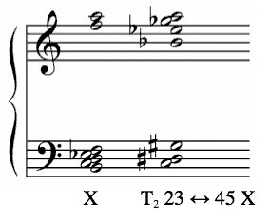

Example 12. Maximally α-like operations for the remaining Z-pairs in Example 5
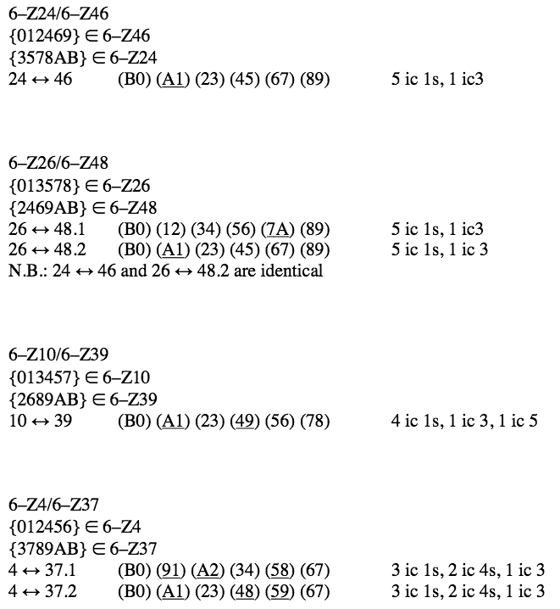

Example 13. Maximally α-like operations in beat-class space
