MTO 14.3 Examples: Kallis, Principles of Pitch Organization in Scriabin's Early Post-tonal Period
(Note: audio, video, and other interactive examples are only available online)
http://www.mtosmt.org/issues/mto.08.14.3/mto.08.14.3.kallis.php
Example 1. Scriabin’s primary pitch material
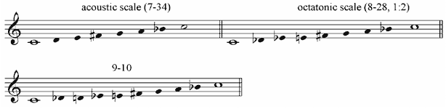

Example 2. Model of pitch organization in Scriabin
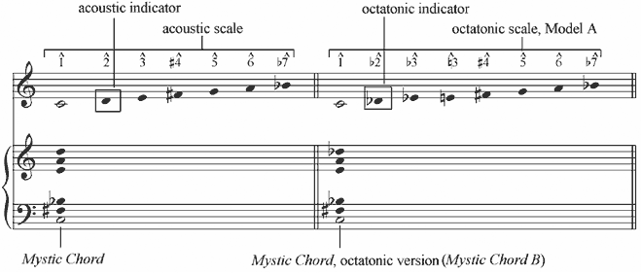

Example 3. Generation of 9-10 from the union of the acoustic and the octatonic scales
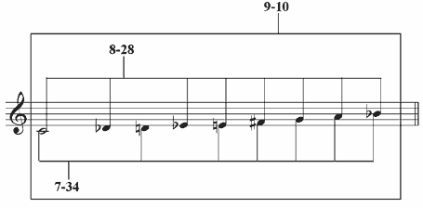

Example 4. Scriabin’s octatonic/acoustic transformations
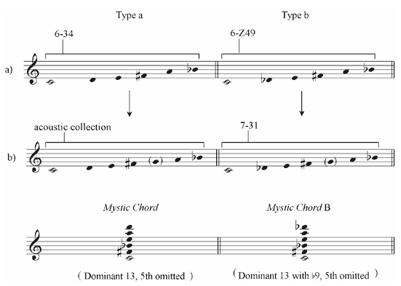

Example 5. Scriabin’s primary pitch material
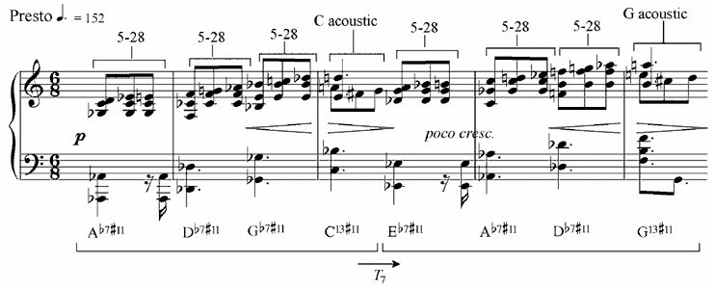

Example 6. 9-10, T₃ operation
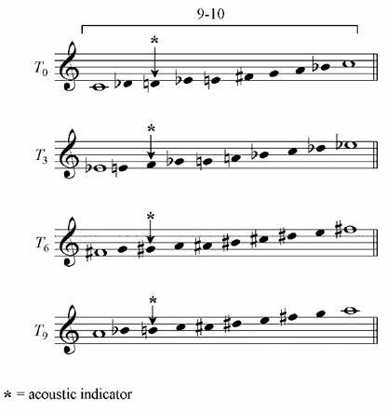

Example 7. Octatonic scale, array of harmonies in Scriabin’s post-tonal oeuvre
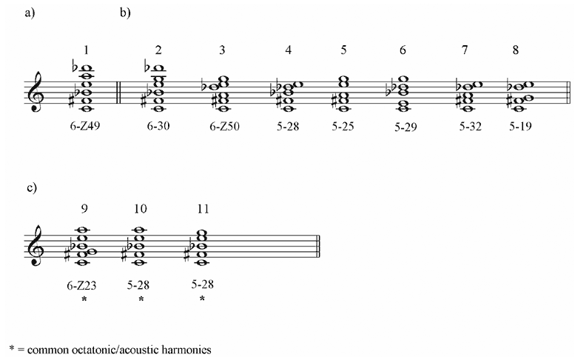

Example 8. Acoustic scale, array of harmonies in Scriabin’s post-tonal oeuvre
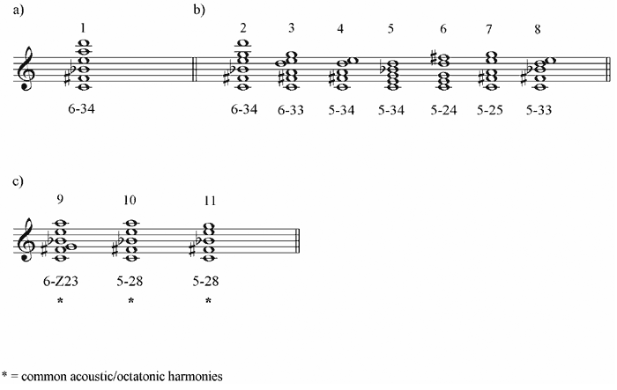

Figure 1.
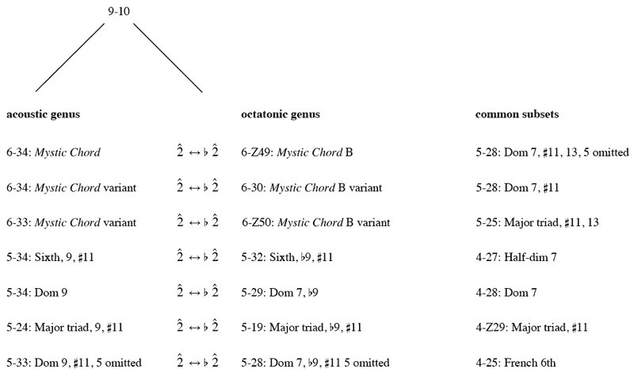

Example 9. Scriabin, Poème-Nocturne, Op. 61, mm. 1–7
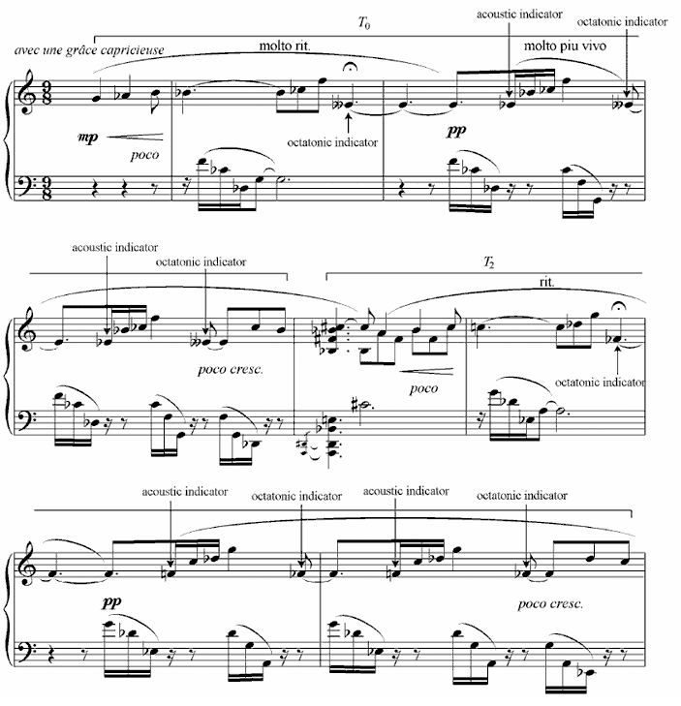

Figure 2. Substitution-based interaction: network of set interrelationships, from Callender (1998, Fig. 11, p. 227)
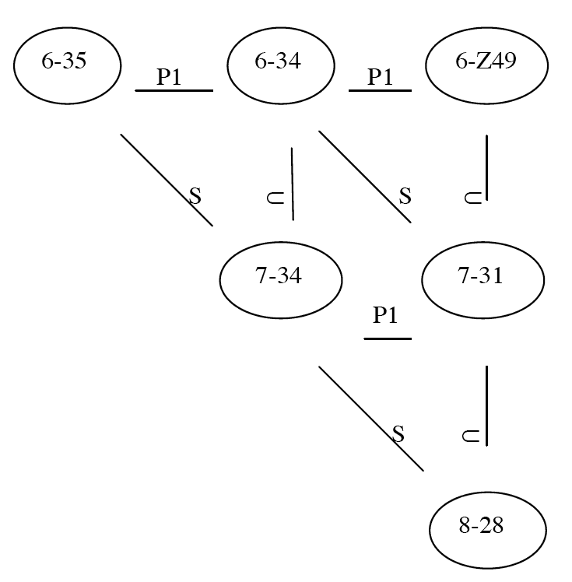

Figure 3. Voice-leading between P1-related sets
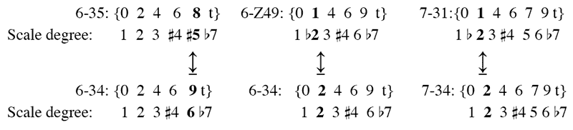

Example 10a. Scriabin, Poème, Op. 69, No. 1, mm. 1–6
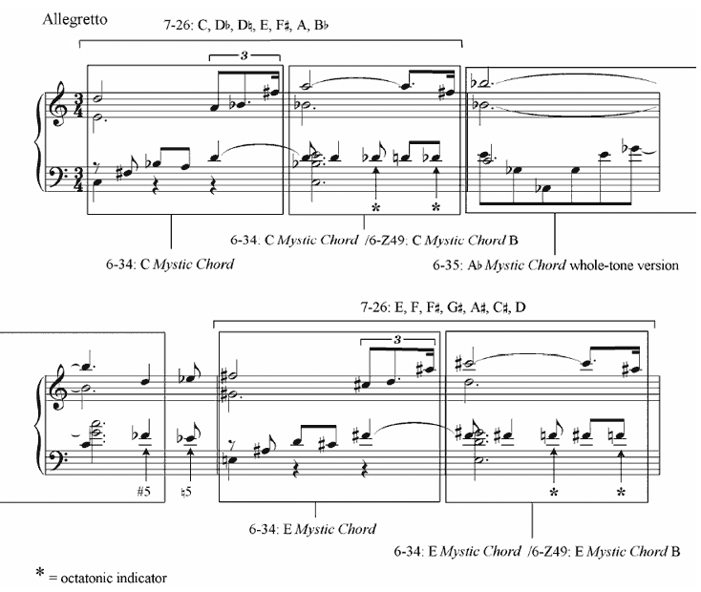

Example 10b. Scriabin, Poème, Op. 69, No. 1, mm. 1–5, acoustic/whole-tone interaction
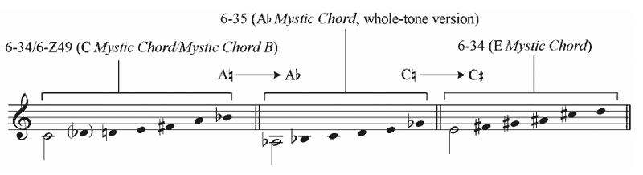

Example 11. Scriabin, Etrangeté, Op. 63, No. 2
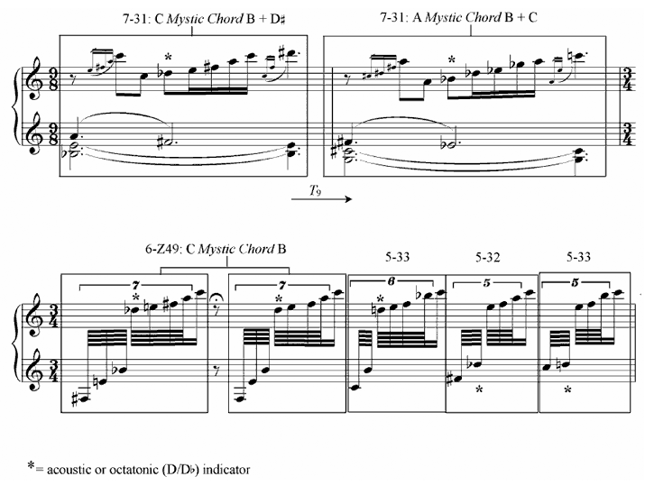

Figure 4. Voice-leading between S-related sets
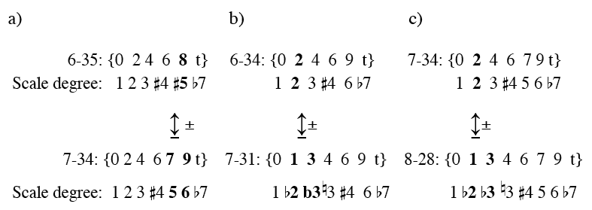

Table 1. Scriabin, Poème, Op. 69, No. 1, mm. 1–6
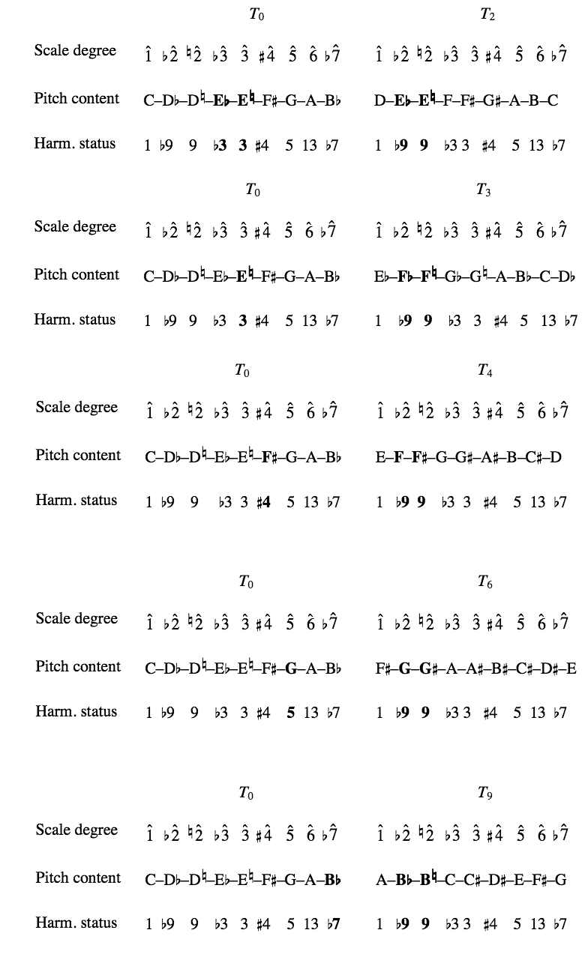
Example 12. Scriabin, Masque, Op. 63, No. 1, mm. 1–4
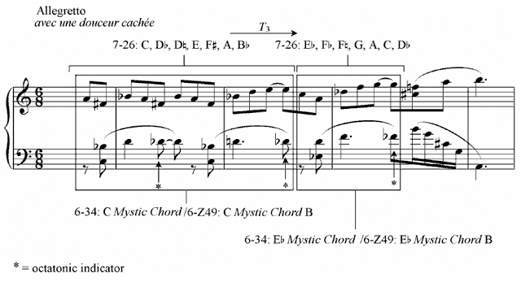

Example 13. Scriabin, Prelude, Op. 59, No. 2, mm. 1–5
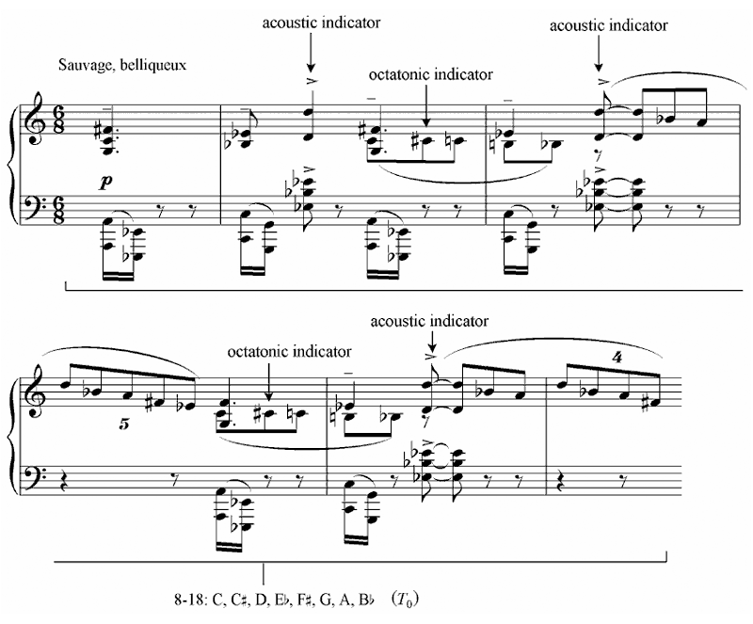

Example 14. Scriabin, Poème-Nocturne, Op. 61, mm. 159–72
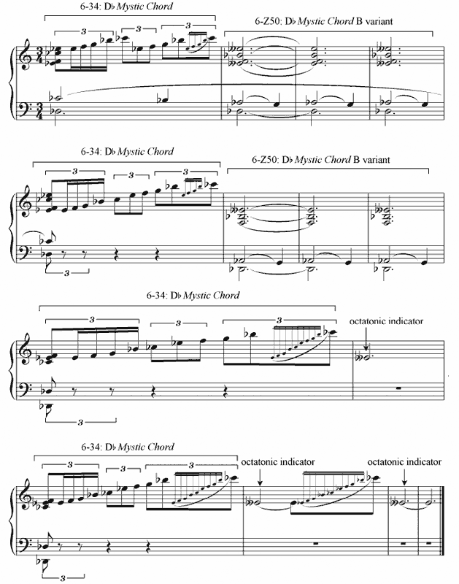

Figure 5.
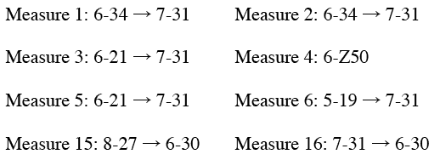

Example 15a. Scriabin, Prelude, Op. 67, No. 1, mm. 1–6. Based on Pople
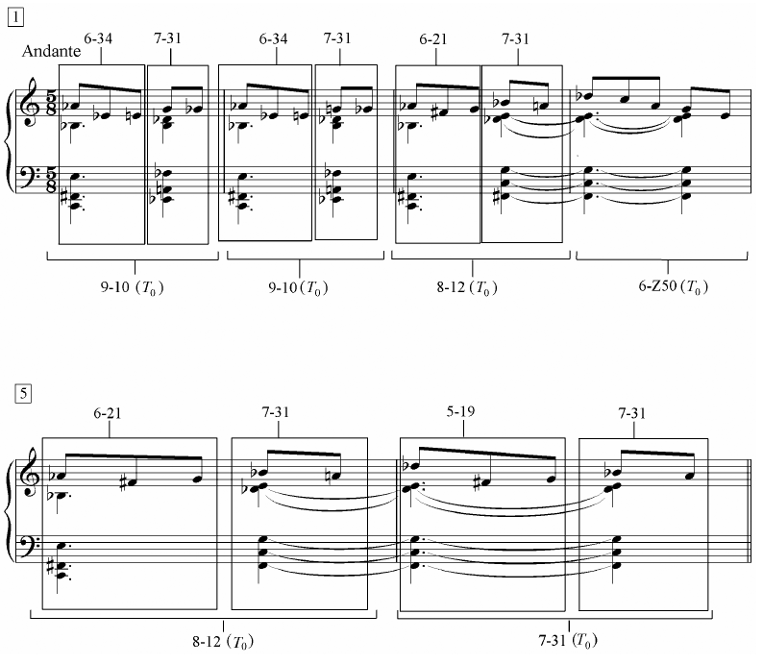
Example 15b. Scriabin, Prelude, Op. 67, No. 1, mm. 15–16
