MTO 15.2 Examples: McFarland, Review of Day-O'Connell
(Note: audio, video, and other interactive examples are only available online)
http://www.mtosmt.org/issues/mto.09.15.2/mto.09.15.2.mcfarland.php
Example 1. Vogler, Pente chordium (1798), beginning
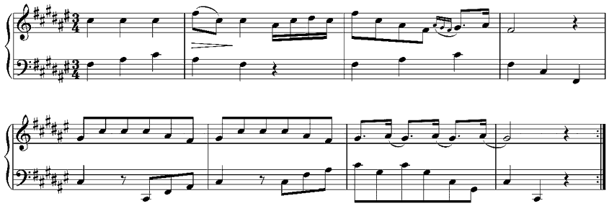

Example 2. Brahms, Schicksalslied (1871), measures 64–69
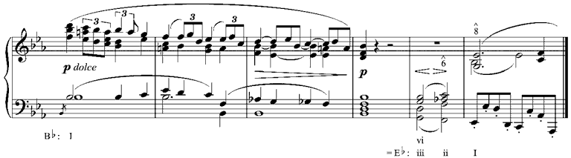

Example 3. Mozart, Die Zauberflöte (1791), I, Quintet, measures 3–10
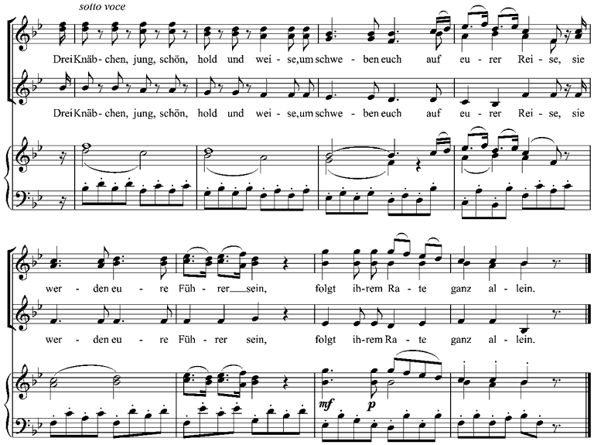

Example 4. Dvorák, Symphony no. 9 (1893), ii, final cadence, measures 112–120
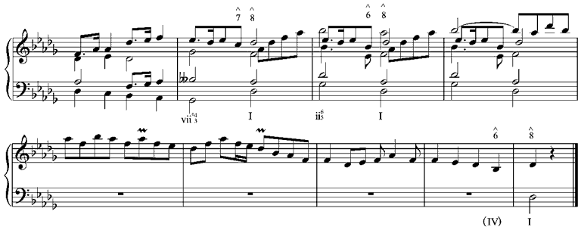

Example 5. Chopin, Etude, op. 25 no. 8 (1837), end
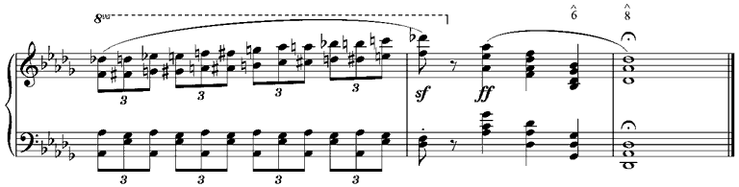

Example 6. Schubert, Winterreise (1828), “Gute Nacht,” measures 71–75
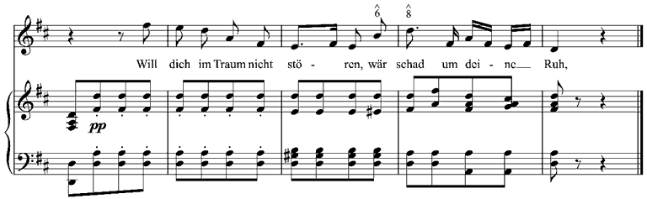
Example 7. Mahler, Symphony no. 1 (1888), iv, reh. 26
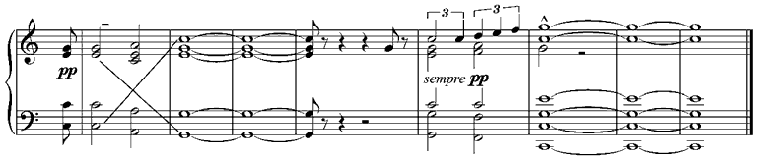

Example 8. Rossini, “L'Amour à Pekin” (1857-68), Gamme chinoise
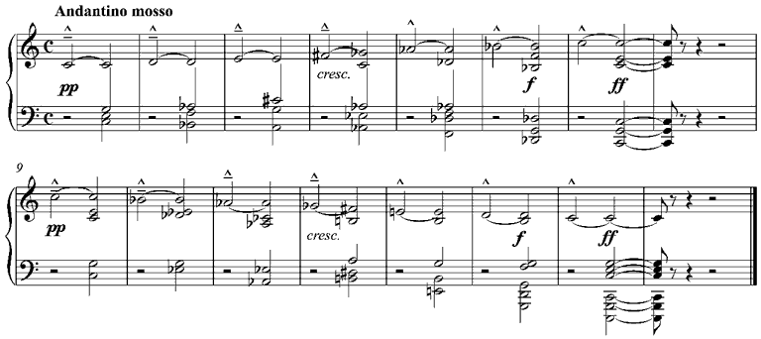

Example 9. Schubert, Piano Trio in B-Flat major, D. 898 (1828), i
(a) First theme, measures 1–3
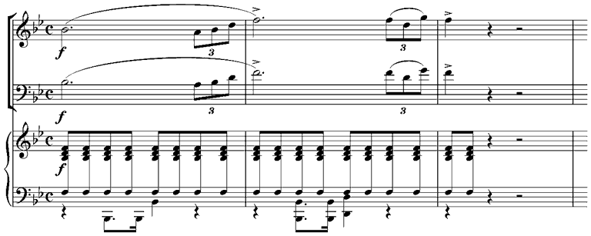
(b) Second theme, measures 12–13
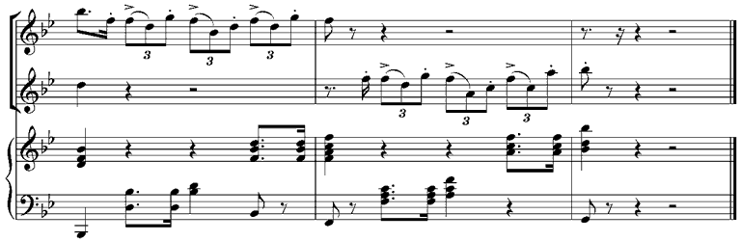
(c) Transition to second group, measures 51–53
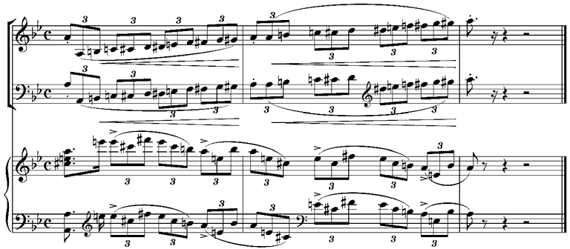

Example 10. Chopin, Nocturne, op. 9 no. 1 (1832), measures 61–66
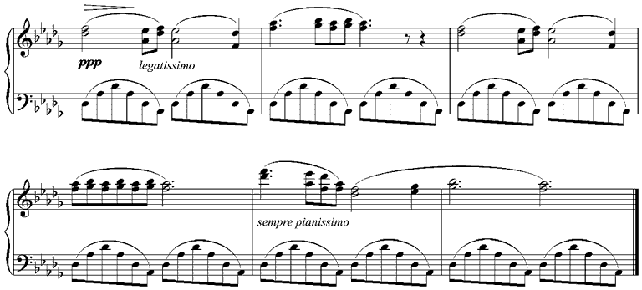

Example 11. Schubert, Die schöne Müllerin (1823), “Des Baches Wiegenlied,” measures 34–38
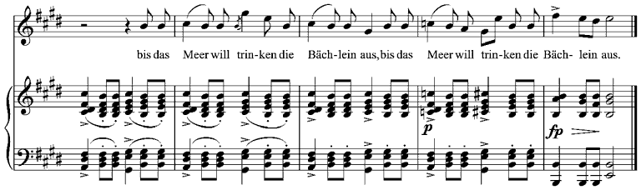

Example 12. Berlioz, Symphonie fantastique (1830–32), I, end
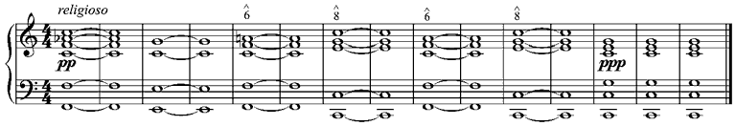

Example 13. Day-O'Connell's example 1.35, “Speech thirds”
(a) From Campbell, Songs in Their Heads: Music and Its Meaning in Children’s Lives, 18
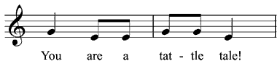
(b) From Heaton, “Air Ball: Spontaneous Large-Group Precision Chanting,” 81
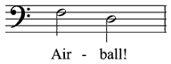
(c) The author’s transcription
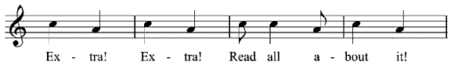
(d) From Massin, Les Cris de la ville, no. 277
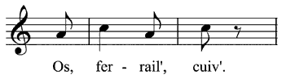
(e) The author’s transcription
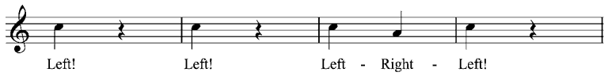

Example 14. Day-O'Connell's example 5.5, Debussy, “La fille aux cheveux de lin,” reduction
