MTO 15.3 Examples: Jensen-Moulton, Music Fundamentals
(Note: audio, video, and other interactive examples are only available online)
http://www.mtosmt.org/issues/mto.09.15.3/mto.09.15.3.jensen-moulton.php
Figure 1. Seating arrangement, Day 1 of Ear Training class
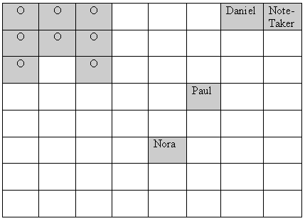

Figure 2. Seating assignments on Day 3, Ear Training class
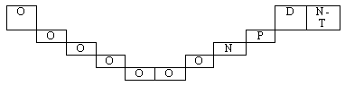

Figure 3. Seating assignments on Day 3.1, Ear Training class
