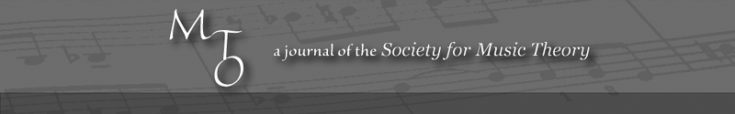
MTO 15.3 Examples: Pacun, Recommendations for Visually Impaired Students
(Note: audio, video, and other interactive examples are only available online)
http://www.mtosmt.org/issues/mto.09.15.3/mto.09.15.3.pacun.php
Figure 1. Some Things to Put in Place
Basics:
- Allow time for special:
  - Handouts and examples in alternative formats
  - Individual instruction
  - Classroom management
- Find readers and/or transcribers (possibly work-study students)
- Visit Academic Support Services for help with scores & texts in Braille or alternative formats
- Request support from Dean or Chair
Physical Plant and Scheduling (daily needs):
- Desks: flat, and large enough for a laptop and educational aids
- Student’s Schedule: “what’s easiest” (especially for first year students)
- Pre-enroll student to give instructor additional preparation time
Classroom issues:
- Student volunteers
- Textbooks: locate alternative format(s); or an alternative textbook if the assigned text is not available
- Envision in advance:
  - Testing: time, format
  - Notation-based skills/activities such as dictation
  - What happens when x isn’t available?
- Envision how challenges may lead to changes in instruction & curriculum
- Be sure to say what you are doing as you are doing it
Technology:
- Compatibility between Academic support, professor, and student software
- Test runs: does it really work the way you need it to?
- Worst-case scenarios: old-school tech—“Slate and Stylus”

Photo 1.
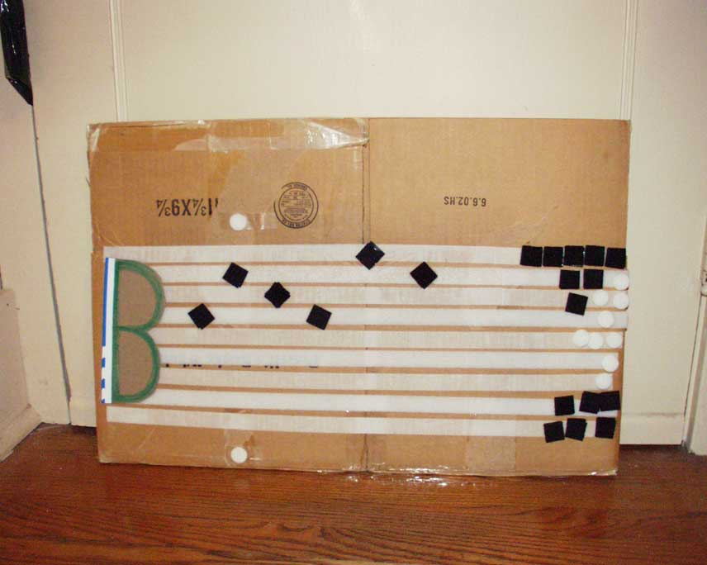
Photo 2.
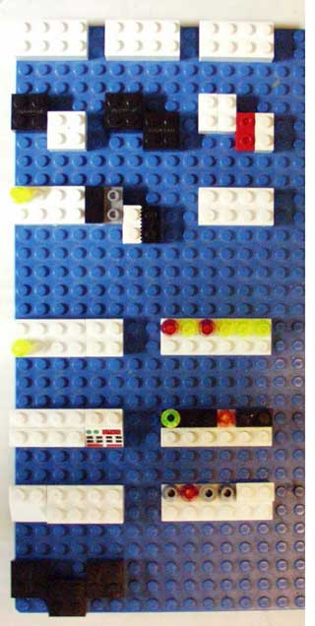

Example 1. Transcription of Lego rhythms
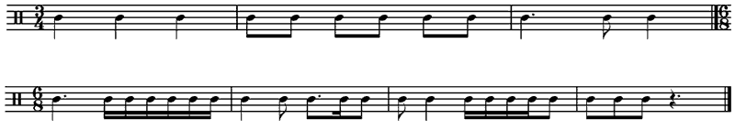
Figure 2. Super Quick Braille Primer
Basics:
Six-dot cells: top four for pitch, bottom two for rhythm. Key signature and meter are shown at top of score.
Note equivalencies for rhythms: 1=1/16; 1/2=32nd, 1/4=64th, 1/8=128th. Gap=barline.
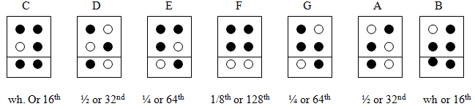
Additional cells necessary for (# of cells in parentheses):
Accidentals (2), Ties (2), Dynamics (2-4), Articulation (1–3), Slurs (2–3), Ornaments (1–2+)
Repeat signs (cells) used whenever possible (measure level); signs also available for diatonic transposition of motives and measures.
Multiple-part formats:
Two or more separate lines: in rough alignment, or unaligned.
Keyboard-style chords: shown by diatonic intervals above the bass (i.e. piano left hand), but below the melody (i.e piano right hand)—all from given pitch.
“In-accord” format for soprano/alto and tenor/bass format (SA/TB): here the A follows the S; the student must assemble the measure in their head or at the keyboard.
Specialized symbols available for all manner of keyboard (stemming) and string formats.
Large-scale format:
Music is best parsed into small segments (8–16 measures for single lines, 4–8 measures for multiple parts—all depending upon the skill and ability of the reader/musician).
Caveats:
Braille notation is distinct from Braille writing: “A[4]” ≠ “A” [tree ...].
Older scores may contain different cells and use unconventional formats.
A linear and additive system
Braille Literacy: owing to recent computer technology, as few as 20% of young blind music students now read Braille notation with any degree of fluency.

