MTO 24.2 Examples: Jakubowski, Spectral Meter: Dramatizing Entrainment and Communicating Form in Gérard Grisey’s Vortex Temporum I (1994–96)
(Note: audio, video, and other interactive examples are only available online) http://mtosmt.org/issues/mto.18.24.2/mto.18.24.2.jakubowski.html
Example 1. Meter in Vortex Temporum I, Reh. 1 (piano part only)
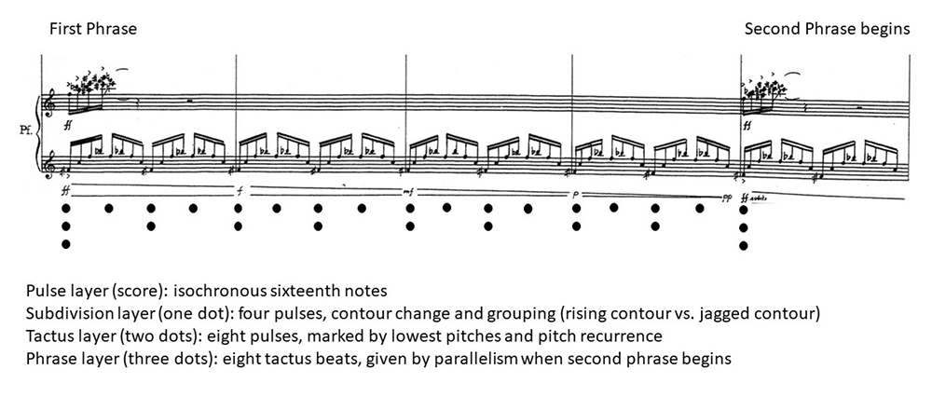

Example 2. Heightened metric complexity near the end of the first section (Reh. 32–34)
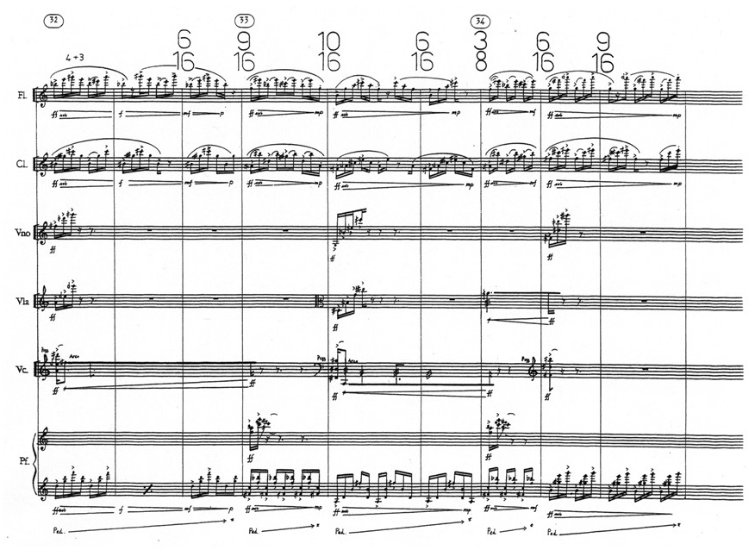

Example 3. The nine meters in Vortex Temporum I, Reh. 1–37
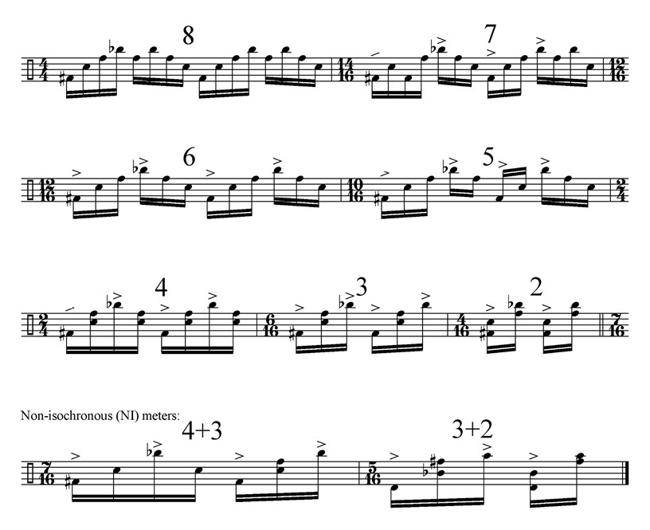

Example 4. A six-pulse tactus meter in a later phrase, exhibiting similar grouping evidence
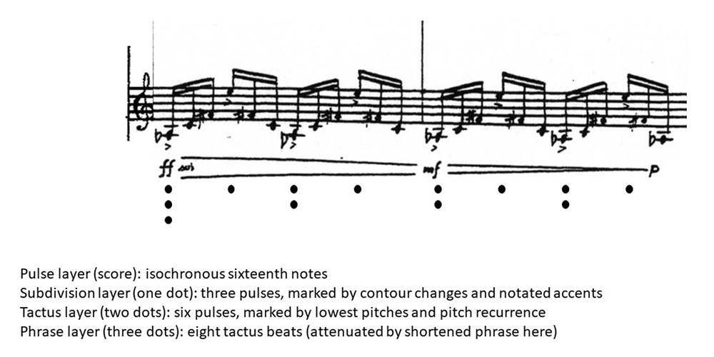

Example 5. Metric ambiguity creating a dynamic “crossfade” between the crescendoing strings and fading piano
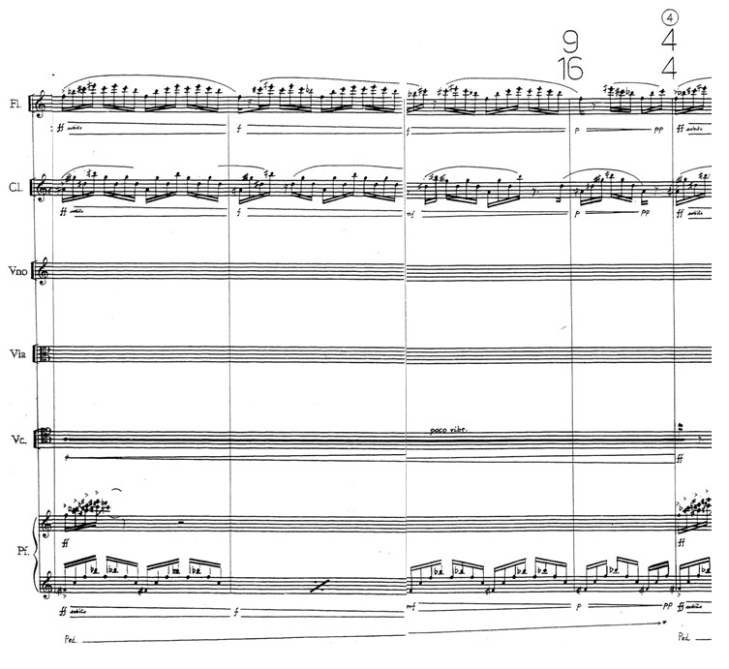

Example 6. Phrases, meters, and displacements in Vortex Temporum I
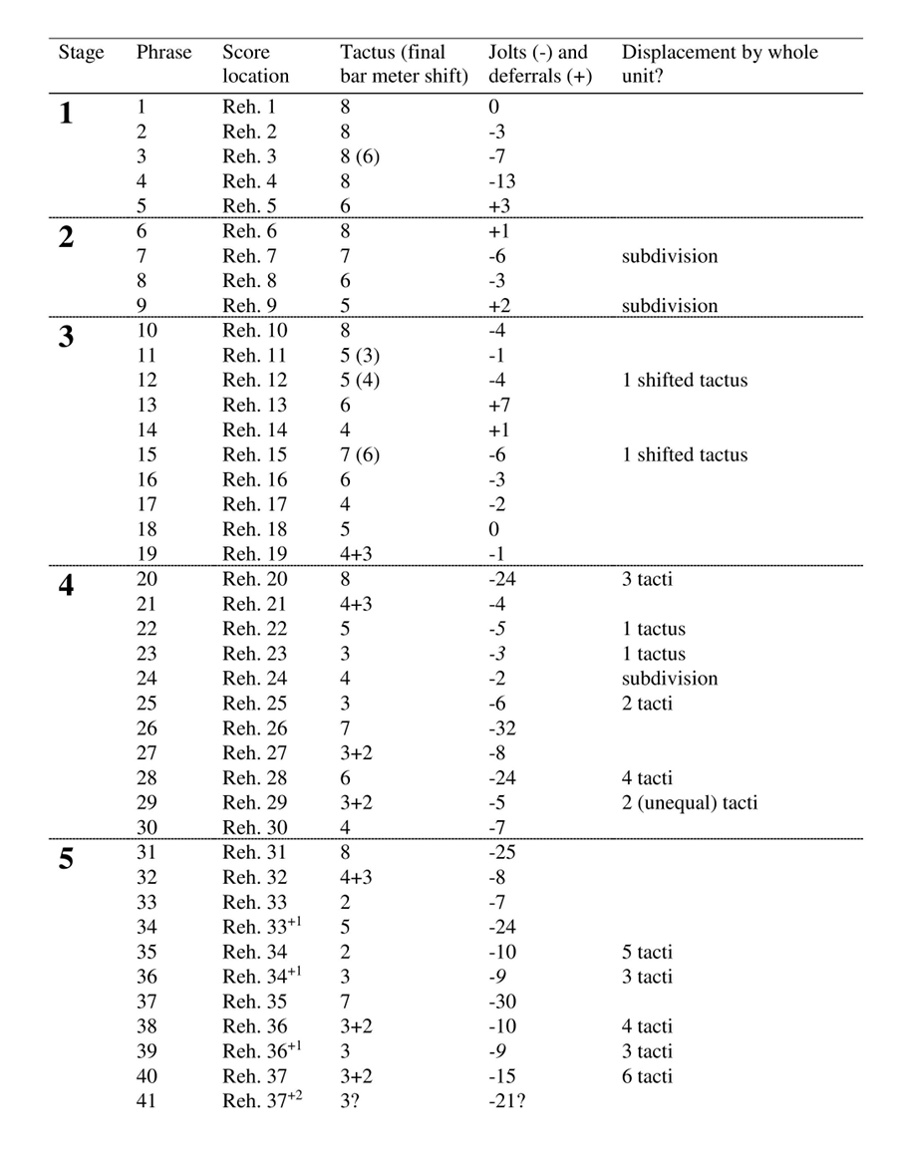

Example 7. Jolt (phrase begins too early), Reh. 10–11
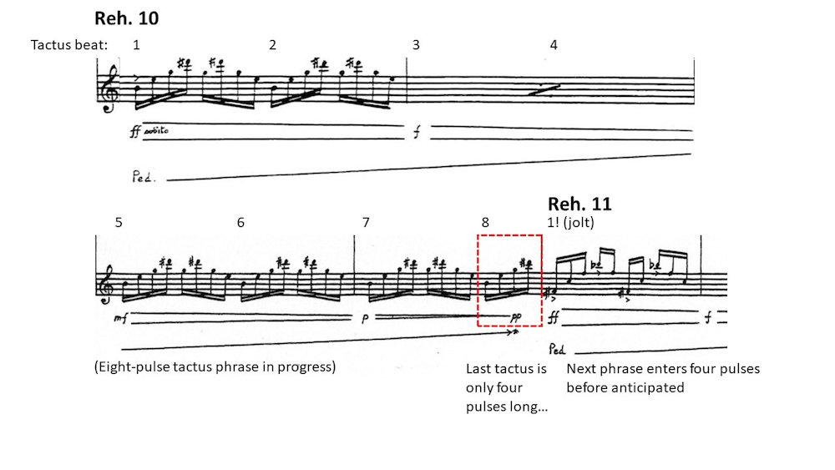

Example 8. Deferral (phrase entrance delayed), Reh. 5–6
Fifth phrase extended by three extra beats (a metric subdivision unit), relative to phrase length expectation (8 repetitions of six-pulse tactus = 48 pulses)
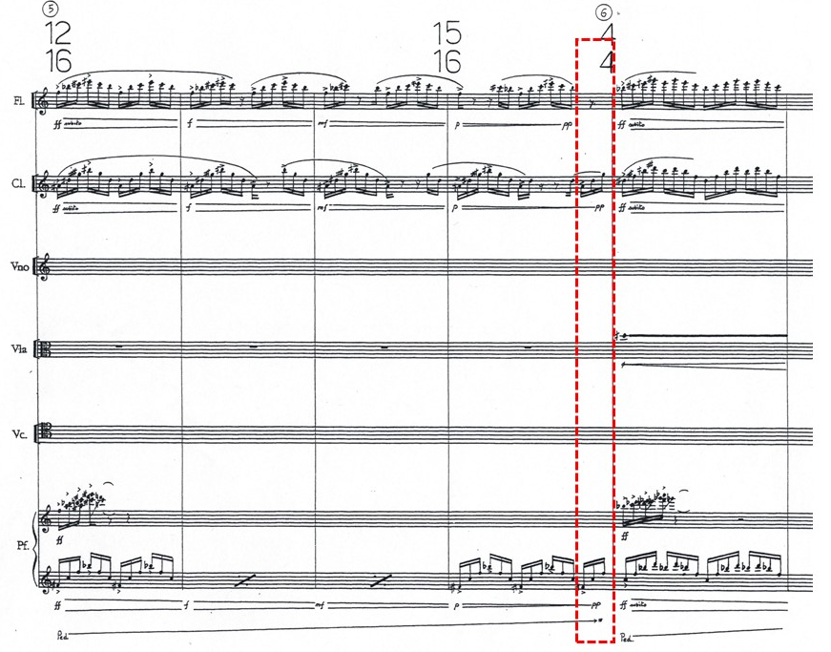

Example 9. Non-unit jolt, Reh. 2–3
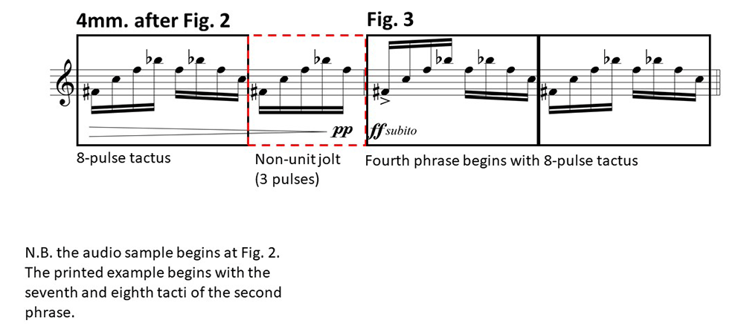

Example 10. Complex meter change, maintaining no periodic layers except the trivial pulse layer (Reh. 10–11)
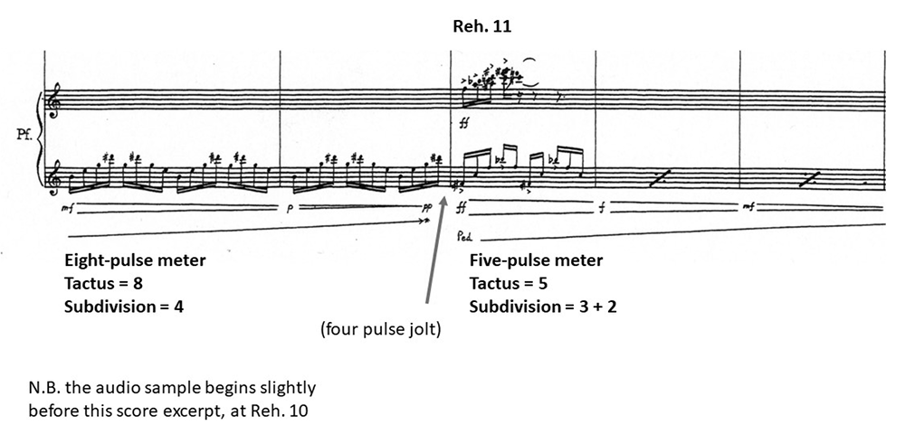

Example 11. Final bar meter shift from an eight- to a six-pulse tactus, Reh. 3–4
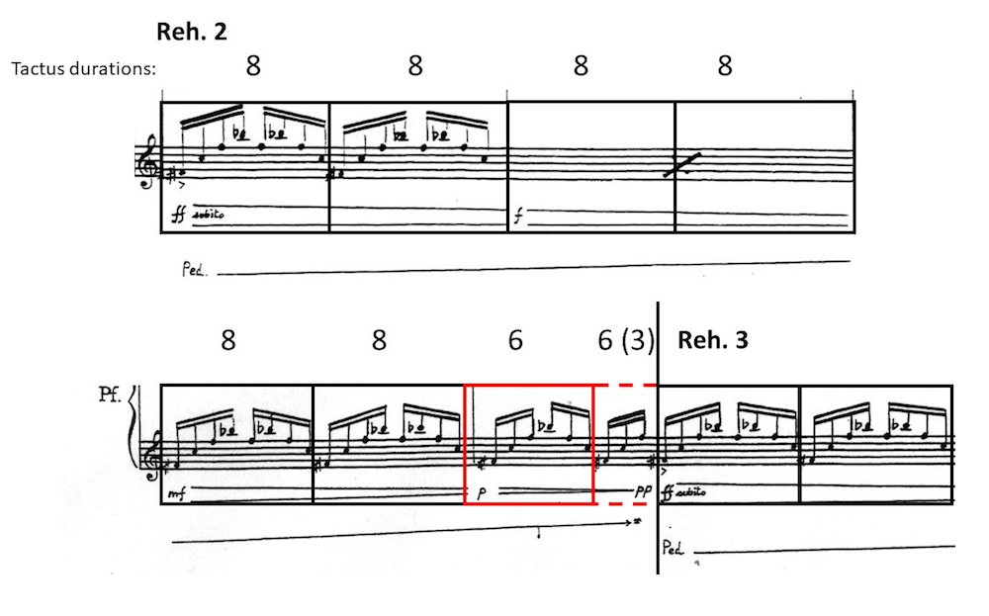

Example 12. Aperiodic subdivision of a 7-pulse tactus and aperiodic bar grouping (successive tacti subdivided differently)
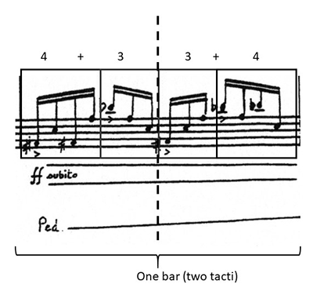

Example 13. Comparison of prime (7) and NI (4+3) meters
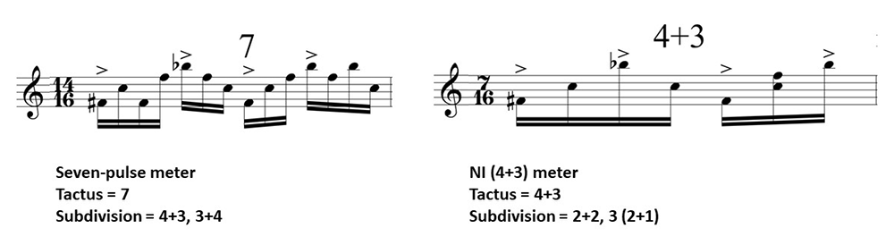

Example 14. Two higher-level forms in Vortex Temporum I, Reh. 1–37
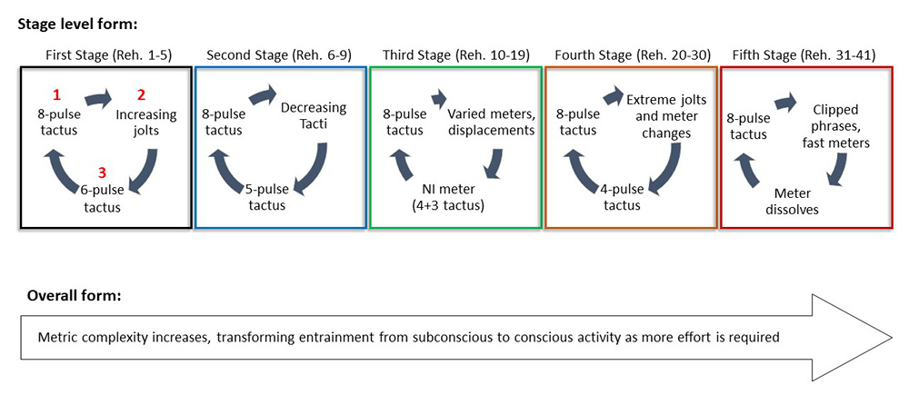

Example 15. First Stage
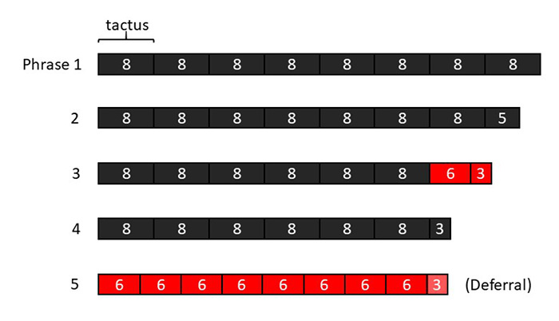

Example 16. Second Stage
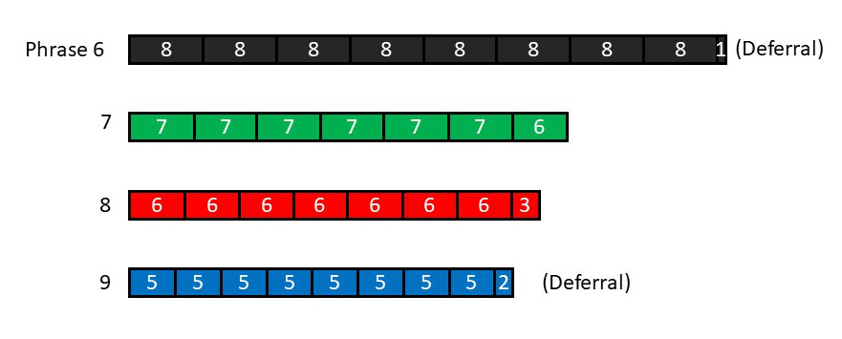

Example 17. Third Stage
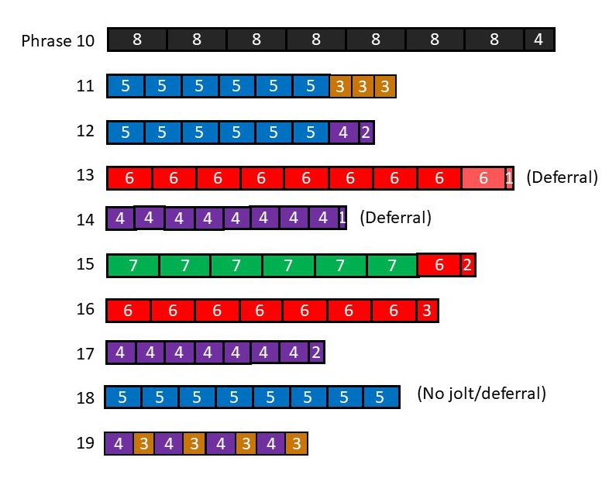

Example 18. Vortex Temporum I, Reh. 10–15, reduction. First and last bars of each prhase (piano part) are shown in each line.
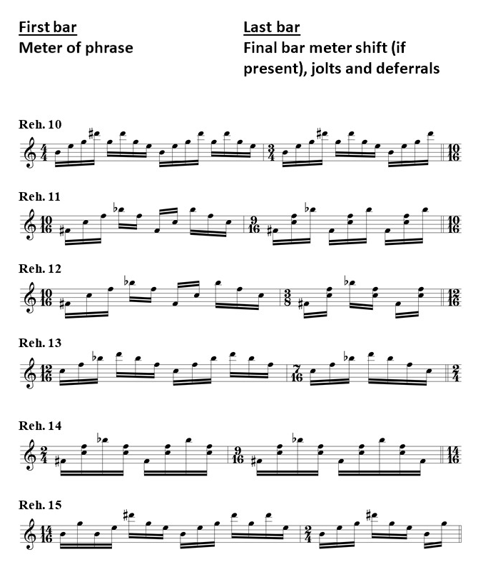

Example 19. Fourth Stage
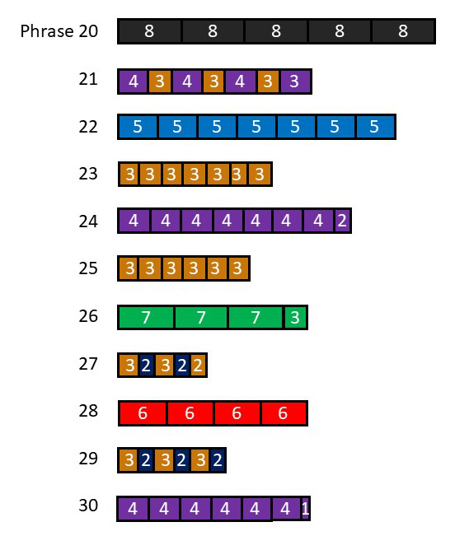

Example 20. Shift between different metric levels, Reh. 25–26. The tactus of the preceding phrase shares the duration of one of the following phrase’s subdivision units.
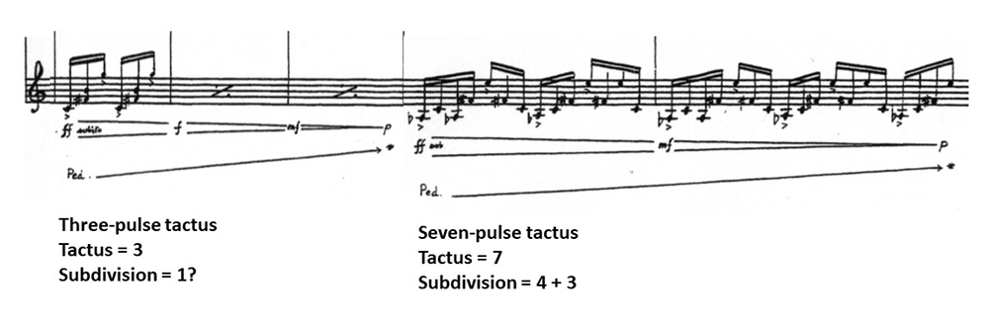

Example 21. Fifth Stage
