MTO 24.2 Examples: Leonard, Musical Mimesis in Orphans of the Storm
(Note: audio, video, and other interactive examples are only available online) http://mtosmt.org/issues/mto.18.24.2/mto.18.24.2.leonard.html
Example 1. Opening tremolo
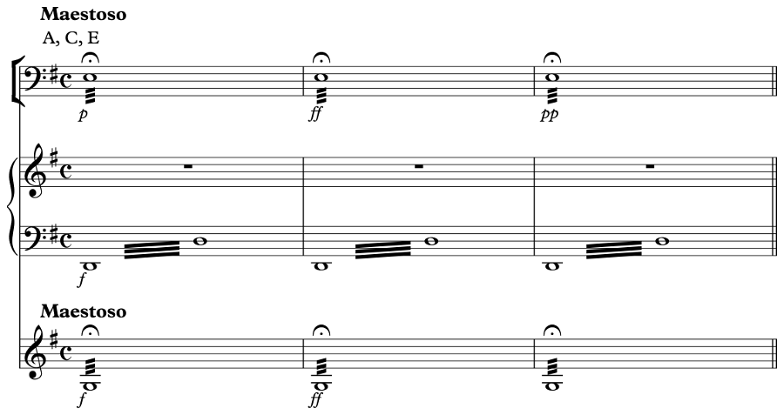

Example 2. Overture, mm. 4–7; the “warning motif”
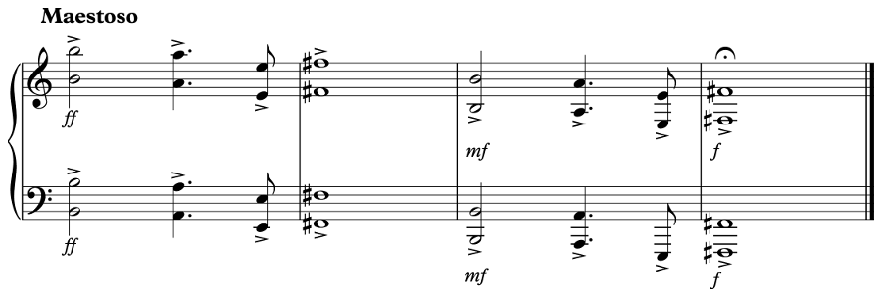
Example 3. Cue 29, mm. 1&8; Henriette quivers with fear over the “pathetic” theme, pleading for her release
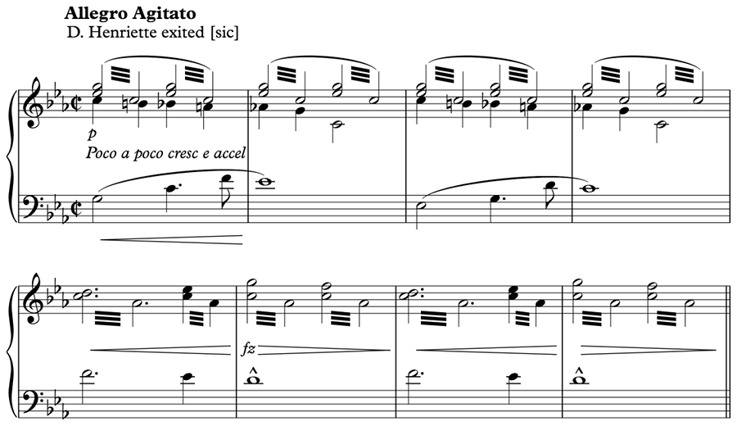

Example 4. Cue 31, mm. 1–8; pathos is trumped by fear: Louise is terrified of Mother Frochard, who keeps her captive in a cellar
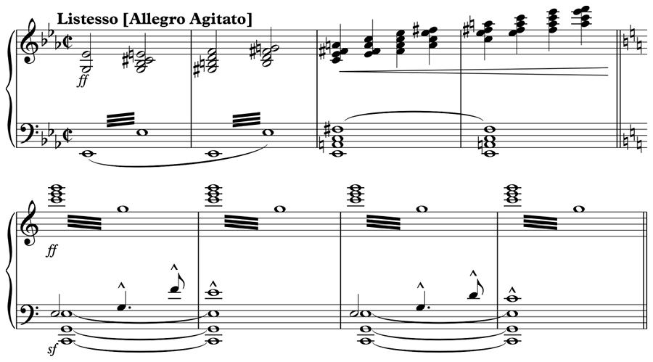

Example 5. The cornet line from M. L. Lake’s 1914 “Hurry,” mm. 1–4
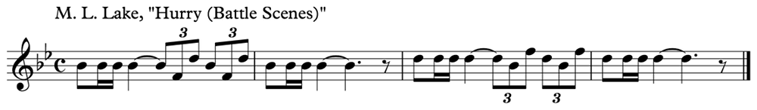

Example 6. The motif for royalty from Orphans of the Storm, cue 9, mm. 1–4, “King’s Palace”
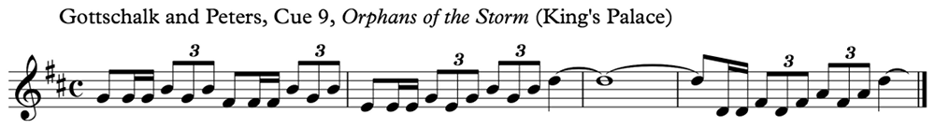

Example 7. Cue 37, mm. 1–8; the military march genre is used to evoke Danton and Robespierre’s revolutionary zeal
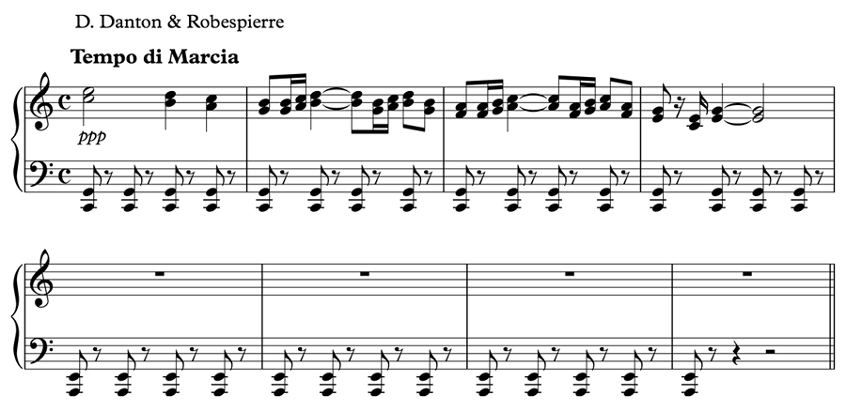

Example 8. Cue 7, mm. 1–8; the Chevalier’s theme
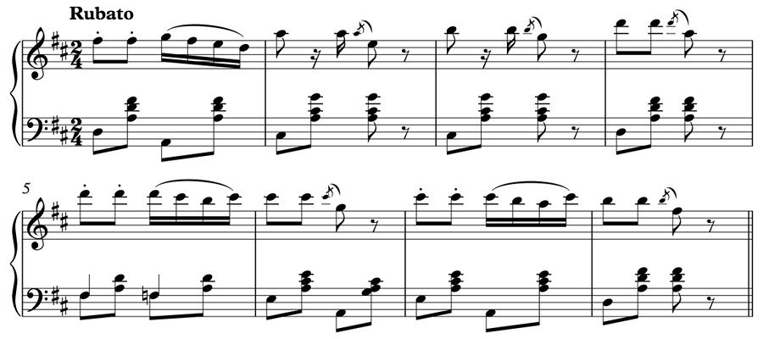

Example 9. Cue 12, mm. 1–4; Louise’s A theme
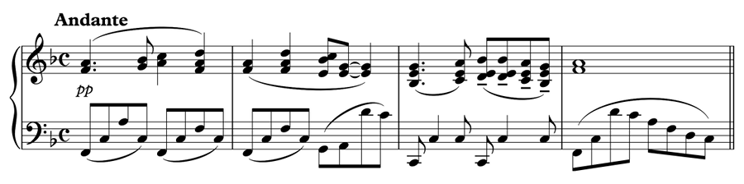

Example 10. Cue 11, mm. 1–8; Louise’s B theme
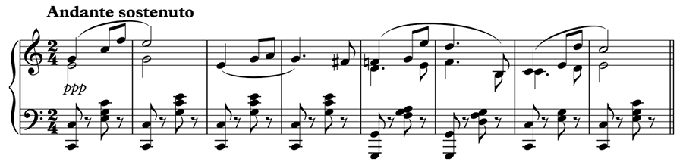

Example 11a. Cue 15, mm. 1–6; Henriette’s A theme
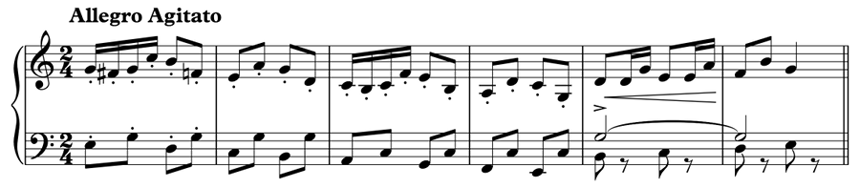

Example 11b. A typical “Allegro,” a generic piece to be used to suggest quick and decisive movement (Langey 1918)
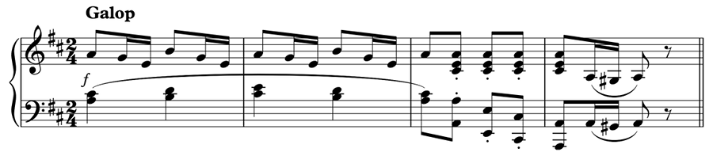

Example 12. Cue 44, mm. 1–4; Henriette’s B theme, after Schubert’s “Ständchen” (D957, no. 4)
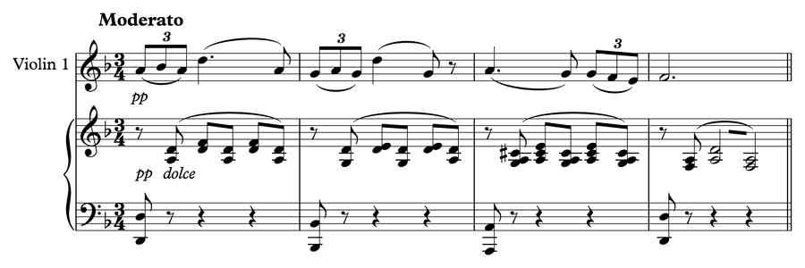

Example 13a. Cue 22, mm. 1–58
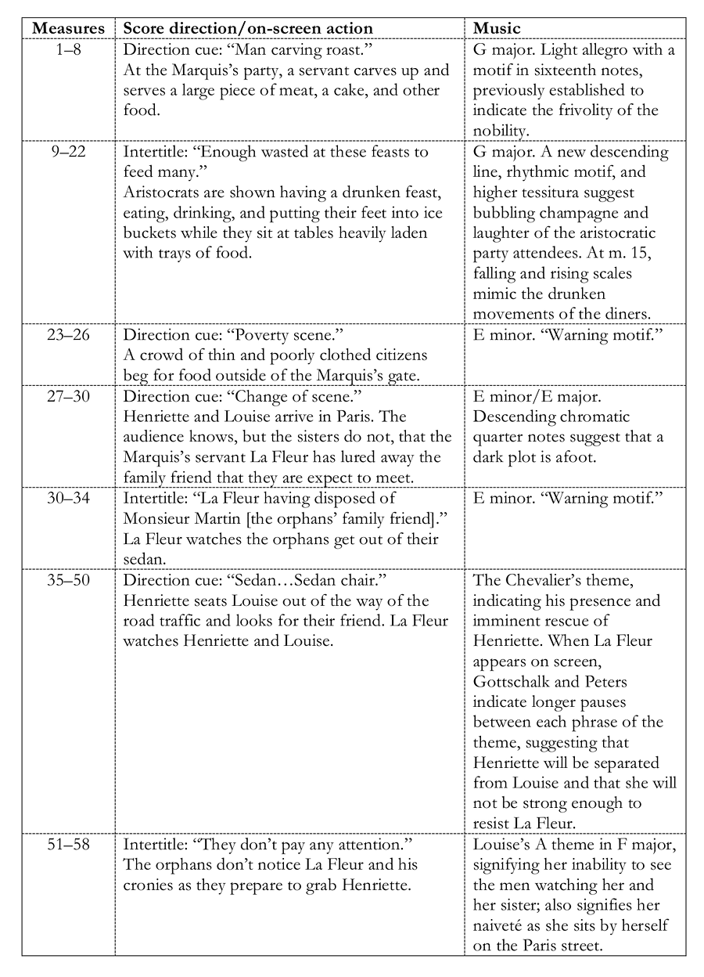

Example 13b. Graphic representation of Cue 22, showing the oscillation of moods, or meta-tremolo, of the scene; green represents positive emotions or actions on the part of the character; blue represents a transition between positive and negative; and red represents a negative event or emotion
