
MTO 7.5 Examples: Hoeckner, Poet’s Love and Composer’s Love
(Note: audio, video, and other interactive examples are only available online)
http://www.mtosmt.org/issues/mto.01.7.5/mto.01.7.5.hoeckner.php

Example 1. Robert Schumann, Heine Liederkreis, Op. 24, No. 1
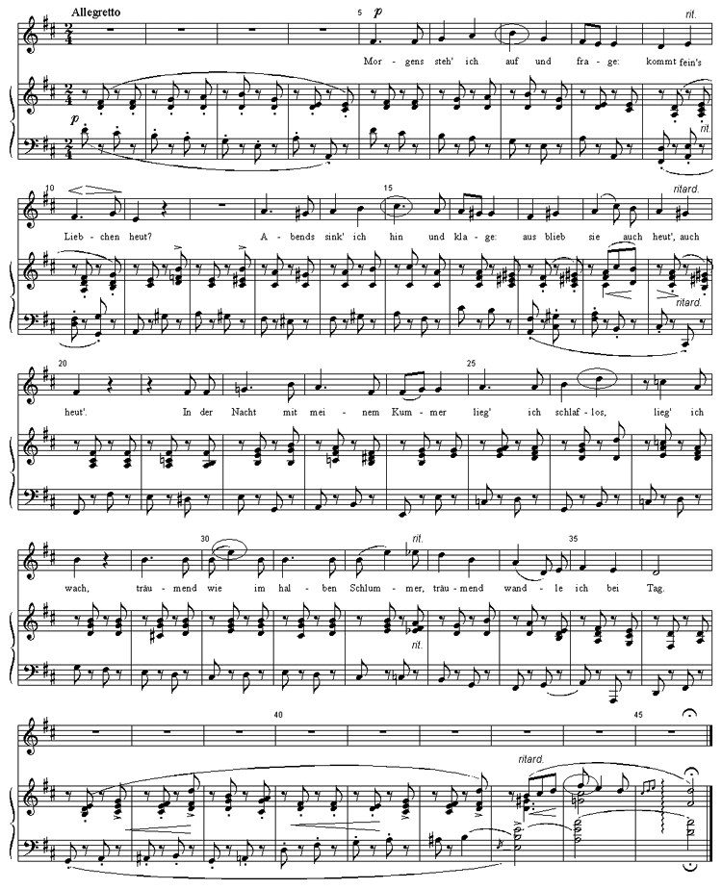

Example 2. Robert Schumann, Heine Liederkreis, Op. 24, No. 1: Melodic Contour
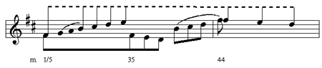

Example 3. The “Dream Motif” in Schumann’s Heine Liederkreis
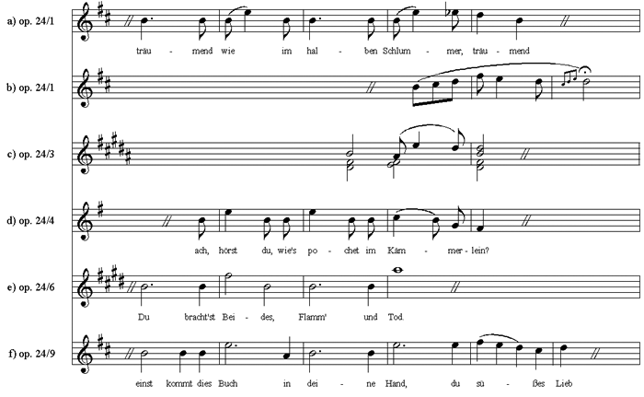

Example 4. Robert Schumann, Heine Liederkreis, Op. 24, No.3, Prelude and First Stanza
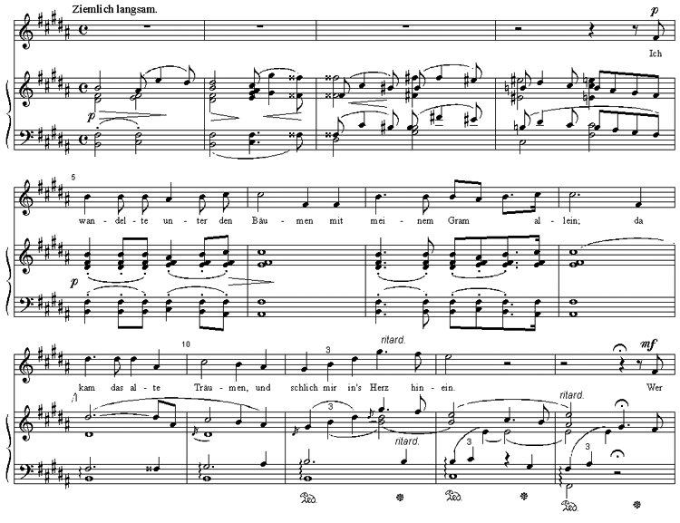

Example 5. Robert Schumann, Heine Liederkreis, Op. 24: Melodic relation between No. 2 and 3
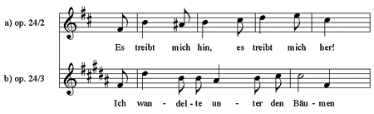

Example 6. Robert Schumann, Heine Liederkreis, Op. 24, No. 5 mm. 81–93
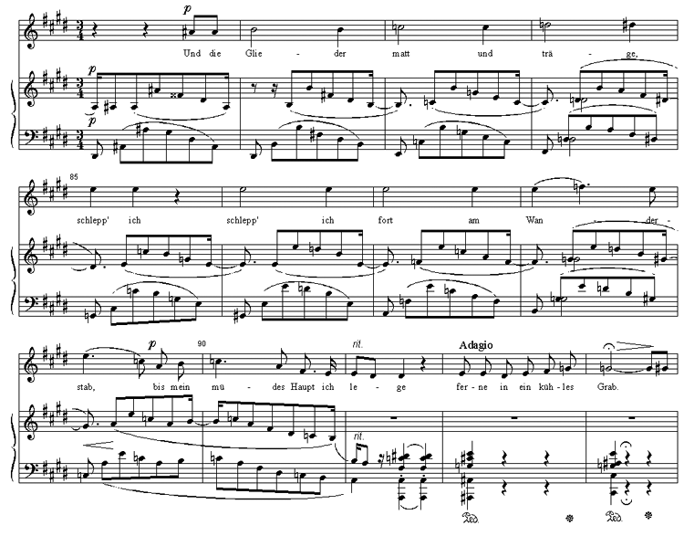

Example 7. Robert Schumann, Heine Liederkreis, Op. 24, No. 7, mm. 33–48
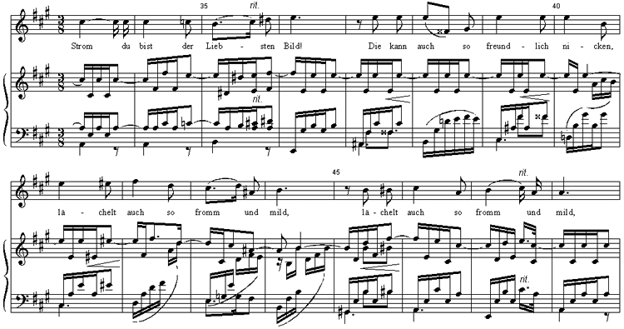

Example 8. Robert Schumann, Heine Liederkreis, Op. 24, No. 9, mm. 49–62
