
MTO 7.6 Examples: Butler, Turning the Beat Around
(Note: audio, video, and other interactive examples are only available online)
http://www.mtosmt.org/issues/mto.01.7.6/mto.01.7.6.butler.php
Example 1a. The Chemical Brothers, “Piku”
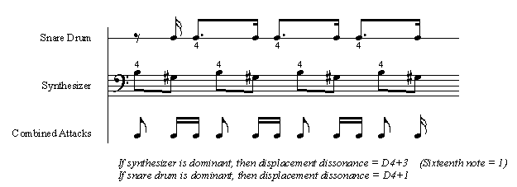

Example 1b. The Chemical Brothers, “Piku”
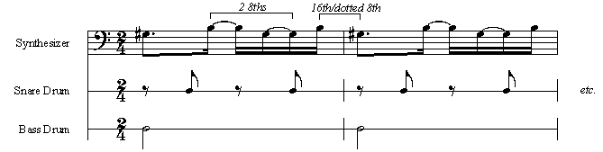

Example 1c. The Chemical Brothers, “Piku,” transcribed so the synthesizer is less syncopated
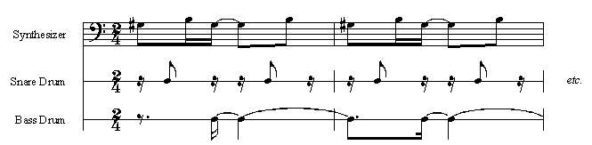

Example 2. Underworld, “Cups”
The three parts of the written example represent the three phases discussed in paragraph 9:
- The entrances of the synthesizer and cymbal patterns (example 2a)
- The entrance of the drumbeat, which will sound like a displacement to more “radical” listeners (example 2b)
- The confirmation of the displacement by an additional synthesizer pattern (example 2c)
The audio file presents these three phases in order.
Example 2a
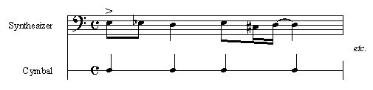
Example 2b
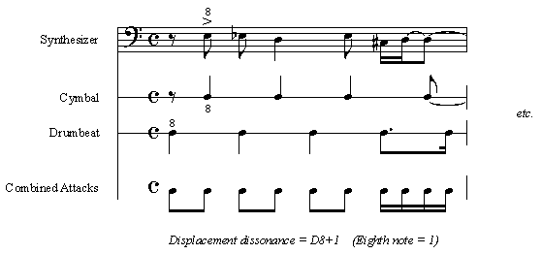
Example 2c
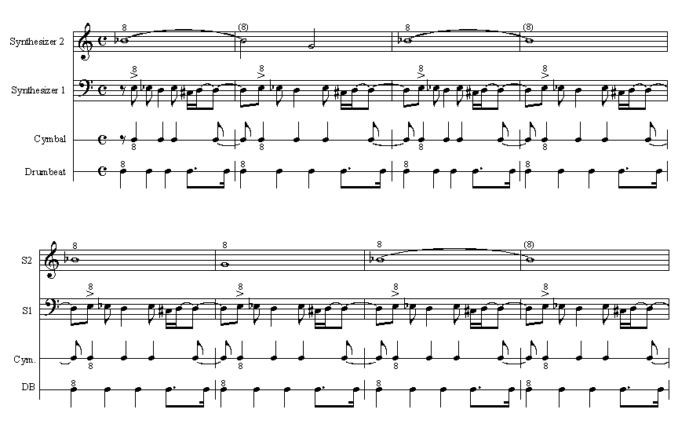
Example 3. Underworld, “Moaner”
The reader is invited to try focusing on different sixteenth notes, and to listen for the timbral change.
Example 3a
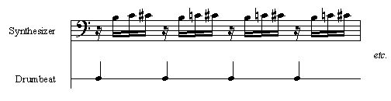
Example 3b
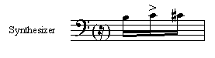
Example 3c
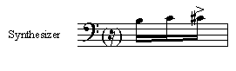
Example 4. Everything But the Girl, “Compression”
The following excerpts show most of the patterns that occur in “Compression.” They proceed in order from the solo drumbeat that begins the song to a texturally dense passage in the middle. The listener should follow parts a through e down the page as the audio file plays; there are pauses after parts b, c, and d. Please note that some passages have been omitted for the sake of concision.
Example 4a
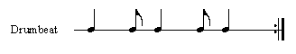
Example 4b
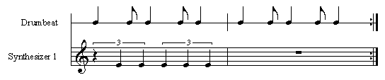
Example 4c
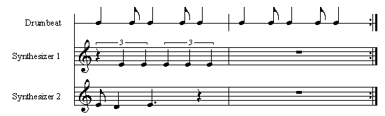
Example 4d
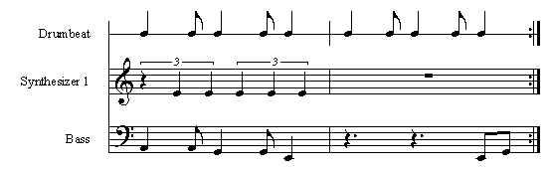
Example 4e
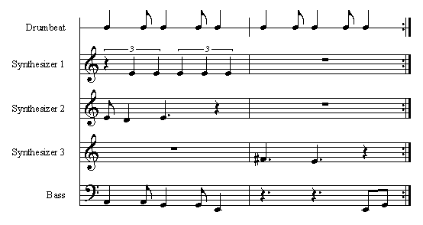

Example 6. Projected Potential (Hasty, Example 7.2, p. 85)
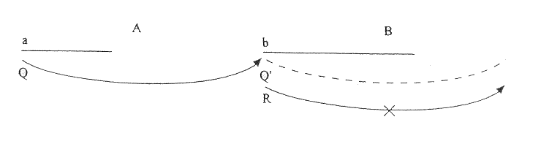

Example 7. Continuation in Duple and Triple Meter (Hasty, Example 9.17, p. 131)
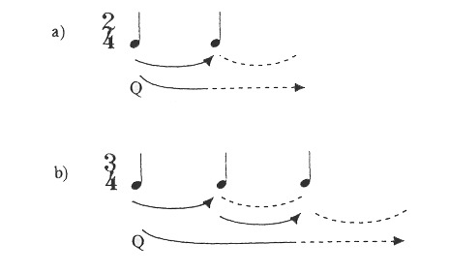

Example 8. Deferral (from Hasty, Example 9.18f, p. 132)
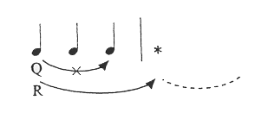

Example 9. Denial of Q′ in 3+2/4 (Hasty, Example 9.28d, p. 146)
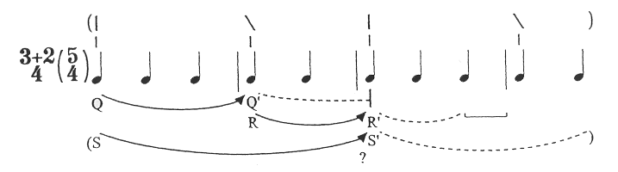
Example 10. Denial of R′ in 2+3/4 (Hasty, Example 9.28c, p. 146)
