
MTO 8.1 Examples: Dodson, Performance and Hypermetric Transformation
(Note: audio, video, and other interactive examples are only available online)
http://www.mtosmt.org/issues/mto.02.8.1/mto.02.8.1.dodson.php
Example 1. Ambiguity and stabilization: (a) the “faces/vase” illusion, (b) faces, (c) vase, (d–e) symmetry effect, (f) tristability, (g) multistability
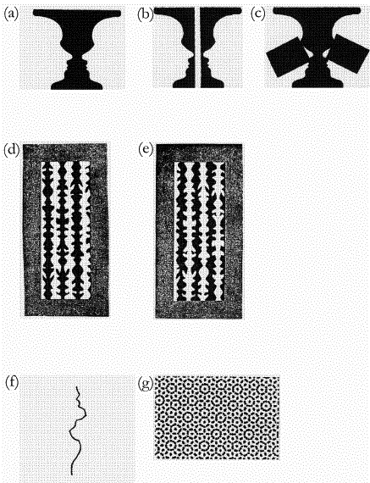

Example 2. Metrical Structure in the opening measures of the Scherzo from Beethoven’s Symphony No. 2
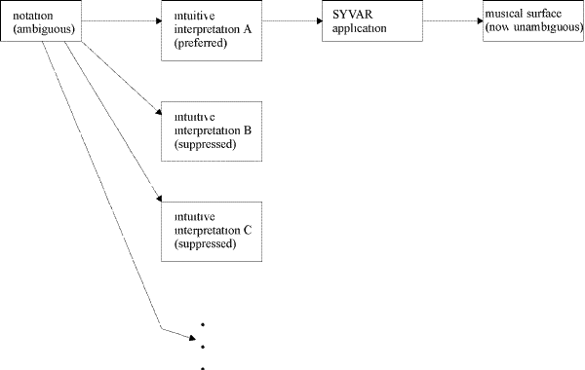

Example 3. Two interpretations of hypermeter in Mozart, Symphony No. 40 in G Minor, K. 550, I, mm. 1–20. Reproduced with the kind permission of MIT Press, Cambridge, Mass.
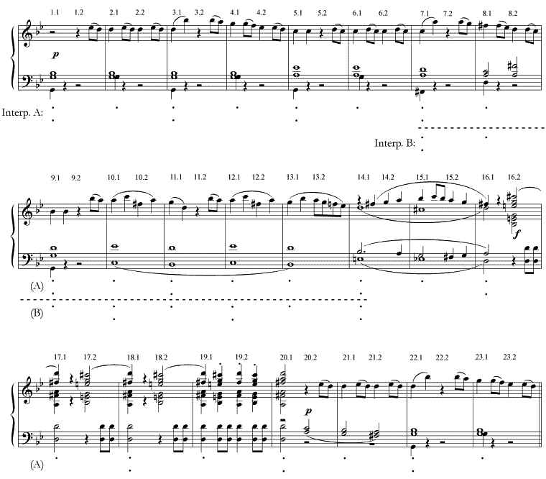

Example 4. Coherence or chaos? (a) regular cross, (b–c) modified crosses, (d) random collection of line segments
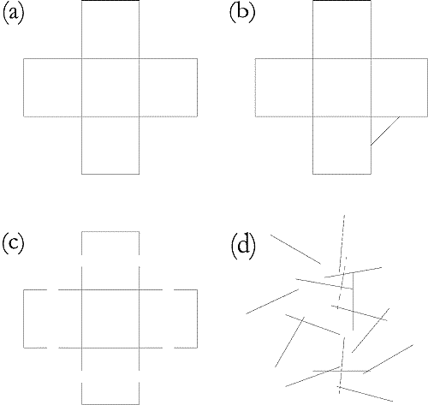

Example 5. Bernstein’s recomposition of the opening of Mozart’s Symphony No. 40 in G Minor, K. 550; Audio: Performance of Bernstein’s recomposition
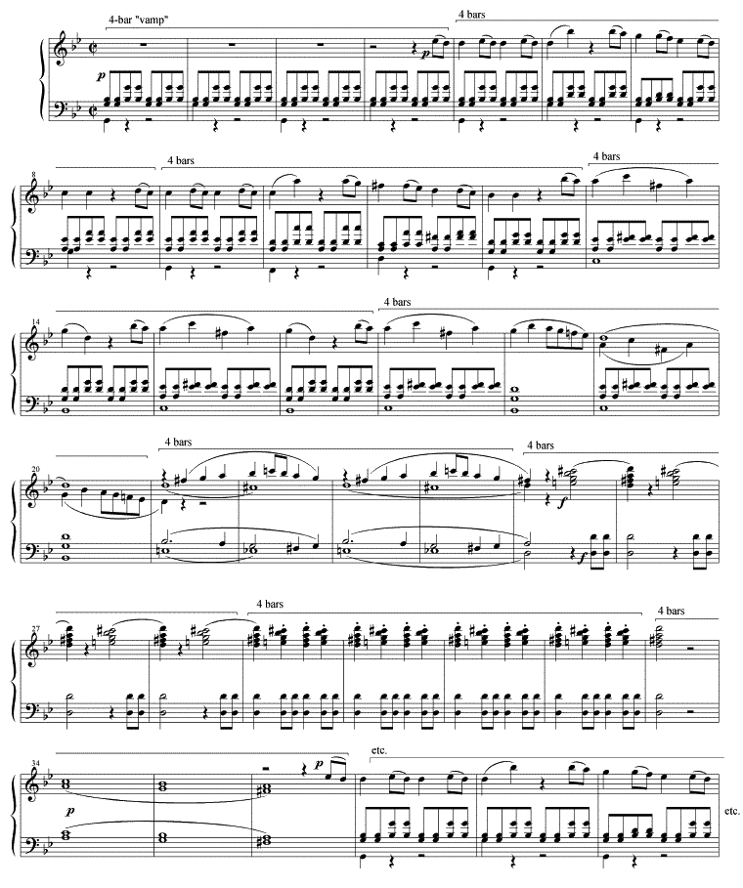
Example 6. (a) Conventional realization of a structurally unambiguous notation, (b) One stable realization of an ambiguous notation, (c) Another stable realization
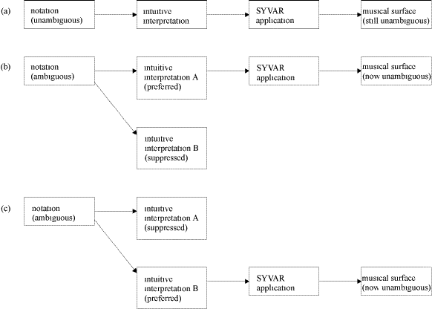

Example 7. Two metrical arrangements of the melody used in Sloboda, “The Communication of Musical Metre in Piano Performance.” Reproduced with the kind permission of the Psychology Press Ltd., Hove, East Sussex, U.K.
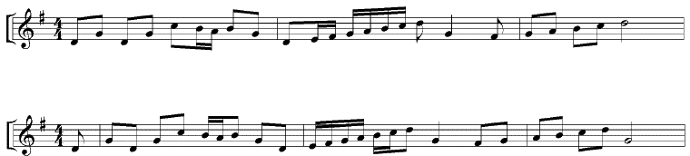

Example 8. Six interpretations of hypermeter in Mozart, Symphony No. 40, I, mm. 1-20. (a) “Interpretation A,” (b) “Interpretation B,” (c) Mozart/Britten, (d) Mozart/Marriner, (e) Mozart/Walter, (f) Mozart/Bernstein
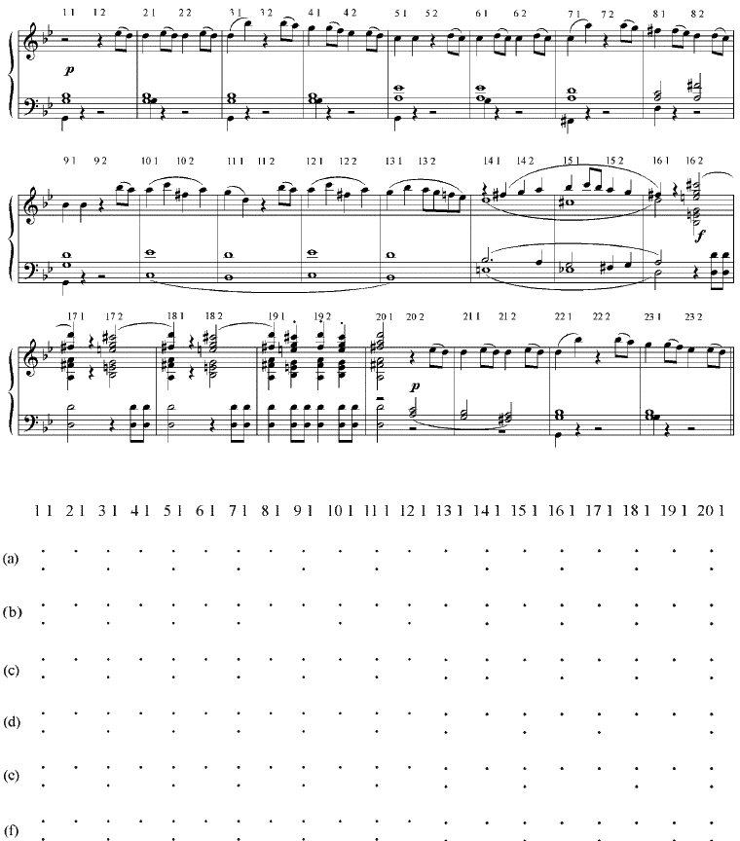
Example 9. Regularized versions of Example 8(a) and (b)
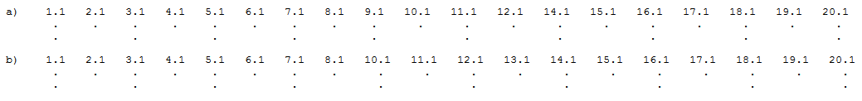

Example 10. Regularized version of Example 8(c); Audio: Mozart/Britten, mm. 1–22
Example 11. Regularized version of Example 8(d); Audio: Mozart/Marriner, mm. 1–22

Example 12. Walter’s hypermetric joke. (a) Gullible listener’s preliminary interpretation, as of m. 19, (b) Revised interpretation, after 20.1 is heard, (c) Regularized version; Audio: Mozart/Walter, mm. 1–22
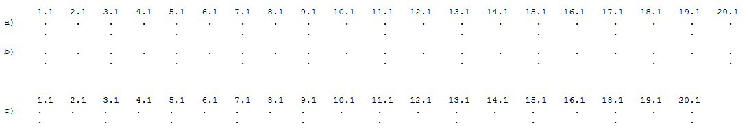

Example 13. Regularized version of Example 8(f); Audio: Mozart/Bernstein, mm. 1–22

Example 14. The MSE suggested by Lerdahl and Jackendoff
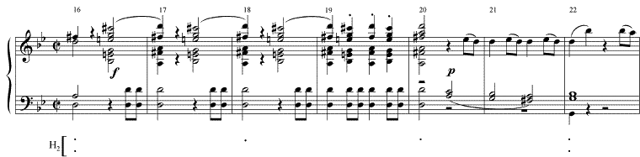

Example 15. (a) H₂ in the first MSE (mm. 1–10) of Mozart/Britten, (b) H₃ in this MSE (fragile); Audio: Mozart/Britten, mm. 1–10
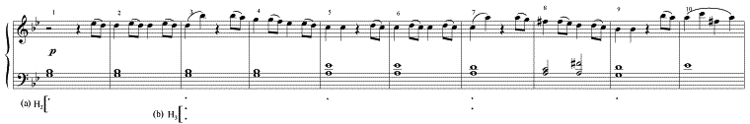

Example 16. (a) H₂ in the second MSE (mm. 14–21) of Mozart/Britten, (b) H₃ in this MSE (fragile); Audio: Mozart/Britten, mm. 14–21
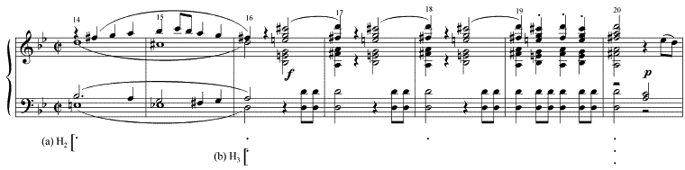

Example 17. (a) H₂ in the first MSE (mm. 1–16) of Mozart/Marriner, (b) H₃ in the first MSE, (c) H₂ at the beginning of the second MSE (mm. 17–23), (d) regularization of H₂ in mm. 1–23; Audio: Mozart/Marriner, mm. 1–23
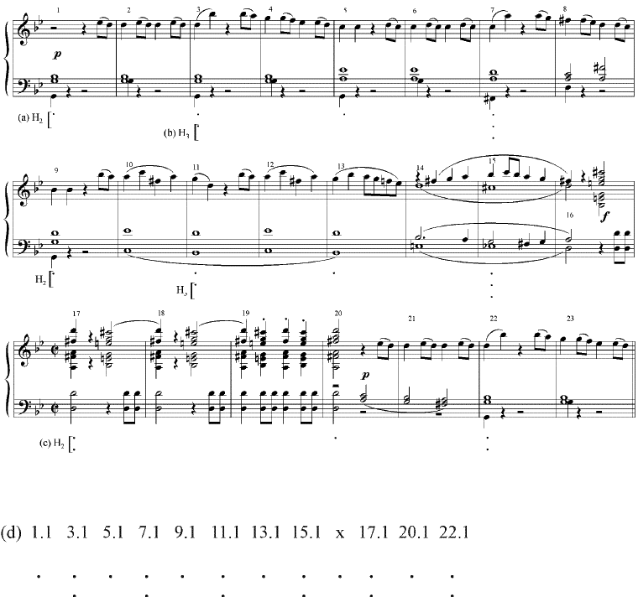

Example 18. (a) H₂ in the first MSE (mm. 1–21) of Mozart/Walter, (b) H₃, (c) H₄ (extremely fragile); Audio: Mozart/Walter, mm. 1–21
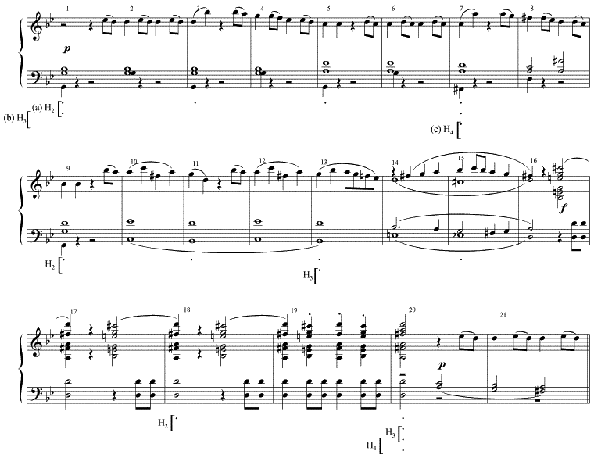

Example 19. (a) H₂ in the first MSE (mm. 1–10) of Mozart/Bernstein, (b) H₃ in the first MSE, (c) H₂ in the second MSE (mm. 11–21), (d) H₃ in the second MSE; Audio: Mozart/Bernstein, mm. 1–21
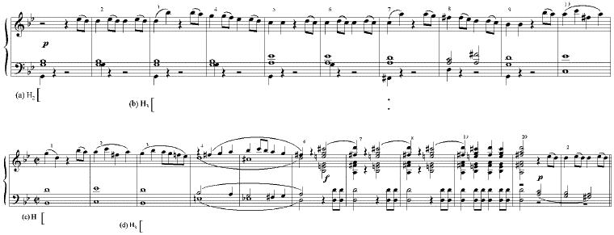

Example 20. (a) Composite MSE resulting from the regularization of level H₂ in Mozart/Bernstein, mm. 1–21, (b) H₃ in the composite MSE, (c) H₄ in the composite MSE
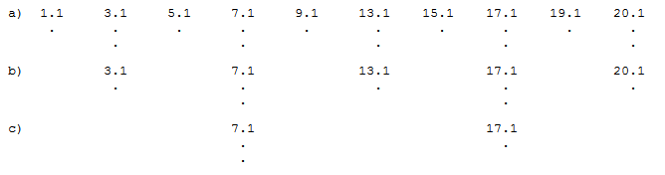

Example 21. Example 6b, extended indefinitely in its range of conceivable intuitive interpretations

Example 22. (a) The link between ambiguous notation and performance, after Palmer (1989), (b) Synthesis of Example 21 and Example 22(a)
