
MTO 8.3 Examples: Scotto, Transformational Networks, Transpositional Combination
(Note: audio, video, and other interactive examples are only available online)
http://www.mtosmt.org/issues/mto.02.8.3/mto.02.8.3.scotto.php
Example 1a. TINV Set Classes
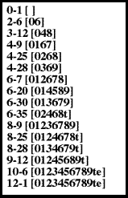

Example 1b. Generators of Set Class 4–25 by TC
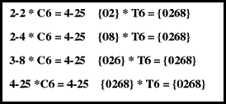

Example 2. Form Chart
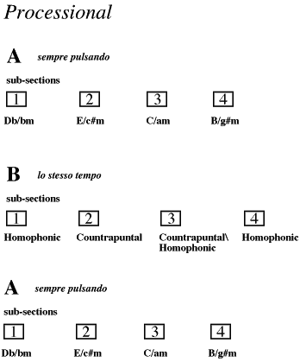

Example 3a. Processional’s Motivic Cell
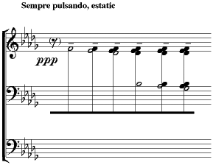

Example 3b. Processional’s Motivic Cell
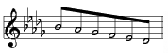

Example 3c. Processional’s Motivic Cell
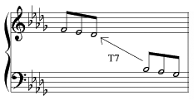

Example 4. Possible Diatonic Contexts for Processional’s Motivic Cell
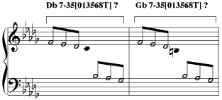

Example 5a. Possible Continuation of TC Generative Path
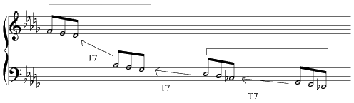

Example 5b. Possible Continuation of TC Generative Path
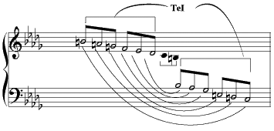

Example 6. Complementary Hexachord in Section 1
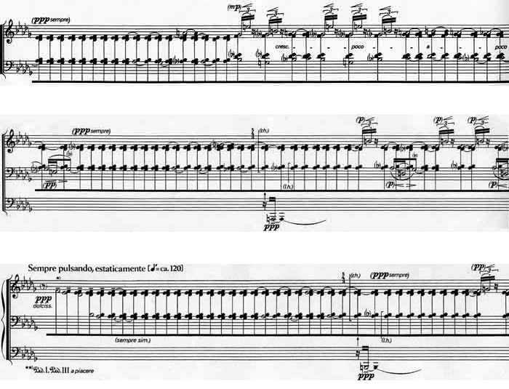

Example 7. Aggregate Completing C4 in Section 1
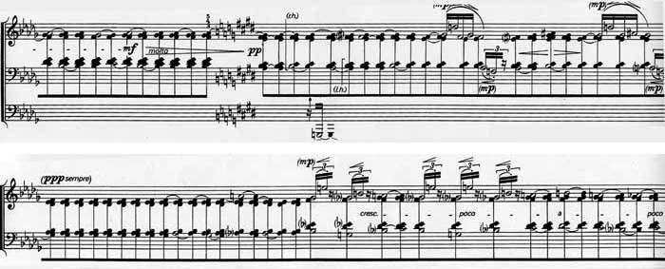

Example 8a. T(0167) [024] TC Networks
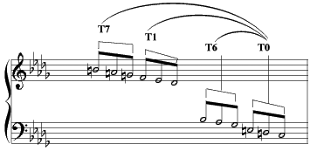

Example 8b. T(0167) [024] TC Networks
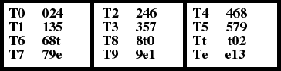

Example 9a. T(0369) [024] TC Networks
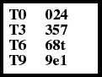

Example 9b. T(0369) [024] TC Networks
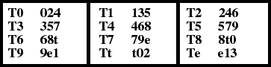

Example 10. Union of [0167] TC Networks
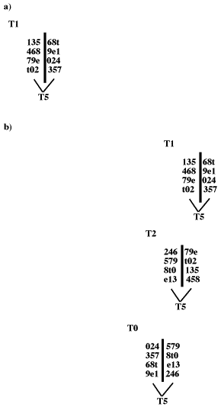

Example 11. Section 2 of Processional
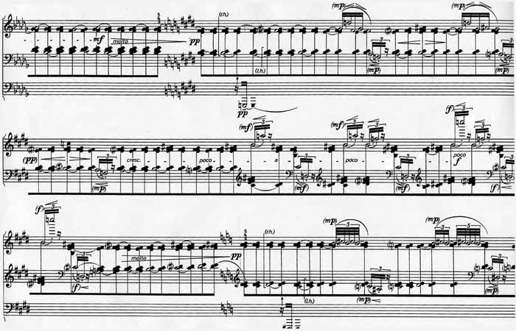

Example 12. Unfolding of the T1 [0369] TC Networks in Different Streams
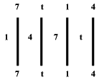

Example 13. Joint Between Sections 1 and 2
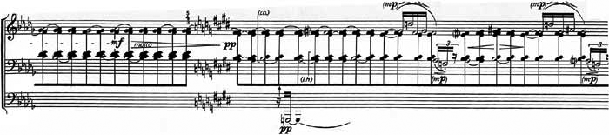

Example 14. Section 3
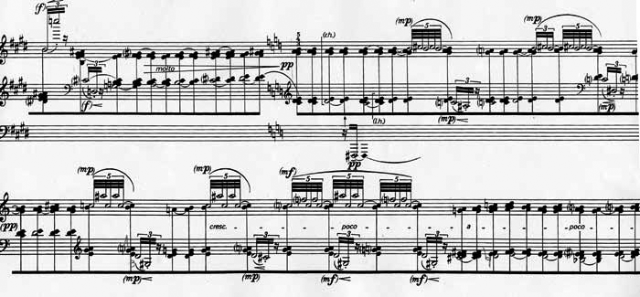

Example 15. Section 4
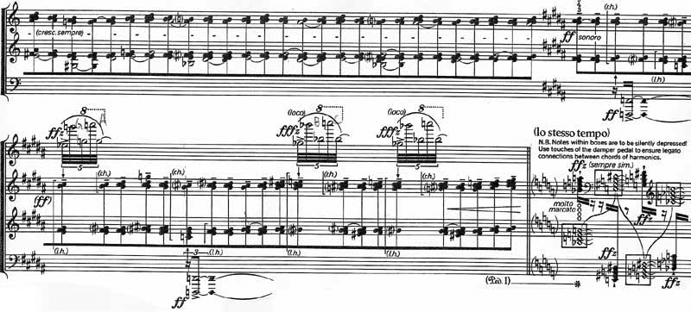

Example 16. Four IS Models
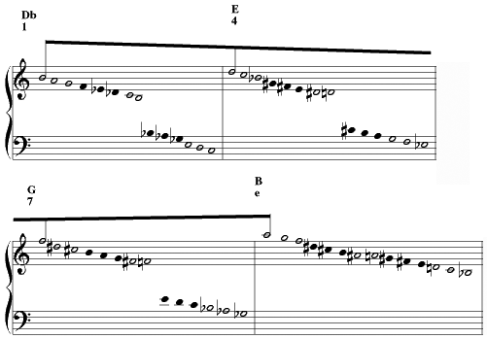

Example 17a. T(0369) [015] TC Networks
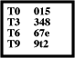

Example 17b. T(0369) [015] TC Networks
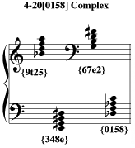
Example 17c. T(0369) [015] TC Networks
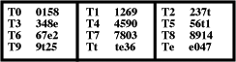

Example 18. First Section of Section B
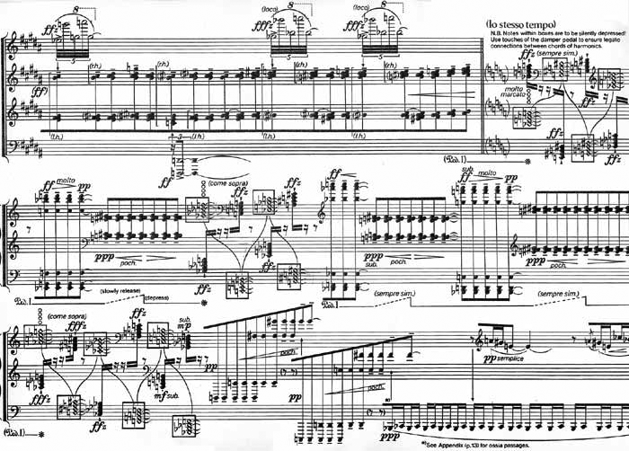

Example 19. Alternation of 4-20 [0158] and 6-32 [024579] Complexes
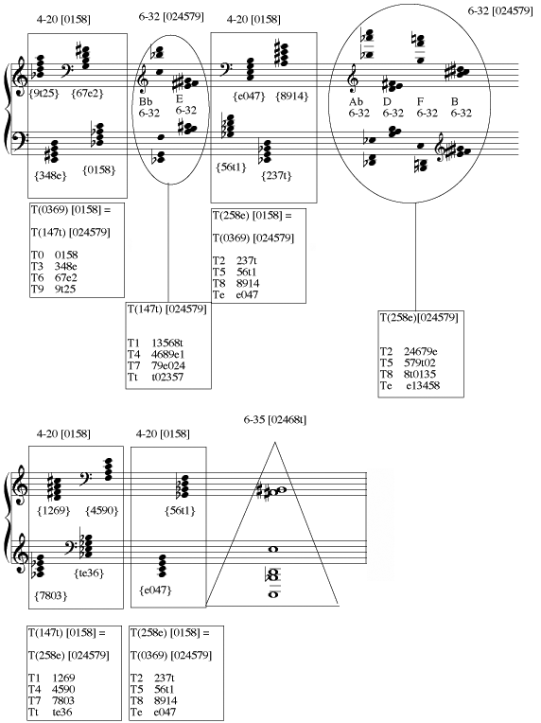

Example 20. Second Section of Section B
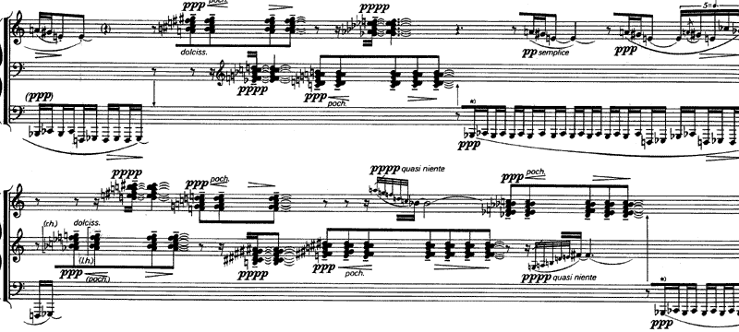

Example 21. Completion of T(0369) 6-32 [024579] Complexes
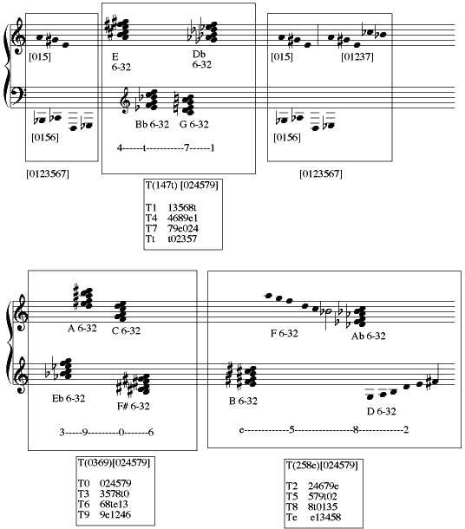

Example 22. Third Section of Section B
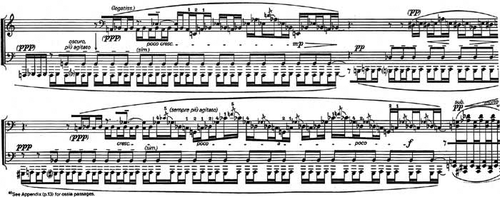

Example 23. Catalog of 8-9[01236789] Octachords
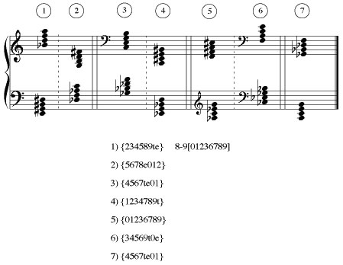

Example 24. Fourth Section of Section B
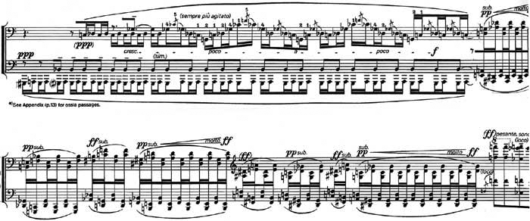

Example 25. Return of the A Section
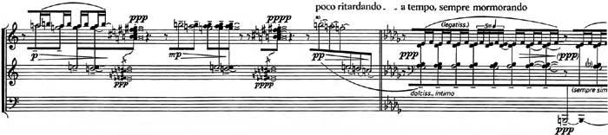

Example 26a. Beginning of the Coda
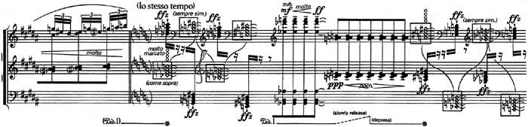
Example 26b. Beginning of the Coda
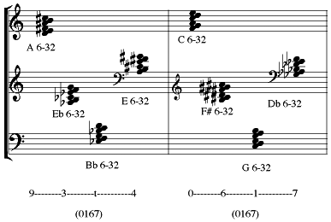

Example 27. T(0167) Unfolding of the 6-32 [024579] Hexachords
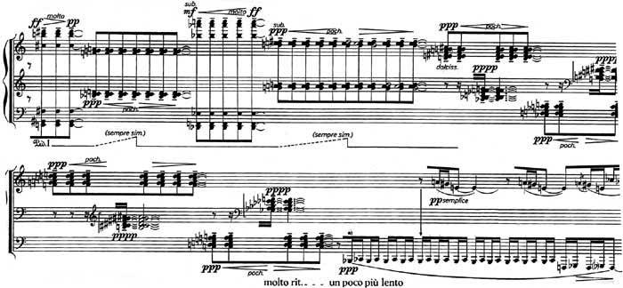

Example 28. 8-9[01236789] in the Coda
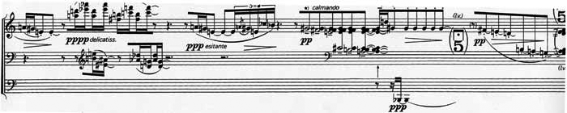

Example 29a. Interweaving of T1 and T2 (0369) 6-32 [024579] Complexes in the Work’s Closing
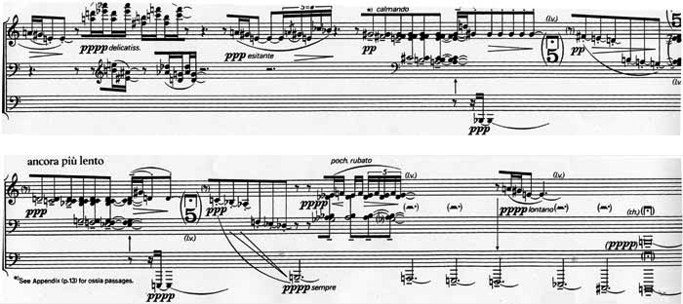

Example 29b. Interweaving of T1 and T2 (0369) 6-32 [024579] Complexes in the Work’s Closing
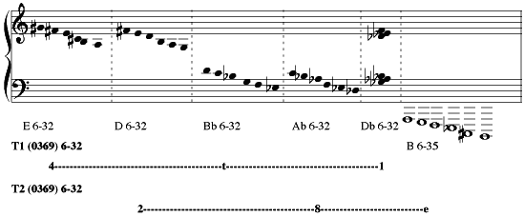

Example 30. Transformational Networks Generating 6-35 [02468t] from 3-6 [024]
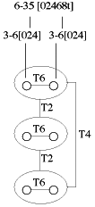

Example 31. Generating Larger Networks from the 6-35 [02468t]/3-6 [024] Networks
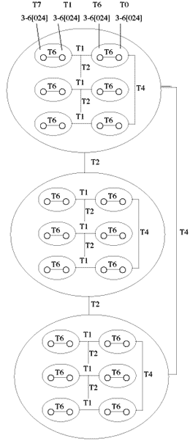

Example 32. Transformation of the Larger Network by Substituting Operations
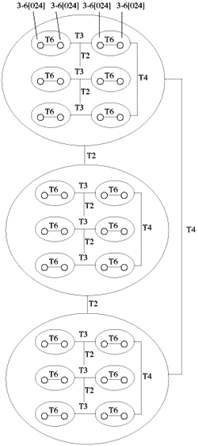

Example 33. Generating a 6-32 [024579] Network from a 6-35 [02468t] Network by Substituting Operations
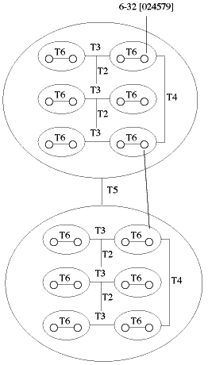

Example 34. Generating the 4-20 [0158] Network from the Same Set of Local Operations
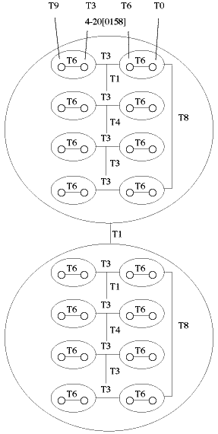

Example 35. T5 transformations of T6 nodes Generates Two T6 related 4-23[0257] tetrachords whose union generates 8-9[01236789]
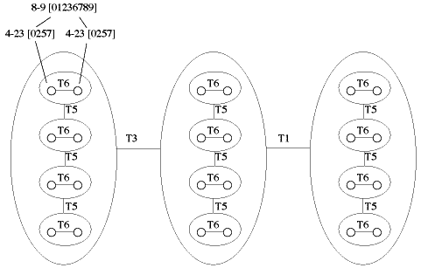

Example 36. K-net Based on T₂ Transformation
