
MTO 8.4 Examples: Leydon, Towards a Typology of Minimalist Tropes
(Note: audio, video, and other interactive examples are only available online)
http://www.mtosmt.org/issues/mto.02.8.4/mto.02.8.4.leydon.php
Figure 1. Parameters that construct the “musical subject”
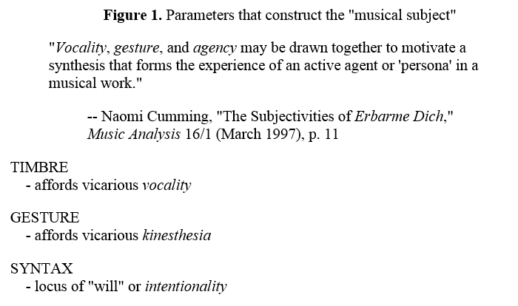

Figure 2. Middleton’s “repetition strategies”
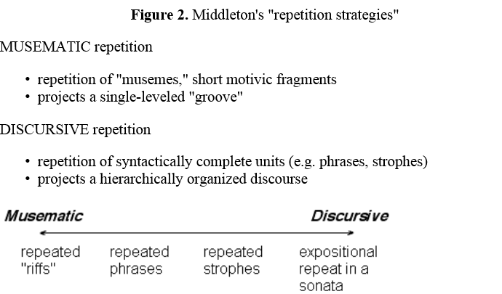

Figure 3. Three accounts of the signifying potential of musical syntax
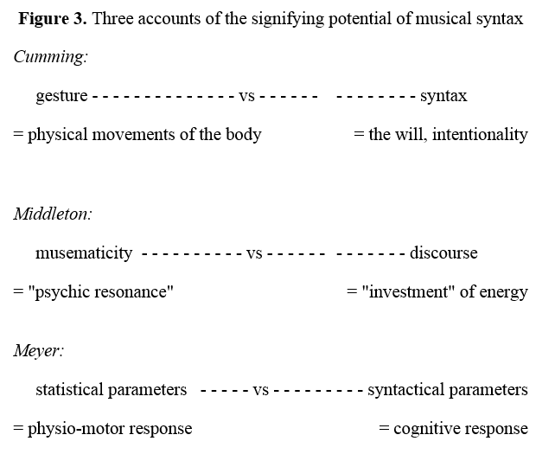

Example 1. Raymond Scott’s Soothing Sounds for Baby, mm. 1–10
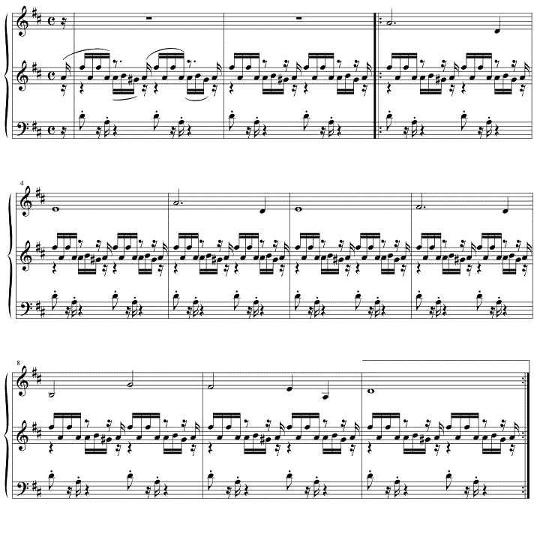

Example 3. Arvo Pärt, “Arbos,” mm. 17–28
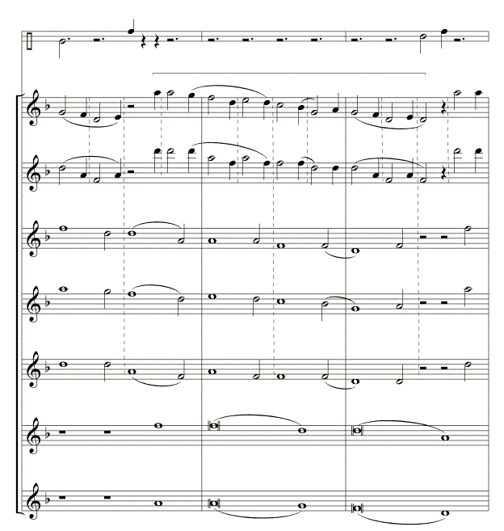
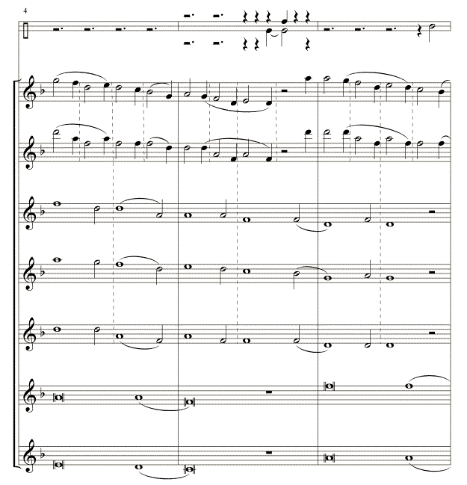
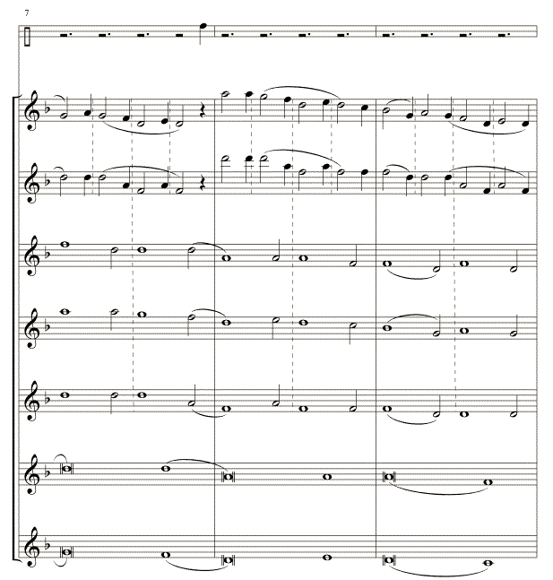
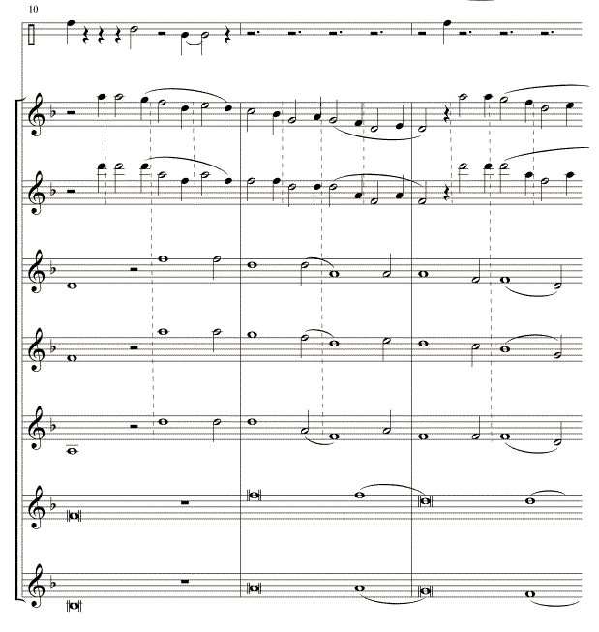

Figure 4. Six repetition “tropes” with some representative works
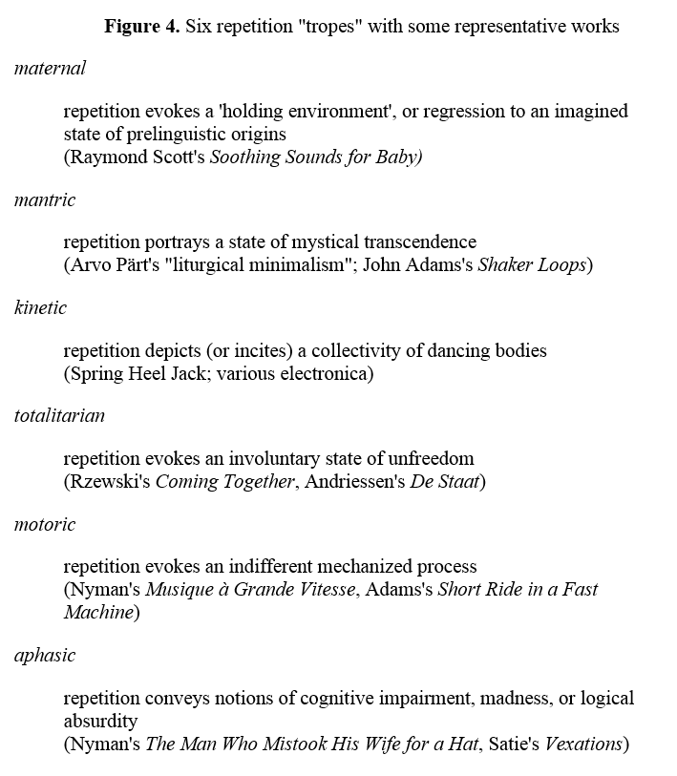

Example 4. Frederic Rzewski, Coming Together, mm. 18–37
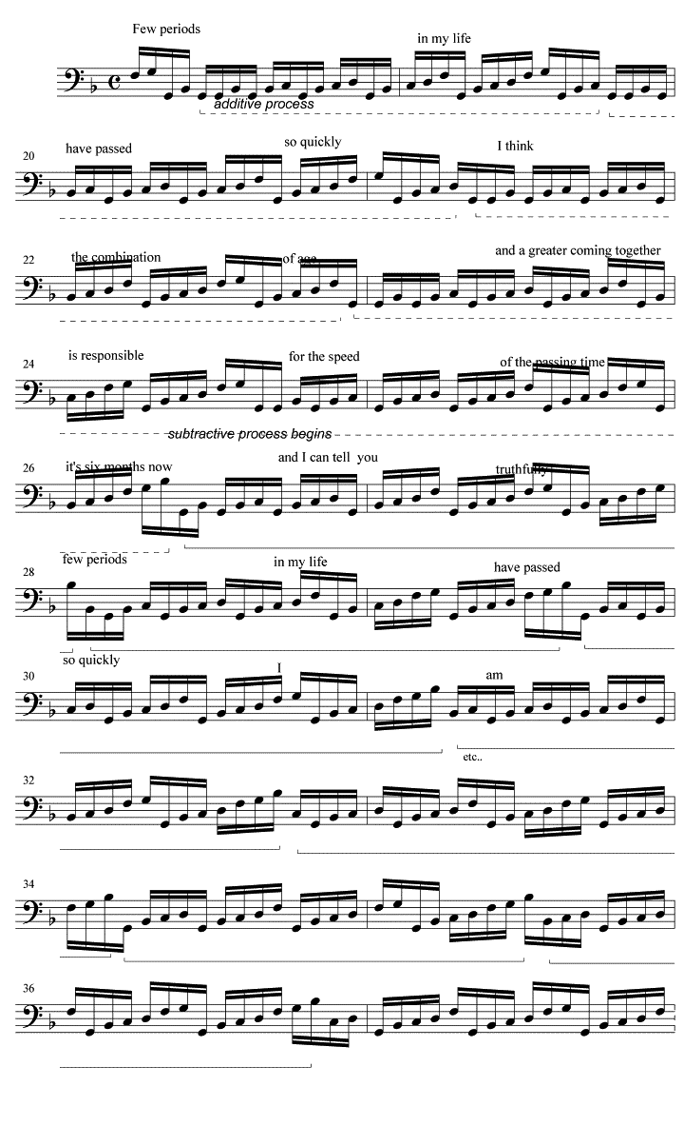
Example 6a. Robert Schumann, “Ich Grolle Nicht” from Dichterliebe, mm. 1–6
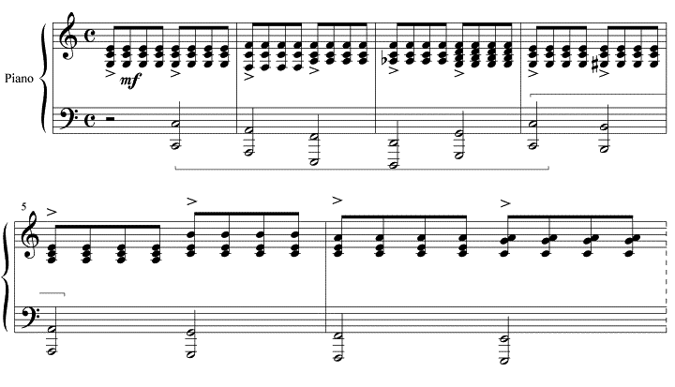

Example 6b. Nyman, “The Man Who Mistook His Wife for a Hat,” mm. 601–622
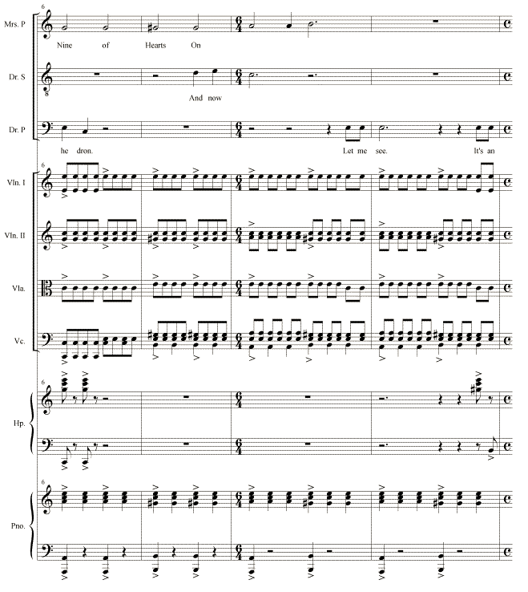
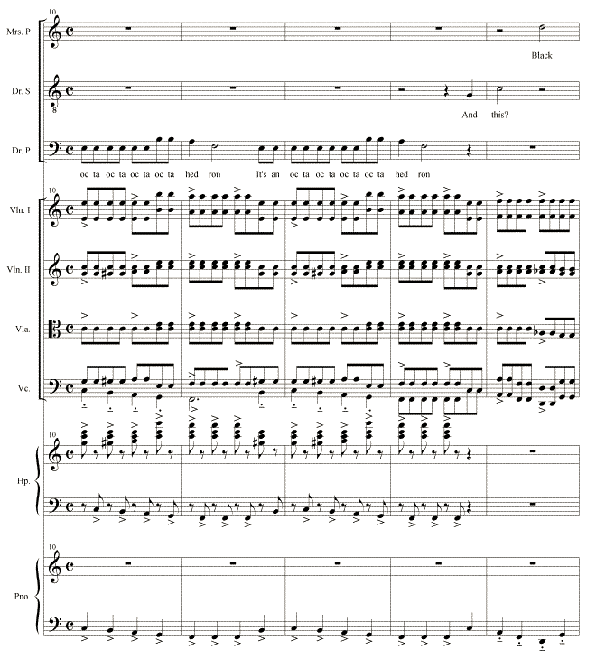
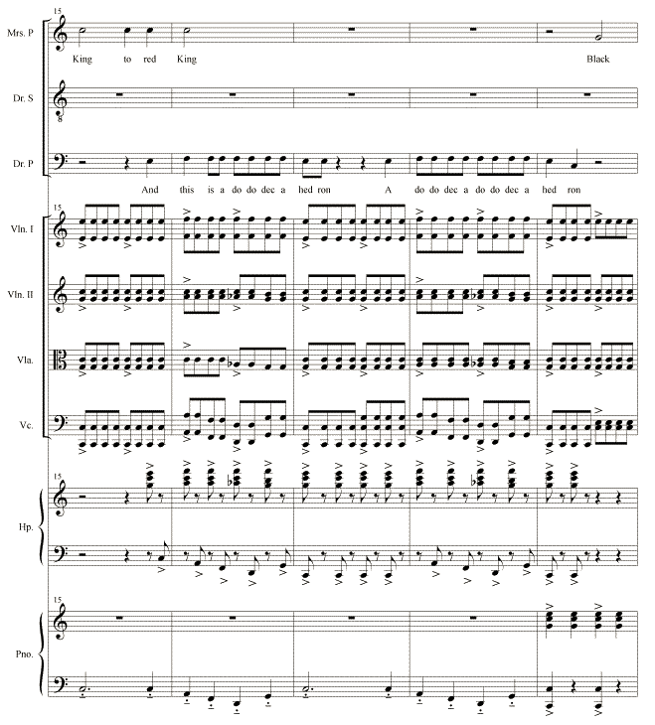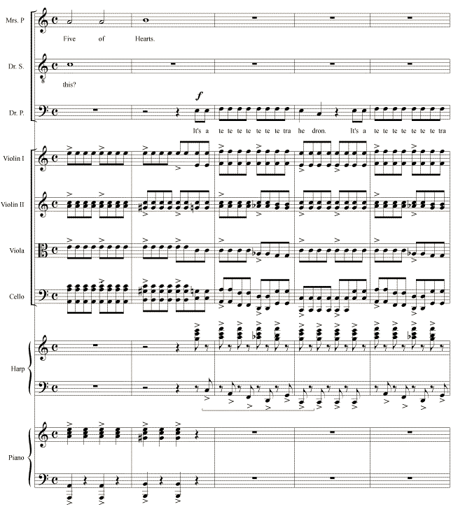
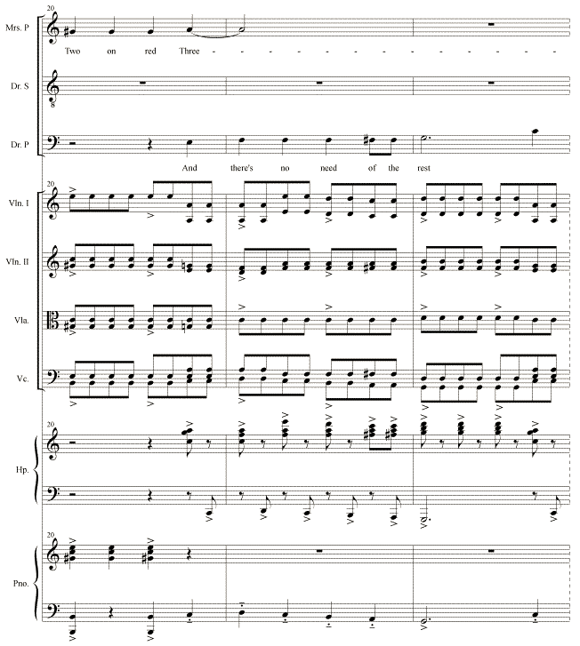

Example 7a. Schumann, “Rätzel,” mm. 1–6
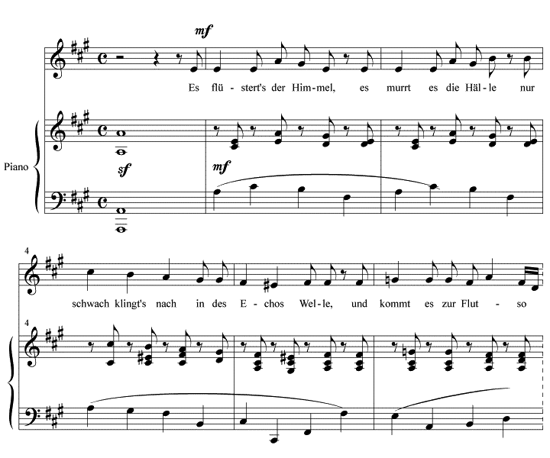

Example 7b. Nyman, “The Man Who Mistook His Wife for a Hat,” mm. 427–435
