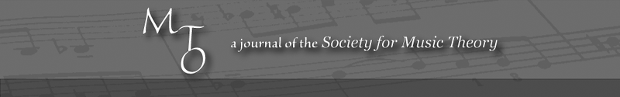
MTO 9.2 Examples: Cramer, Harmonic Function of the Altered Octave
(Note: audio, video, and other interactive examples are only available online)
http://www.mtosmt.org/issues/mto.03.9.2/mto.03.9.2.cramer.php
Figure 1. Saussure’s “plane of vague, amorphous thought” (A) and “the equally featureless plane of sound” (B)
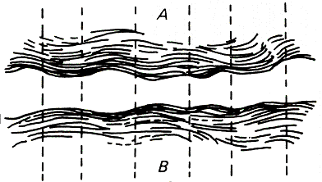

Figure 2.
2a
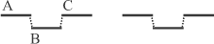
2b
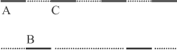
2c
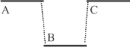
Table 1. Factors in auditory stream integration and segregation
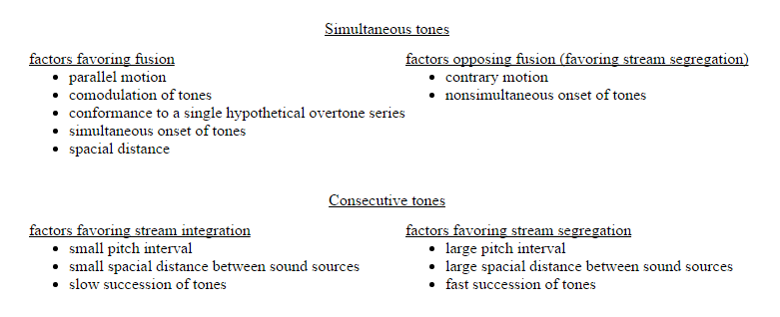

Figure 3.
3a  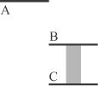 |  | 3b  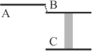
3c  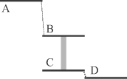 |  | 3d  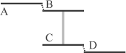

Figure 4. Critical band interactions of intervals
Long dark lines represent partials of a pitch in mid-treble register, such as g₁. Short dark lines represent the partials of tones at the specified interval above mid-treble pitch. Shaded bands represent critical bands.
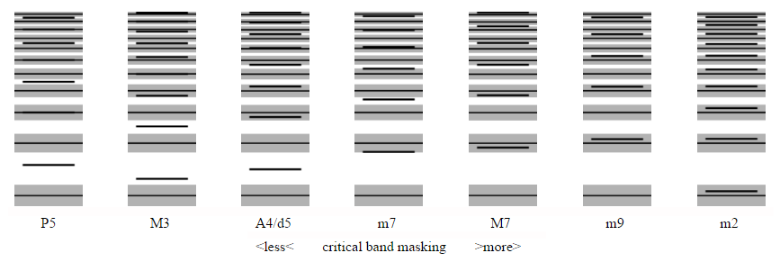

Figure 5.
5a
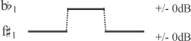
5b
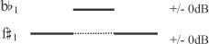

Figure 6.
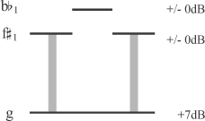
Figure 7.
7a
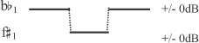
7b
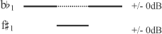

Figure 8.
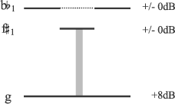
Figure 9.
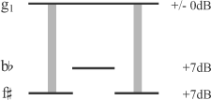

Figure 10.
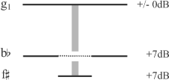
Example 1. Webern, String quartet movement op. 5, no. 5, mm. 26–26
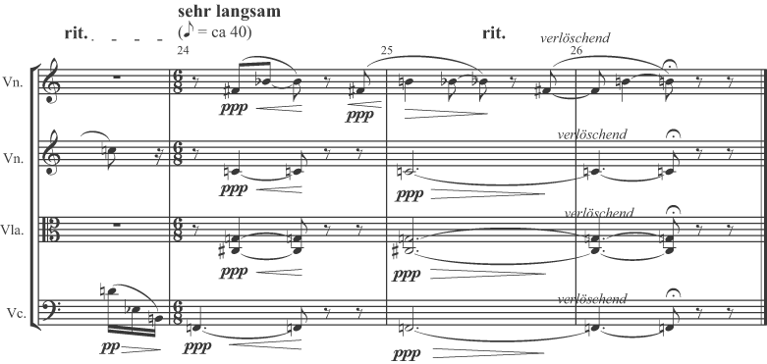
Figure 11.
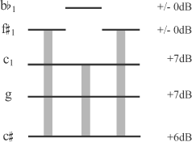

Figure 12.
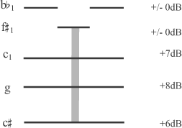
Figure 13.
13a  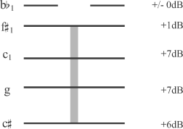 |  | 13b  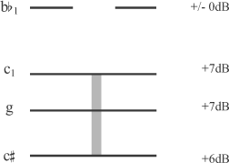
13c  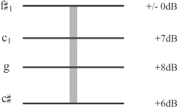 |  | 13d  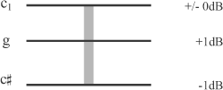
Figure 14.
14a  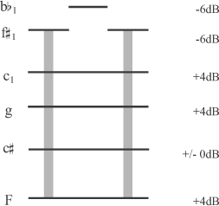 |  | 14b  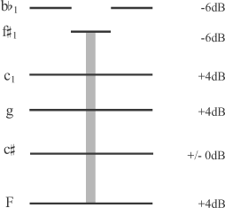 |  | 14c  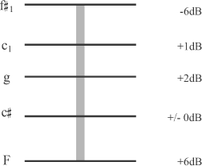

Figure 15.
15a  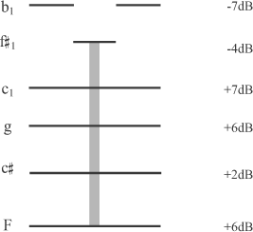 |  | 15b  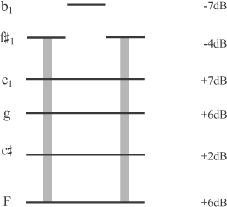

Figure 16.
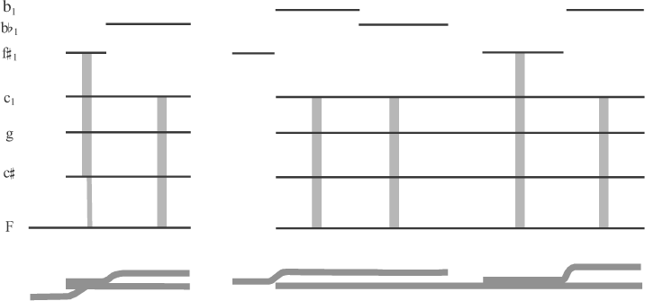

Example 2. Webern, Orchestral Piece op. 22, no. 1 (1913), mm. 2–3
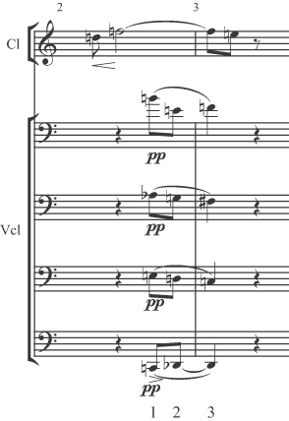

Figure 17. Schoenberg, “Seraphita,” op. 22, no. 1, measures 2–3, cellos after Cramer, “Klang and Klangfarbenmelodie,” page 29
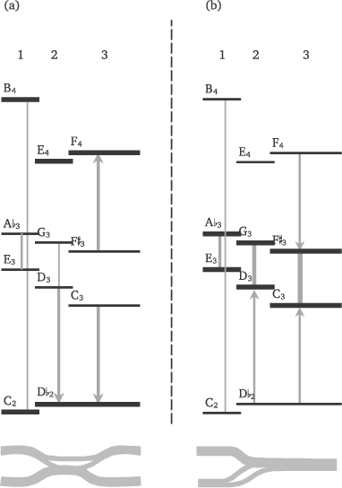

Example 3. Webern, Orchestral Piece op. 6, no. 1 (1909), mm. 2–4
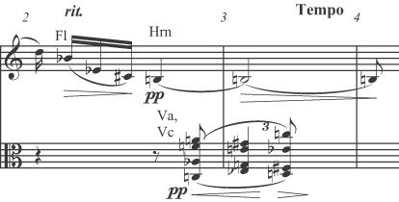

Figure 18.
18a  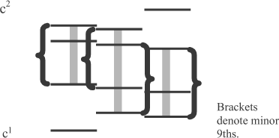 |  | 18b  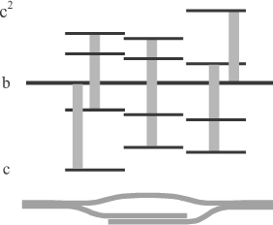

Example 4. Webern, Orchestral Piece op. 6, no. 1 (1909), mm. 8–9
