
MTO 14.2 Examples: Biamonte, Augmented-Sixth Chords vs. Tritone Substitutes
(Note: audio, video, and other interactive examples are only available online)
http://www.mtosmt.org/issues/mto.08.14.2/mto.08.14.2.biamonte.php
Example 1. Augmented Sixth as Pre-Dominant: Beethoven Symphony No. 5, first movement, mm. 18–21
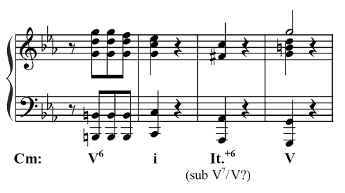

Example 2. Augmented Sixth as Dominant: Schubert, String Quintet in C, fourth movement, mm. 425–431
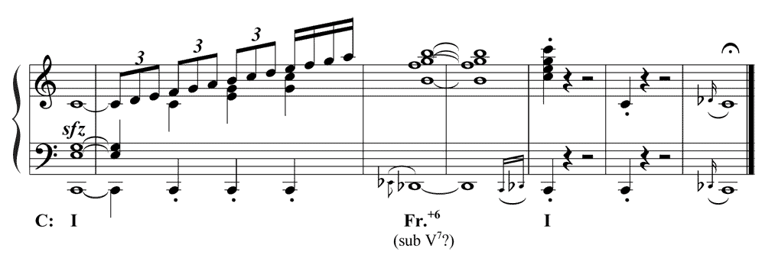

Example 3. Tritone Substitution and Resolution
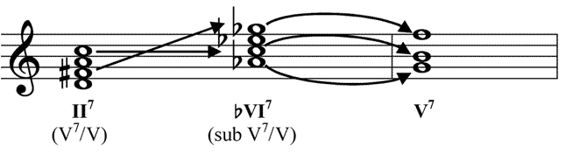

Example 4. Tritone Substitution for ii⁷–V⁷: Ellington, “Satin Doll,” end of A phrase
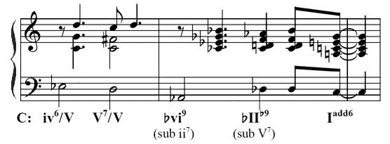

Example 5. Tritone substitution for ii^{ø7} (II⁷): Arlen, “Come Rain or Come Shine,” end of chorus
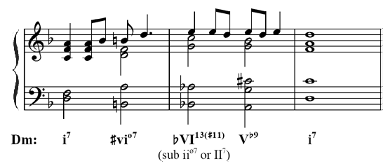

Example 6. Enharmonically Related Dominant-Seventh and Augmented-Sixth Chords
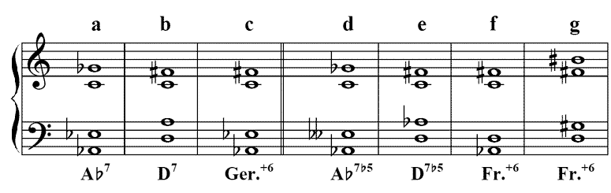

Example 7. Derivations of Augmented-Sixth Chords from Diatonic and Applied Harmonies
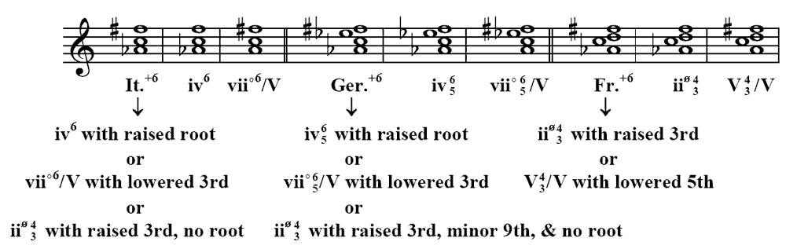

Example 8. Tritone-Related Chord Voicings
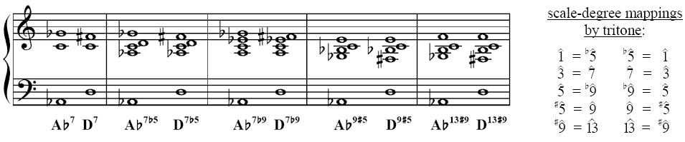

Example 9. Tritone-Related Chord-Scales
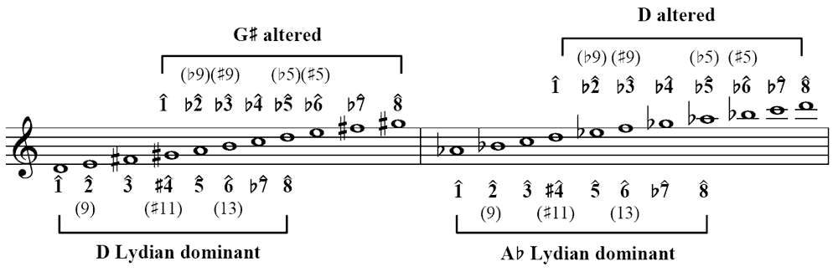

Example 10a. Tritone Substitutes as Augmented Sixths: Ellington, “In a Sentimental Mood,” ending
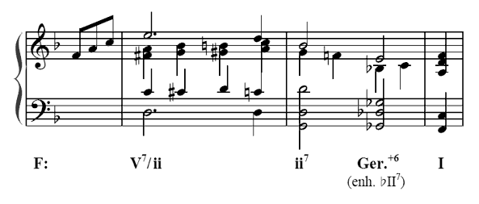
Example 10b. Tritone Substitutes as Augmented Sixths: Ellington, “Mood Indigo,” end of second bridge
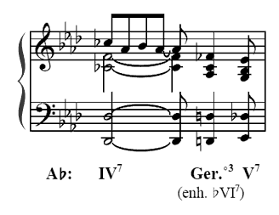
Example 11. Augmented Sixth Resolving Down in Parallel: Beethoven Sonata Op. 57, 2nd movement, mm. 5–8
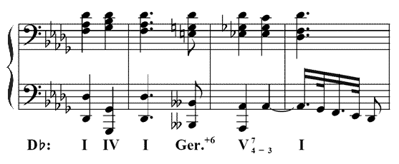
Example 12. Augmented Sixth as Tritone Substitute: Mozart, Symphony No. 40, 2nd movement, mm. 66–67
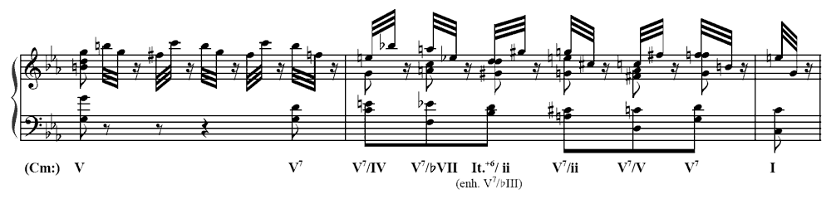

Example 13. Augmented 6th as Dominant 7th: Schubert, Impromptu Op. 90 No. 3, mm. 78–82
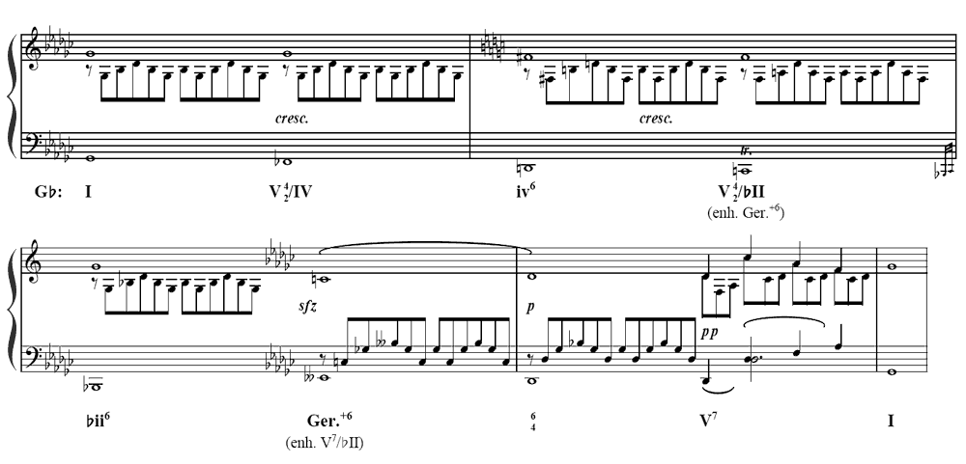
Example 14. Dual-Root Dominant: Seress, “Gloomy Sunday,” end of A section
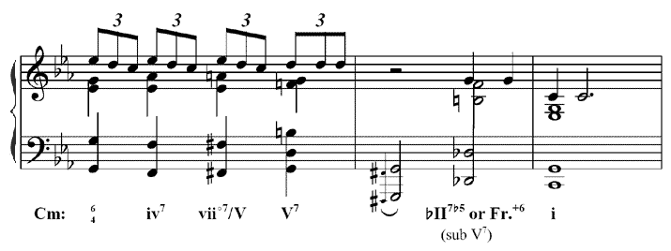

Example 15. Dual-Root Dominant Expansion: Gershwin, Rhapsody in Blue, bridge to second theme
