
MTO 15.2 Examples: Amiot, Discrete Fourier Transform and Bach's Good Temperament
(Note: audio, video, and other interactive examples are only available online)
http://www.mtosmt.org/issues/mto.09.15.2/mto.09.15.2.amiot.php
Figure 1. Bach’s diagram on the first page of the WTC
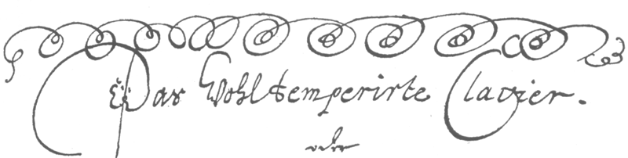

Video 1.
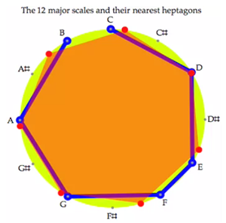

Figure 2. Major scales are best approximations of regular heptagons
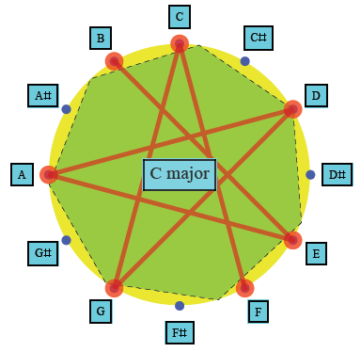

Figure 3. DFT of a major scale and a chromatic 7-note scale
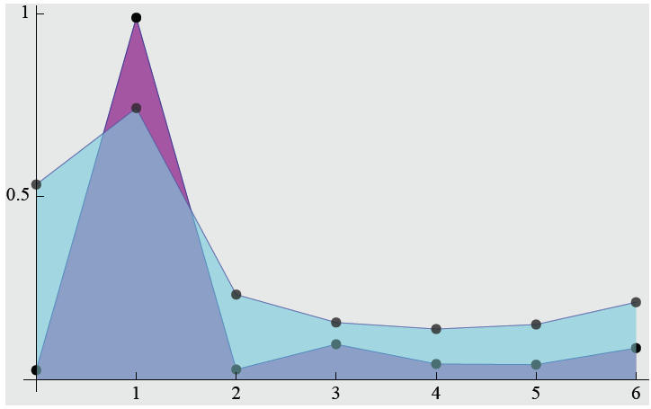
Figure 4. A program for computing MSS
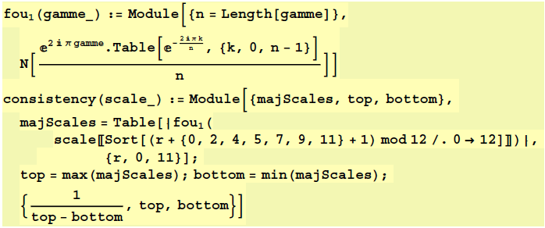

Table 1. Values of MSS for different tunings
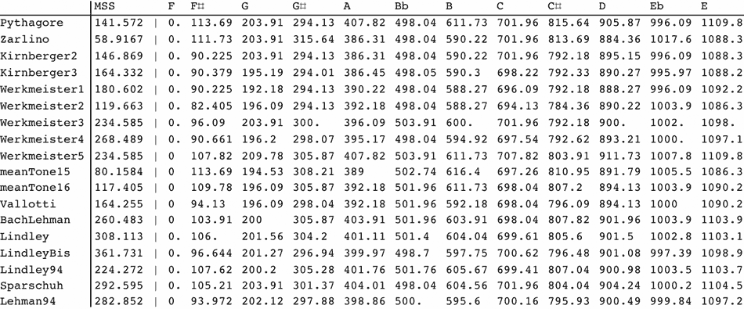

Table 2. MSS for O’Donnell-like tunings
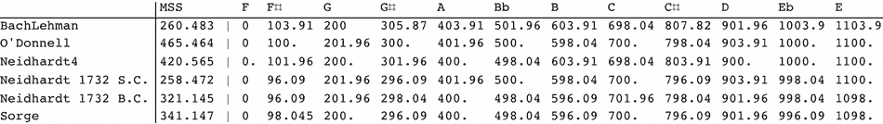

Figure 5. The sum increases when the points are closer
