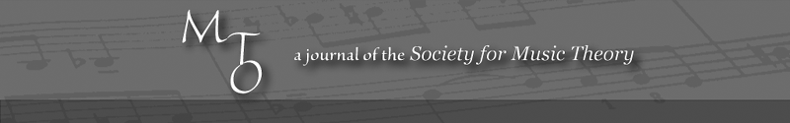
MTO 15.2 Examples: Samarotto, Plays of Opposing Motion
(Note: audio, video, and other interactive examples are only available online)
http://www.mtosmt.org/issues/mto.09.15.2/mto.09.15.2.samarotto.php
Example 1. Examples from Schenker
a) Free Composition, Figure 124, 2a
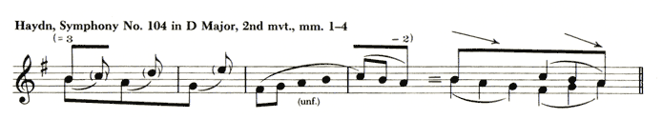
b) Free Composition, Figure 120, 6a and 6b
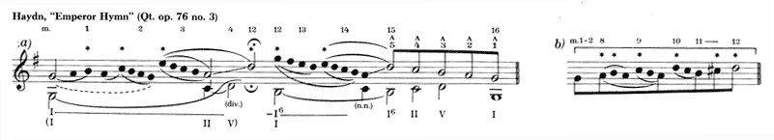
c) Free Composition, Figure 40, 9
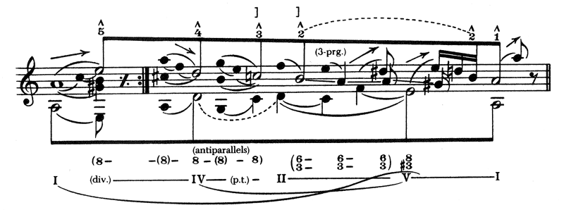
d) Oster collection, File 10, 8r
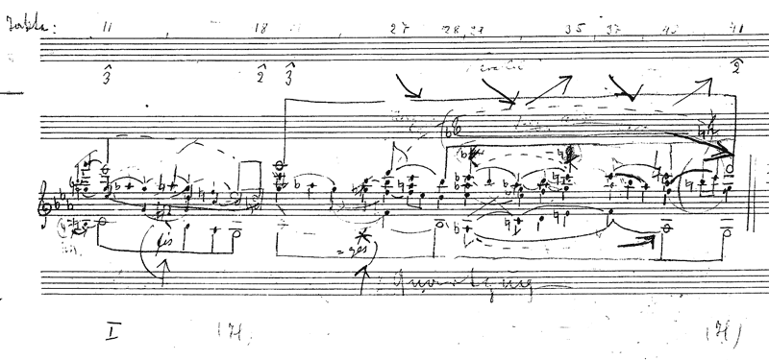

Example 2. J. S. Bach, “Fugue in B Major” from The Well-Tempered Clavier, Book II
a) Opening
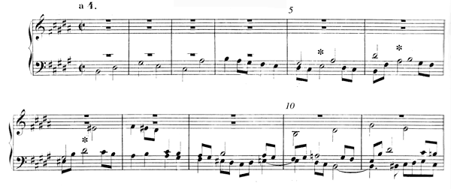
b) Schenker’s analysis of the subject (MW I)
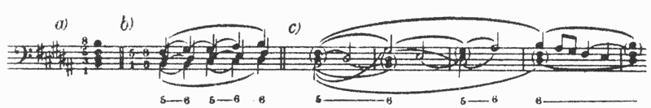
c) Closing
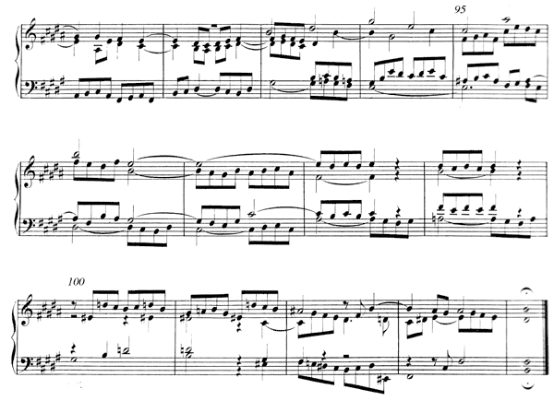
d) Author’s sketch of the closing
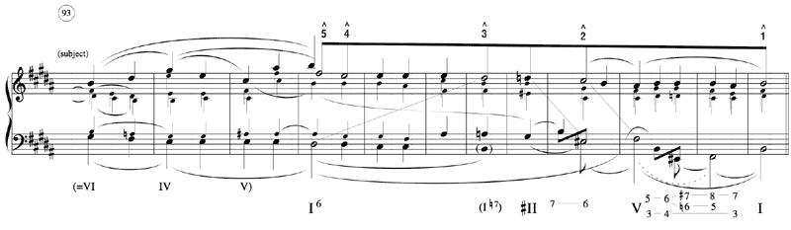

Example 3. J. S. Bach, “Fugue,” BWV 903b
a) Opening
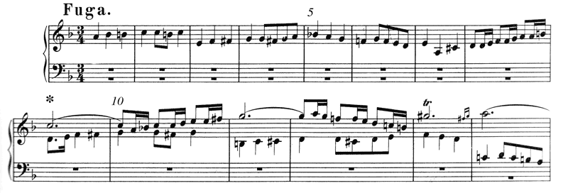
b) Schenker’s analysis of the subject (MW I)
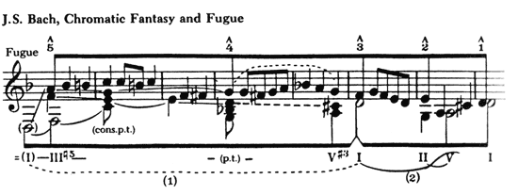
c) Closing
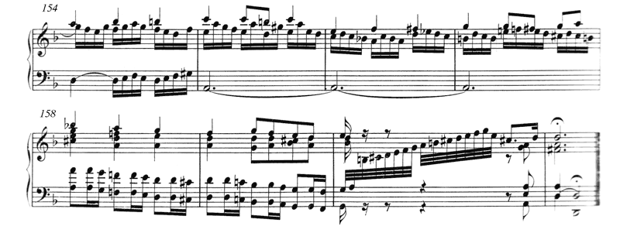
d) Author’s sketch of the closing
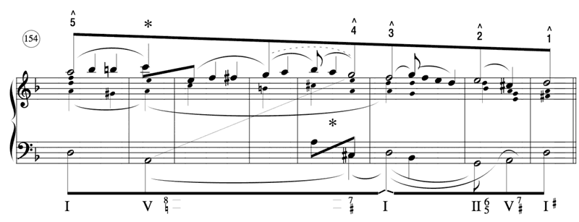
Example 4. Haydn, Symphony No. 104, movement II, measures 1–37
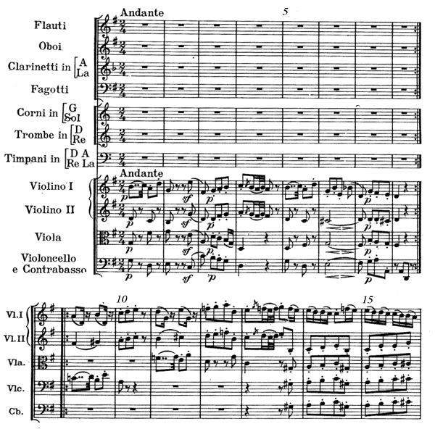
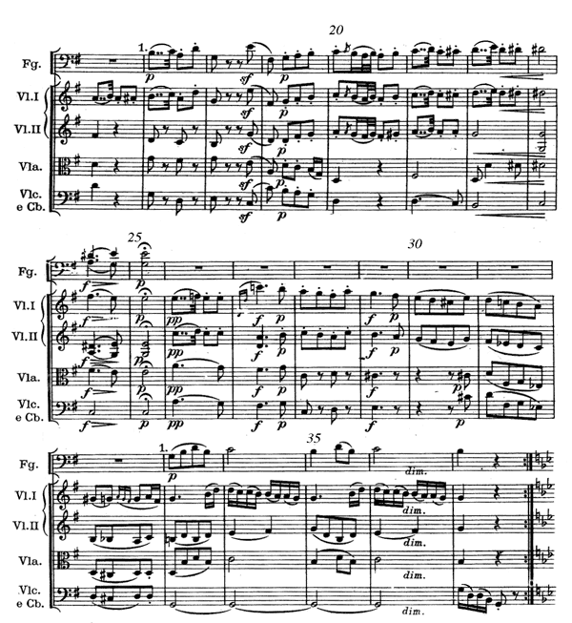
Example 5. Haydn, Symphony No. 104, movement II, measures 1–37, melodic and structural analyses
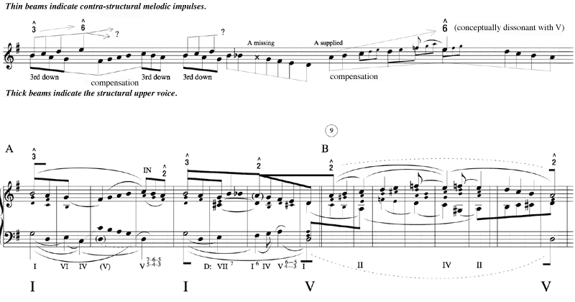
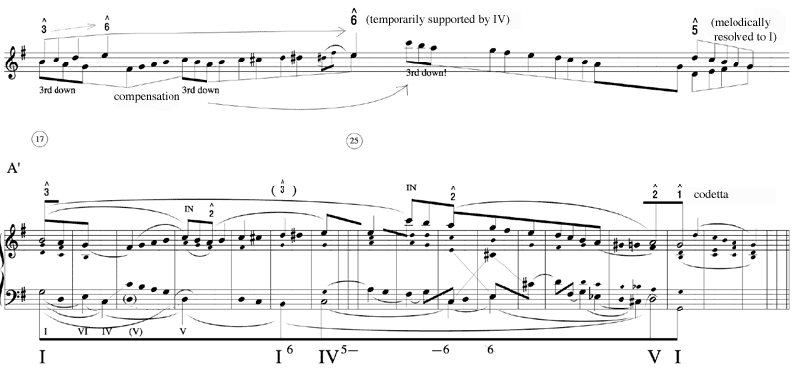

Example 6. Haydn, Op. 64, no. 5, movement iii, minuet only
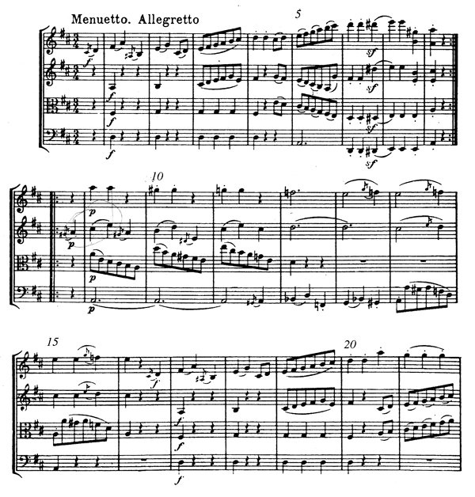
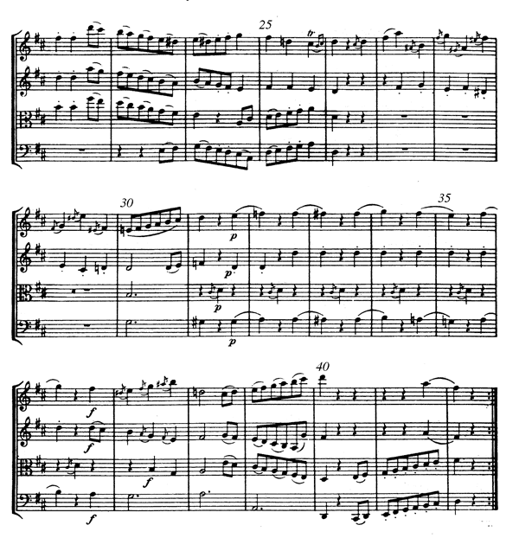

Example 7. Haydn, Op. 64, no. 5, movement iii, minuet, sketch with contra-structural melodic impulses
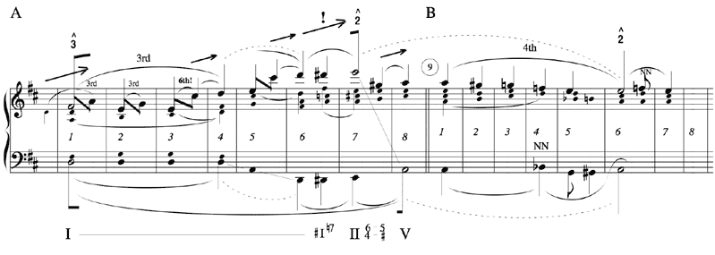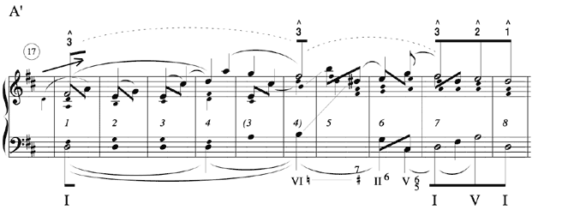
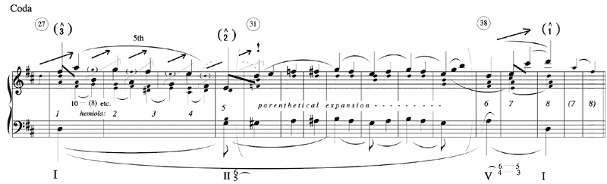

Example 8. Beethoven, Piano Sonata Op. 7, movement iii, Trio only
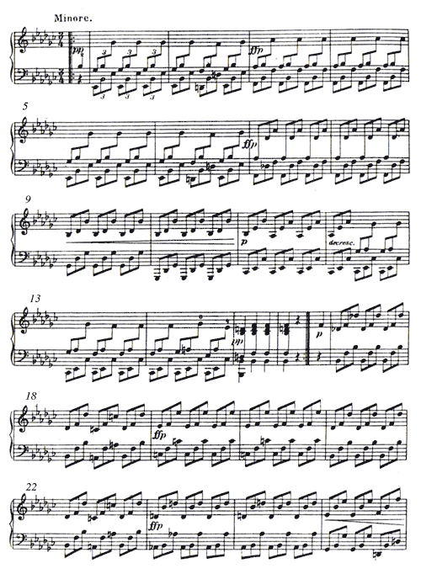
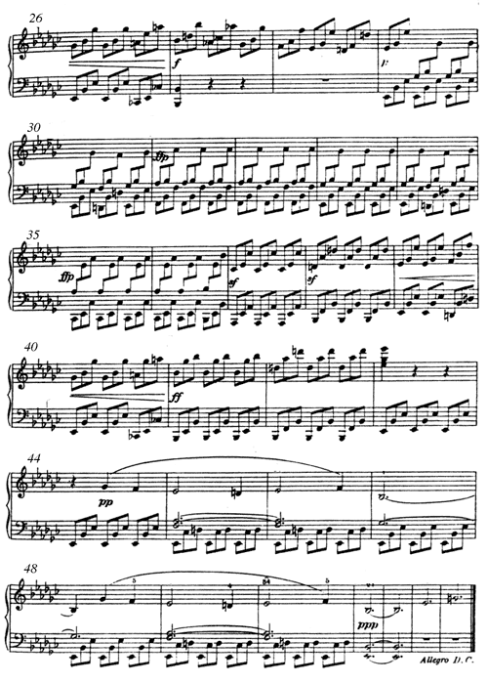

Example 9. Beethoven, Piano Sonata Op. 7, movement iii, Trio
a) Sketch
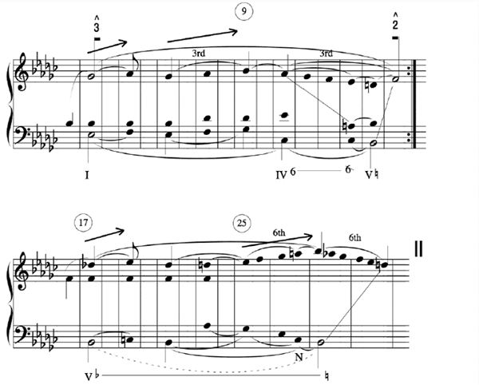
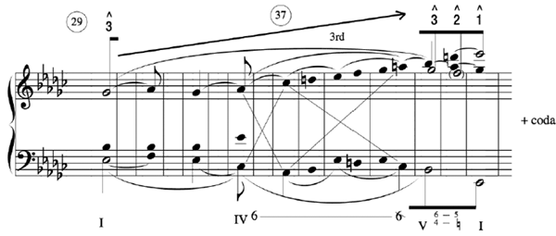

b) Durational reduction
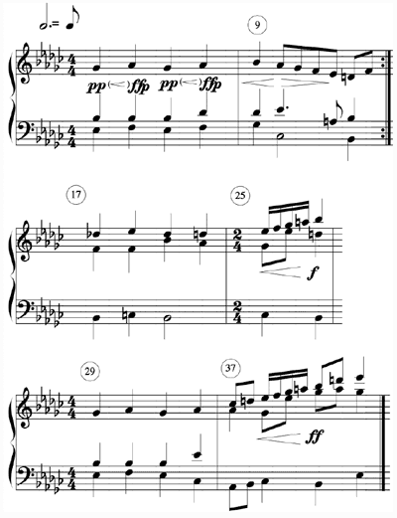

Example 10. Schubert, Nähe des Geliebten (second version)
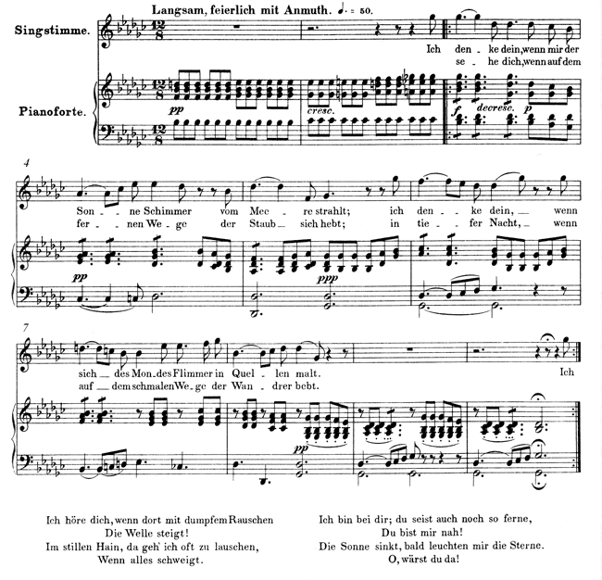
Example 11. Schubert, Nähe des Geliebten, sketch
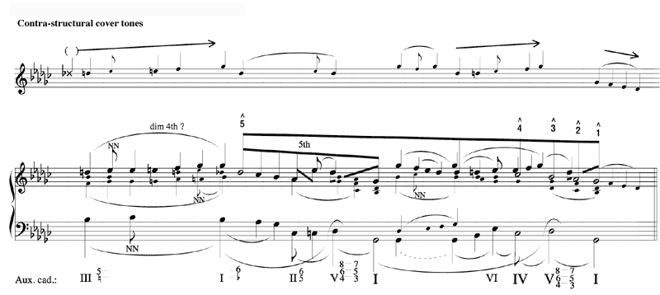

Example 12. Schumann, Loreley, Op. 53, no. 2
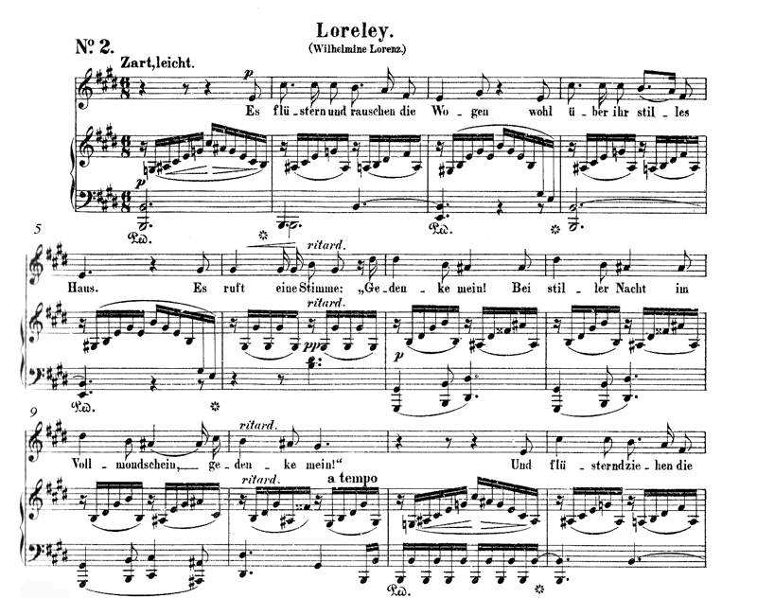
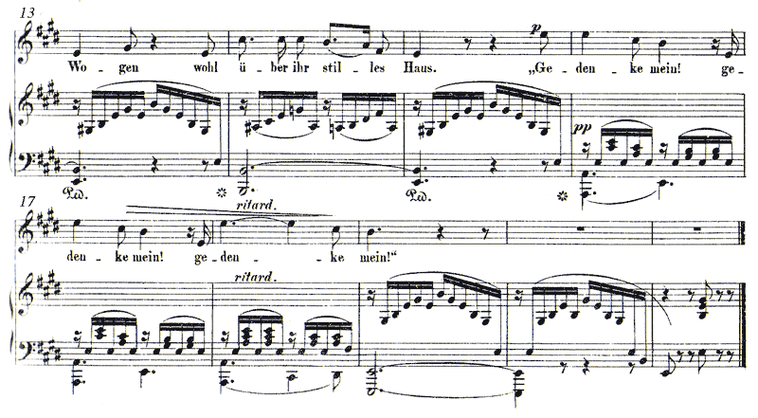

Example 13. Schumann, Loreley, Op. 53, no. 2, sketch
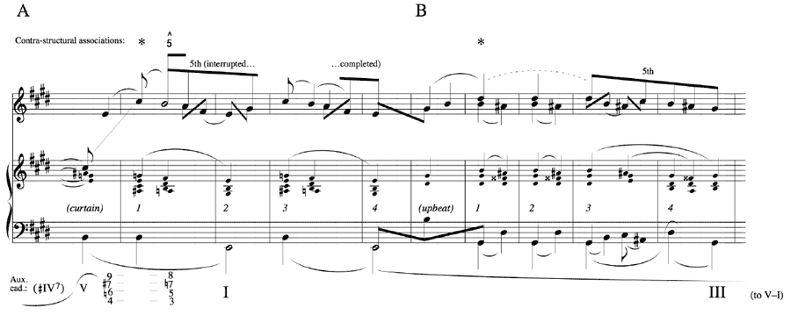
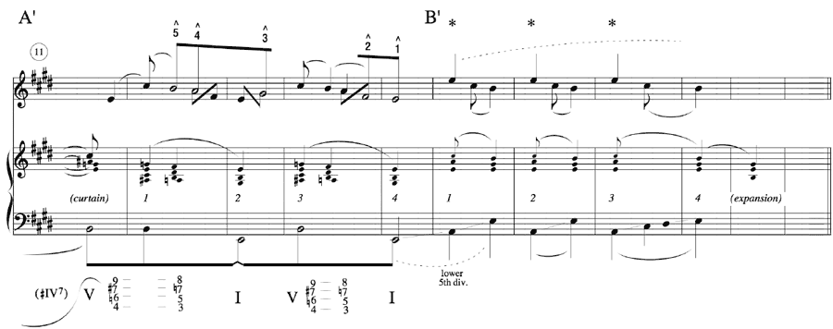

Example 14. Brahms, Meine Lieder, Op. 106, no. 4
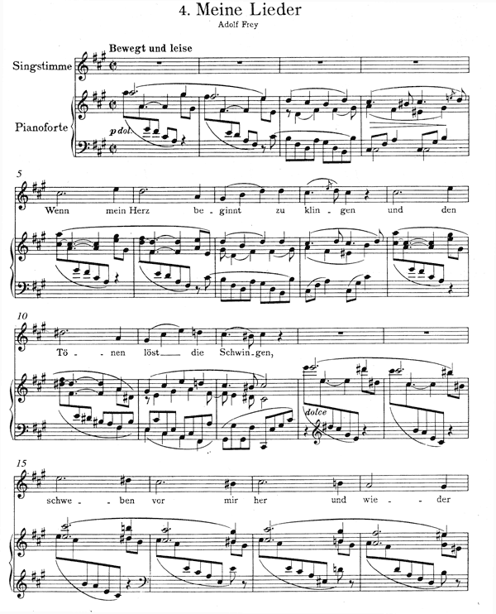
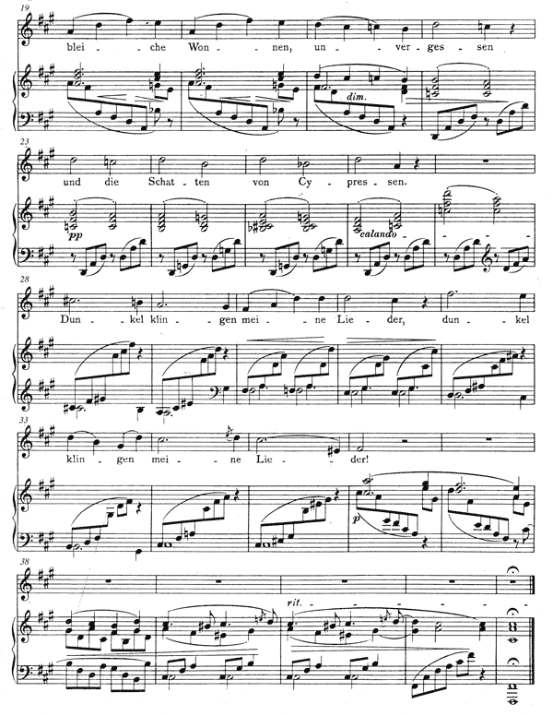

Example 15. Brahms, Meine Lieder, Op. 106, no. 4, sketch
