
MTO 15.3 Examples: Johnson, Notational Systems and Conceptualizing Music
(Note: audio, video, and other interactive examples are only available online)
http://www.mtosmt.org/issues/mto.09.15.3/mto.09.15.3.johnson.php
Example 1. Braille symbols for eighth notes
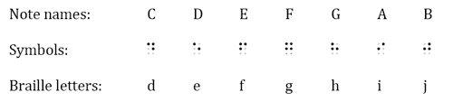

Example 2. “My Bonnie Lies Over the Ocean”
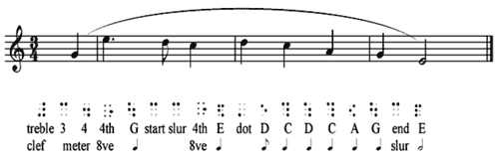

Example 3a. Chorale alto line in Braille music
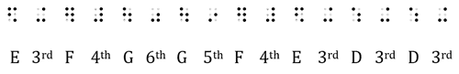
Example 3b. Print chorale
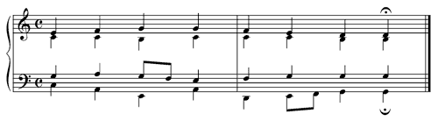

Example 4a. J.S. Bach, Fugue No. 16 from The Well-Tempered Clavier, Book I, Exposition: Print exposition
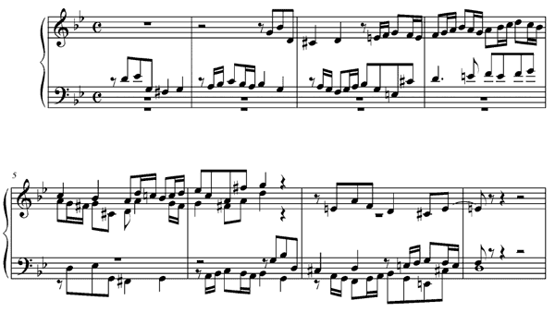

Example 4b. J.S. Bach, Fugue No. 16 from The Well-Tempered Clavier, Book I, Exposition: Braille exposition
