
MTO 24.2 Examples: Bazayev, An Octatonic History of
Prokofiev’s Compositional Oeuvre
(Note: audio, video, and other interactive examples are only available online) http://mtosmt.org/issues/mto.18.24.2/mto.18.24.2.bazayev.html
Example 1a. Rimsky-Korsakov’s Ton-Poluton scale (also gamma Rimskovo-Korsakova)
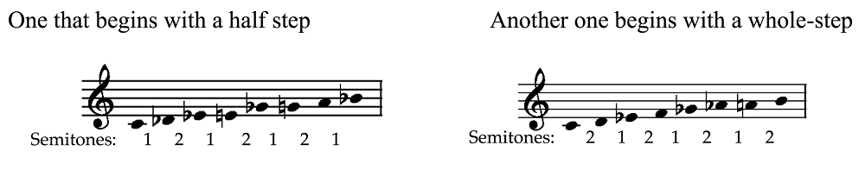

Example 1b. Kholopov’s hemitonic (half-step) system applied to Rimsky-Korsakov’s Sadko (1895–6) (Kholopov 1988, 212–13)
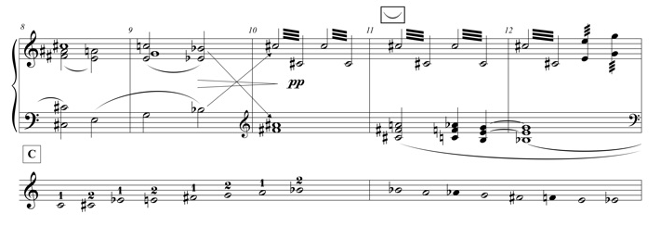

Example 1c. Yavorsky’s duplex-chain mode, which describes the diminished mode (octatonic collection) as a stable resolution of four sets of tritones (after Ewell 2012, Example 9a)
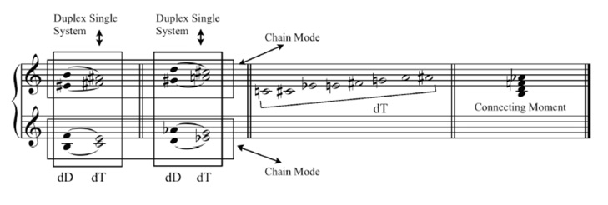

Example 1d. Modal Gravitation for the C-Duplex-Major Mode (after Ewell 2012, Example 11)
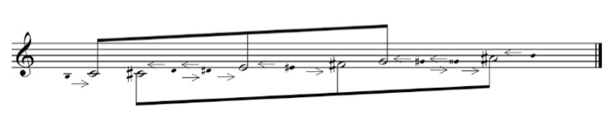

Example 1e. Berger’s octatonic collections
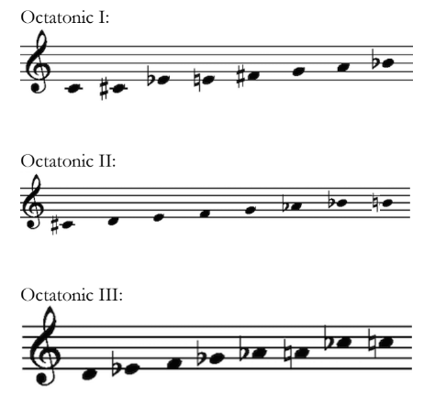

Example 2. The diminished mode in The Love for Three Oranges (1919), rehearsal 68 (1st tableau), as identified by Kholopov 1967a, 247–9
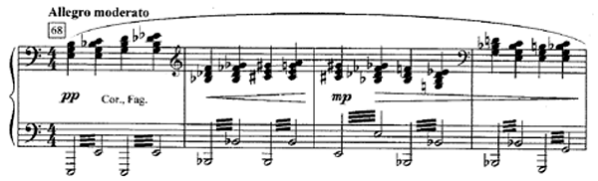

Example 3. Visions fugitives, no. 3 (1921), mm. 13–22, with F as a non-collection tone
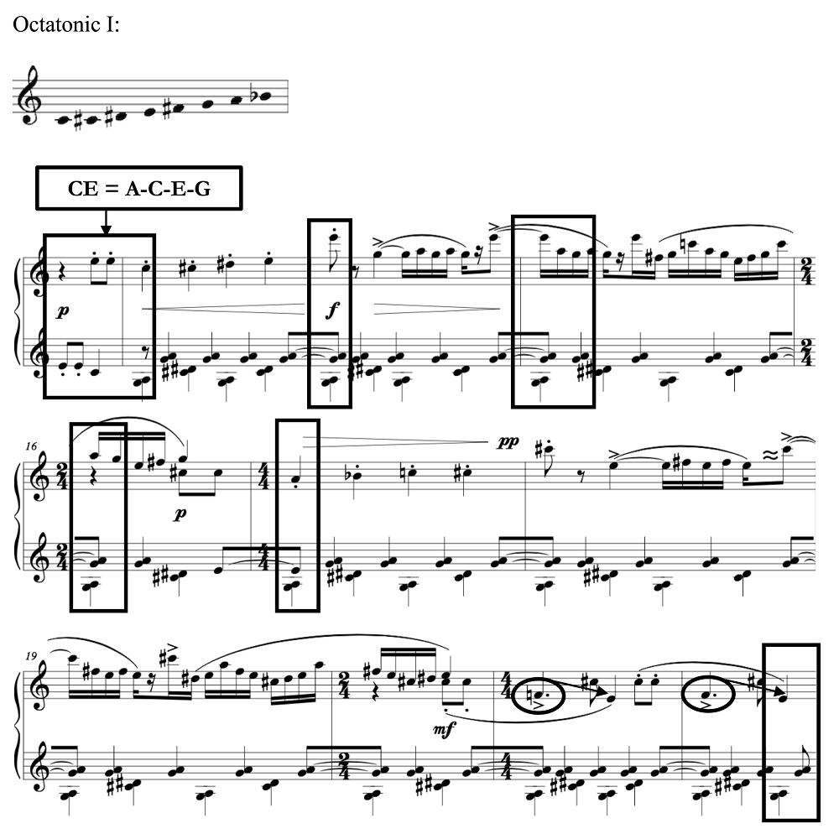

Example 4a. “Quarrel” from Six Pieces for Piano, Cinderella Suite (1944), op. 102, main theme, mm. 38–48; Octatonic III, with D and G as non-collection tones
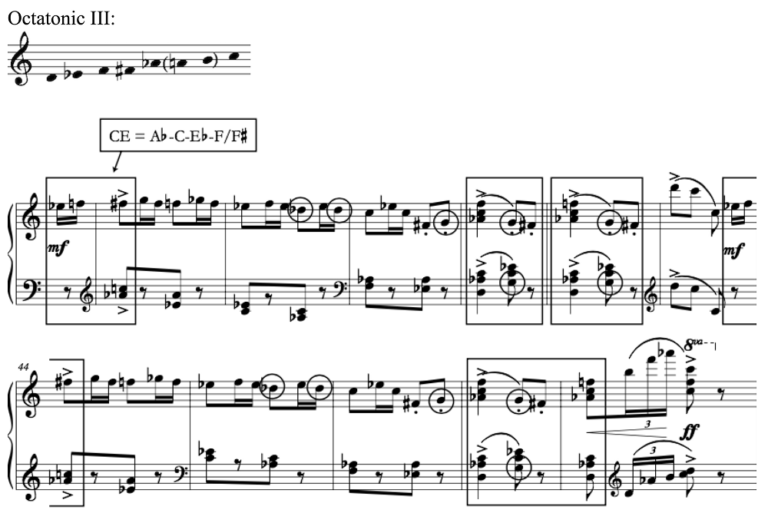

Example 4b. The linear progressions with non-chord tones D and G
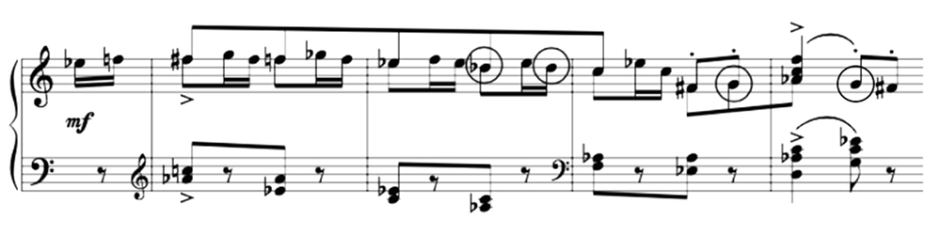

Example 5a. “March” from The Love for Three Oranges, op. 33 (1919), mm. 1–6, Octatonic III, with E as non-chord tone
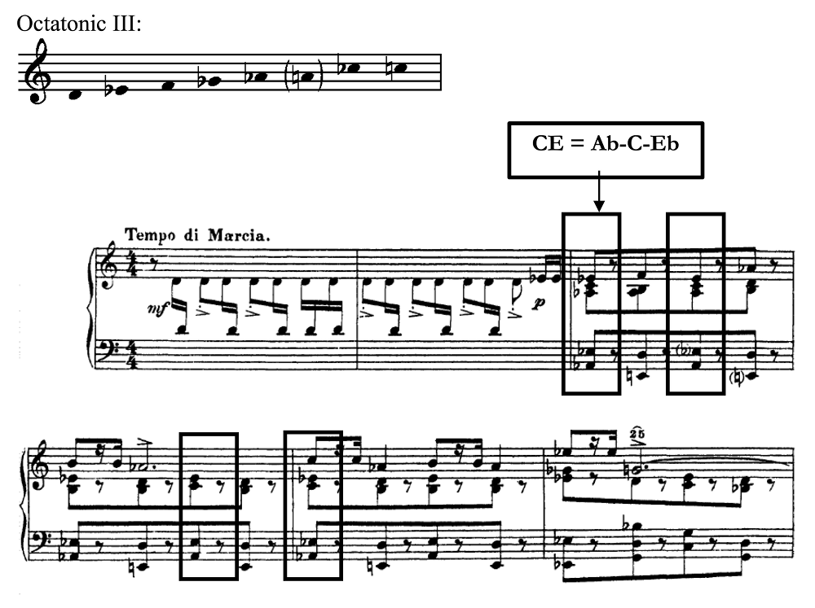

Example 5b. The dissonant E-natural pedal point with its final resolution at m. 6 with minor dominant harmony
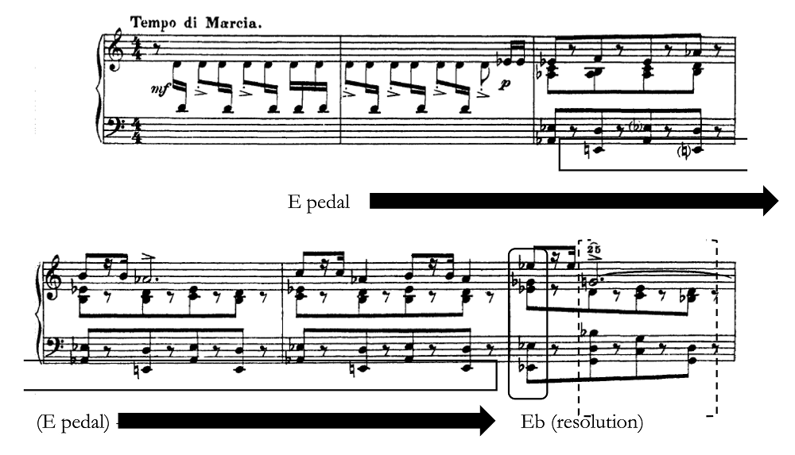

Table 1. The form chart of Sonata no. 6 (1940), I
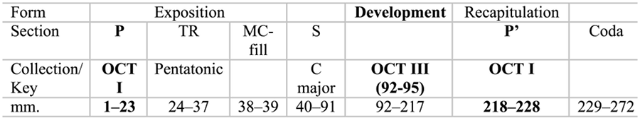

Example 6a. Sonata no. 6, opening theme, mm. 1–11, Octatonic I, with D as a non-collection tone
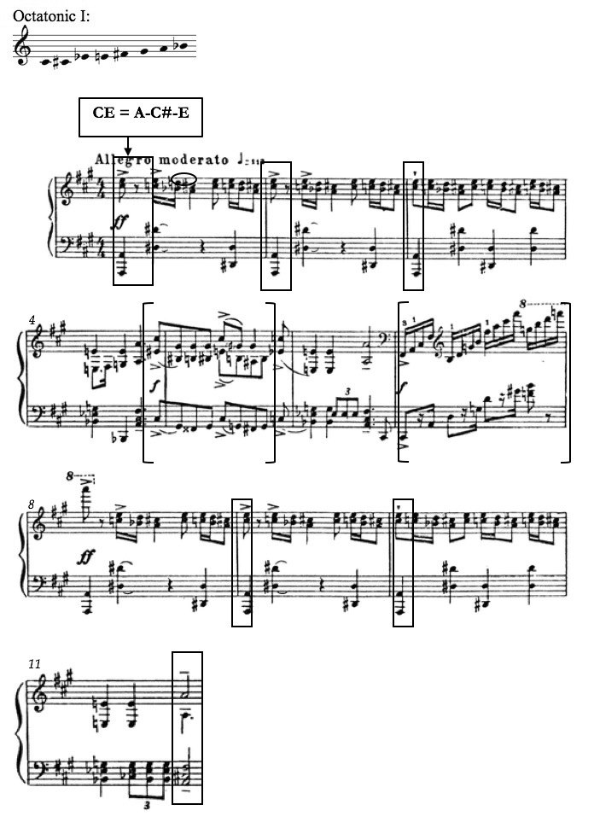
Example 6b. The main theme of the development section, mm. 92–95, featuring the Octatonic III collection, with C as its non-chord tone
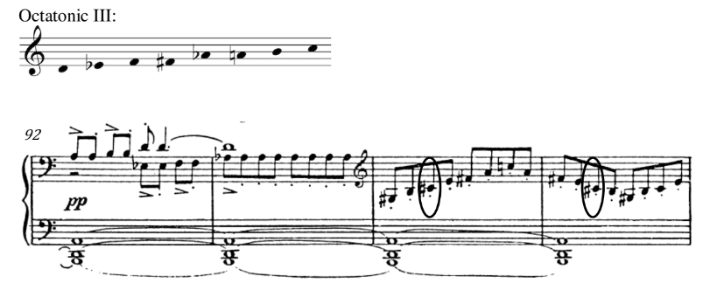

Table 2. The form chart of Sonata no. 6, IV
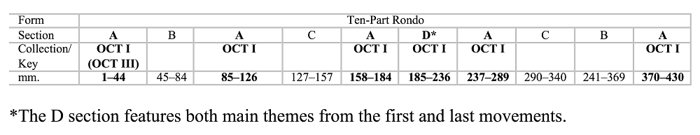

Example 6c. Sonata no. 6, IV, mm. 1–15, opening theme, Octatonic I, with B and D as non-chord tones
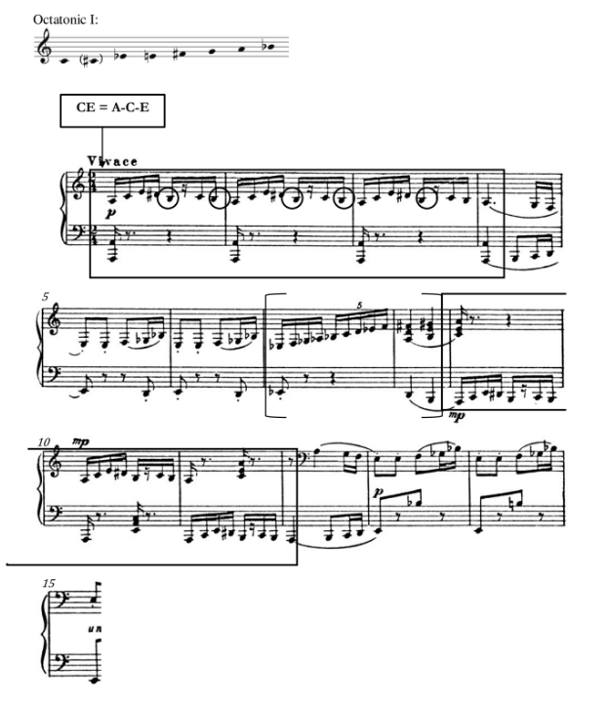

Example 6d. Sonata no. 6, IV, climax, Octatonic I, mm. 224–62, with D as a non-chord tone
