
MTO 24.2 Examples: Martin, Four Studies of Charlie Parker’s Compositional Processes
(Note: audio, video, and other interactive examples are only available online) http://mtosmt.org/issues/mto.18.24.2/mto.18.24.2.martin.html

Example 1. Parker alto part to “Passport Rhythm”
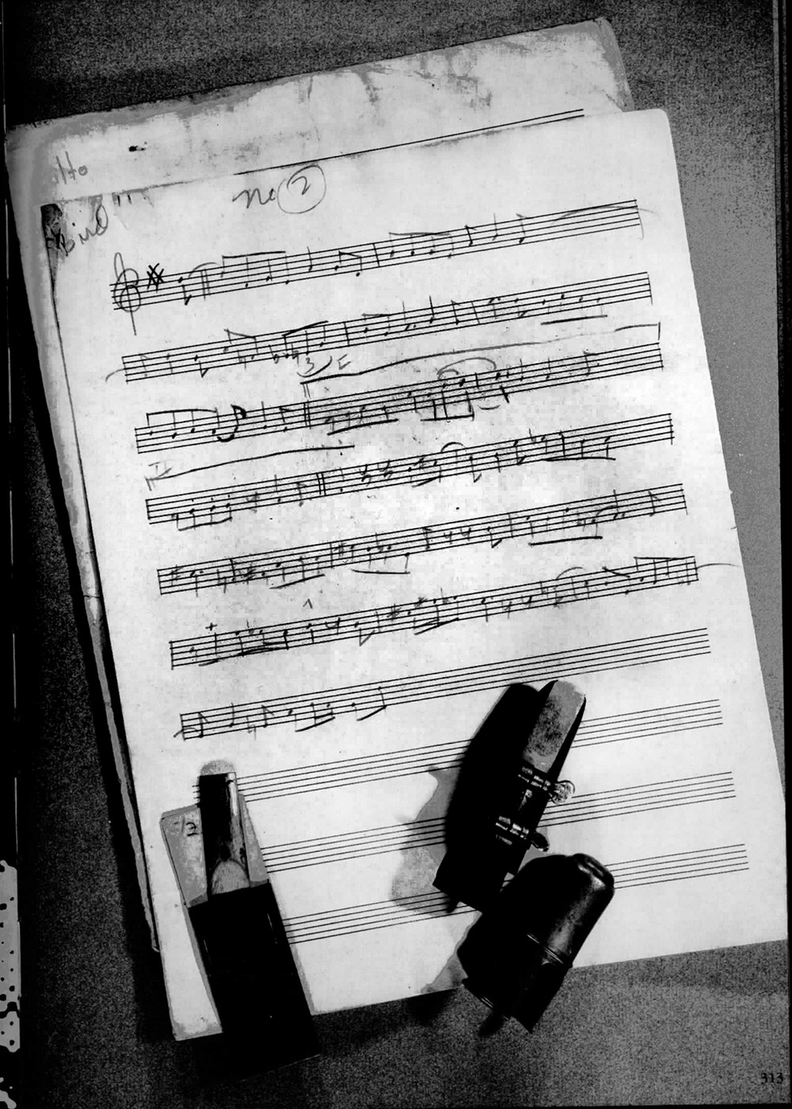
Example 2. Trumpet part to “Swedish Schnapps”
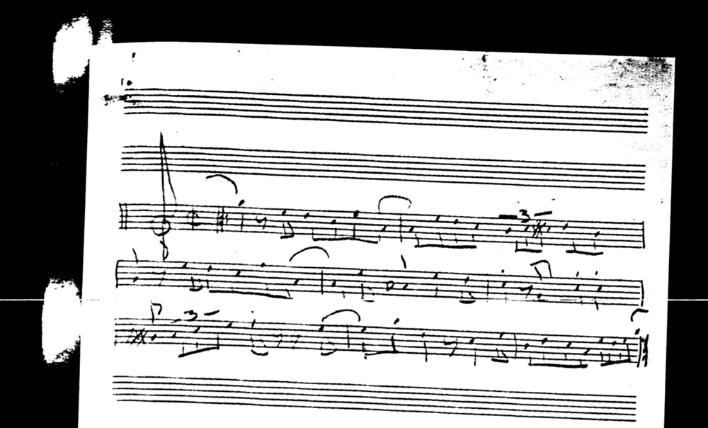

Example 3. Trumpet part to “Back Home Blues”
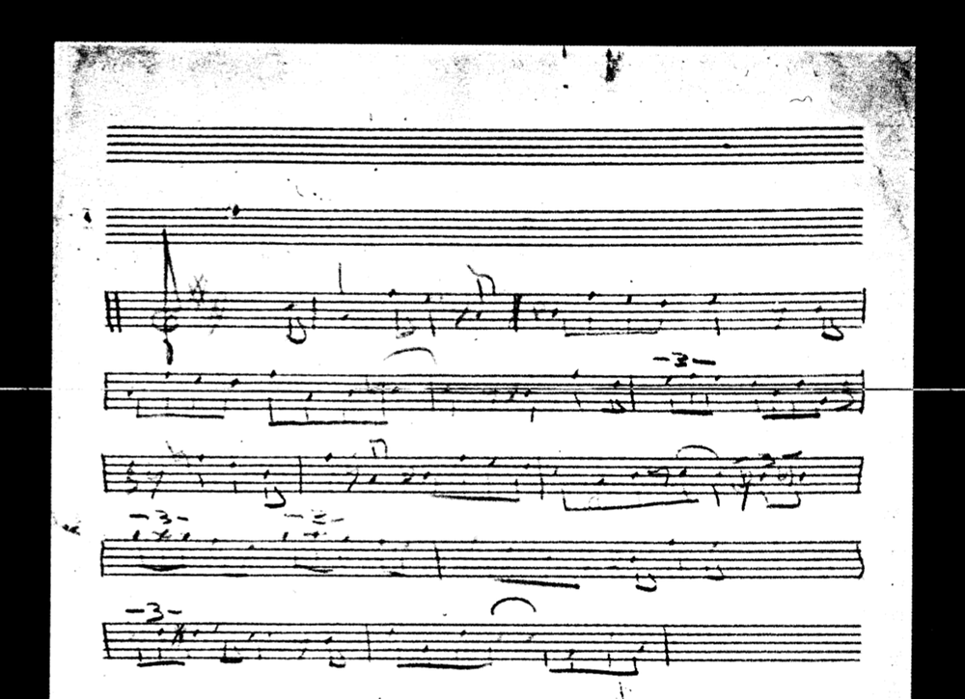

Example 4. Library of Congress deposit EU449253 of “Bill’s Bounce”
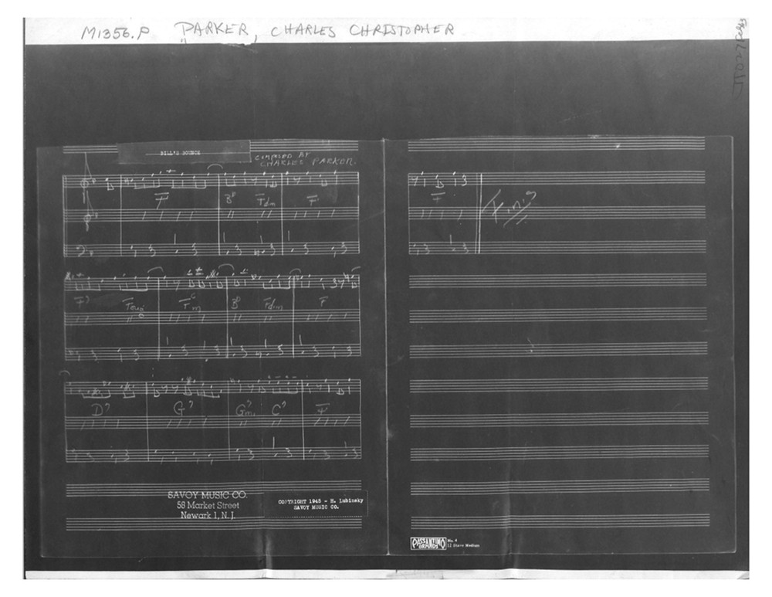

Example 5. Library of Congress deposit EU659286 of “Bird of Paradise”
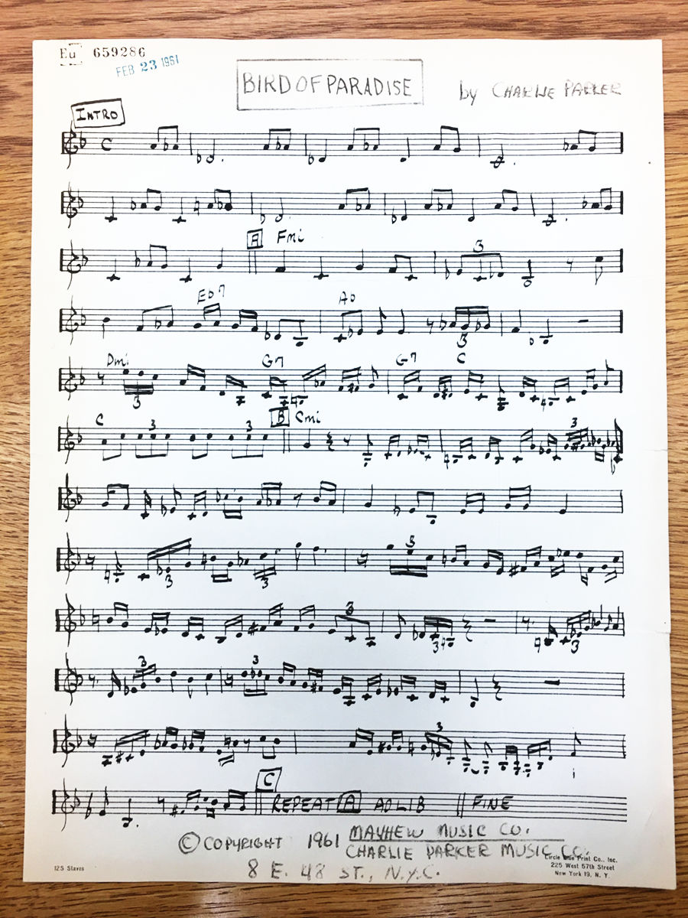

Example 6. Suggestive precedents of the “Ornithology” opening idea
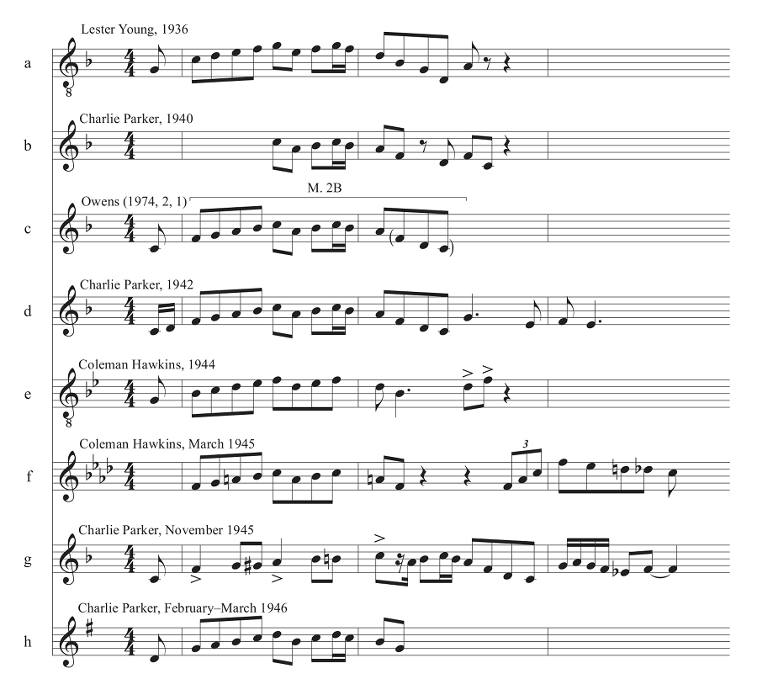

Example 7. Measures 7–8 of Harris’s solo on “How High the Moon” vs. mm. 7–8 of “Ornithology”
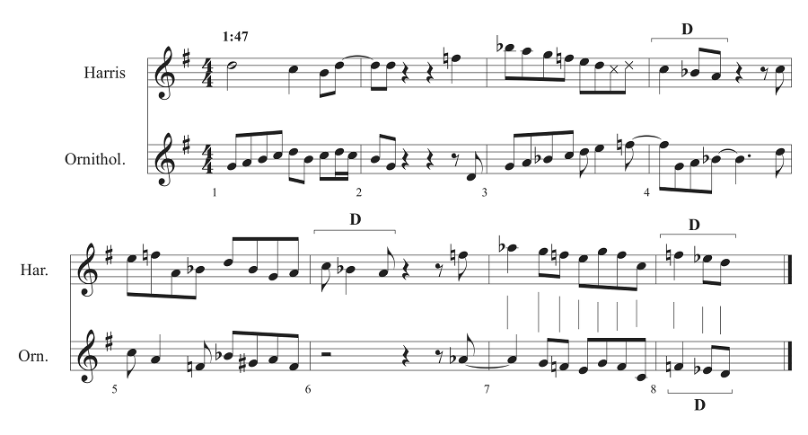

Example 8. Continuation of “Ornithology” in mm. 7–11 with development of motive D
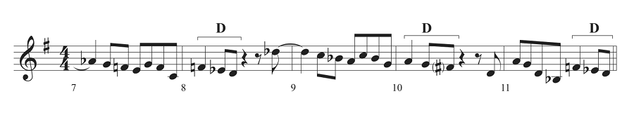

Example 9 and Audio Example 1. Continuation of “Ornithology” with triplet figures
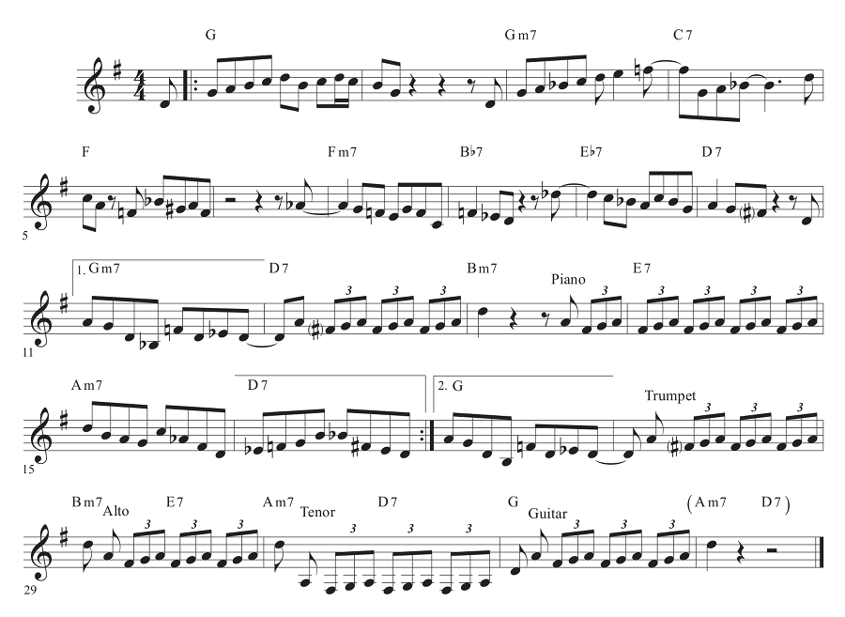

Example 10 and Audio Example 2. “Ornithology” mm. 12–16 and 28–32 finals with voice leading
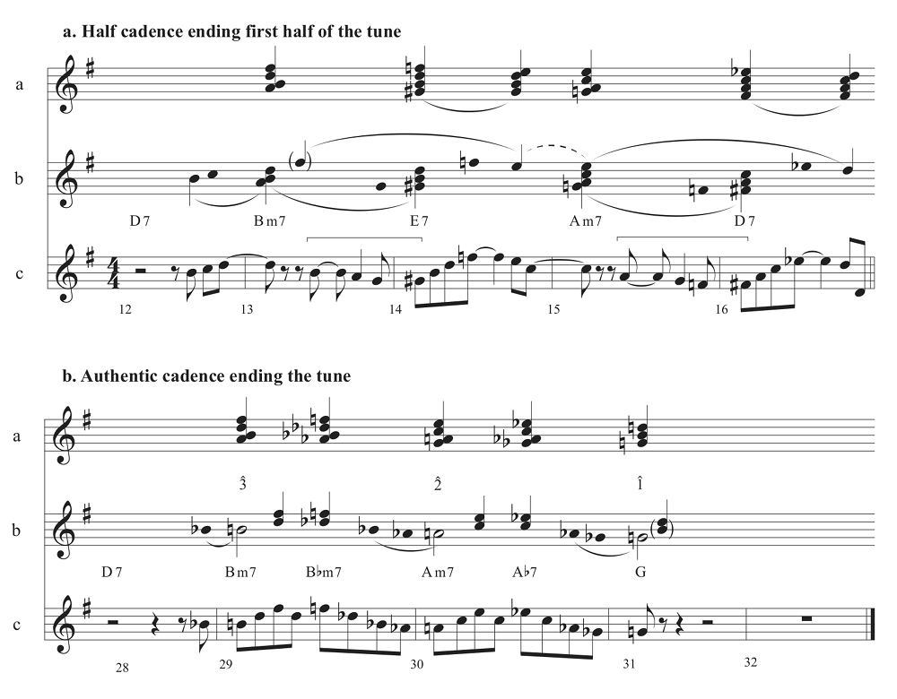

Example 11 and Audio Example 3. “Pedro Gomez” sheet music, pp. 1 and 2
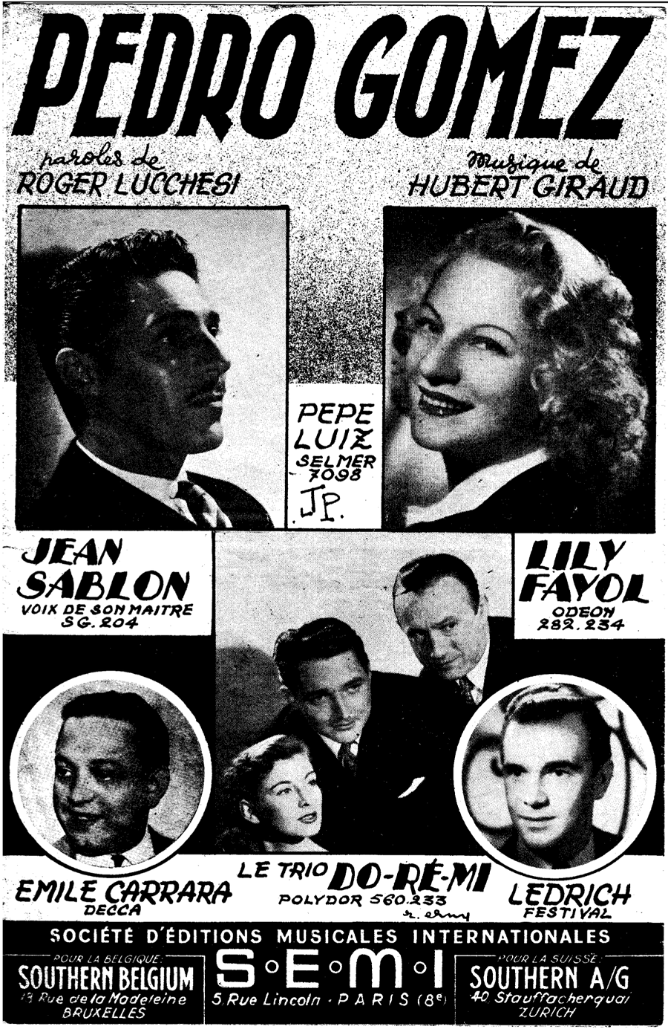
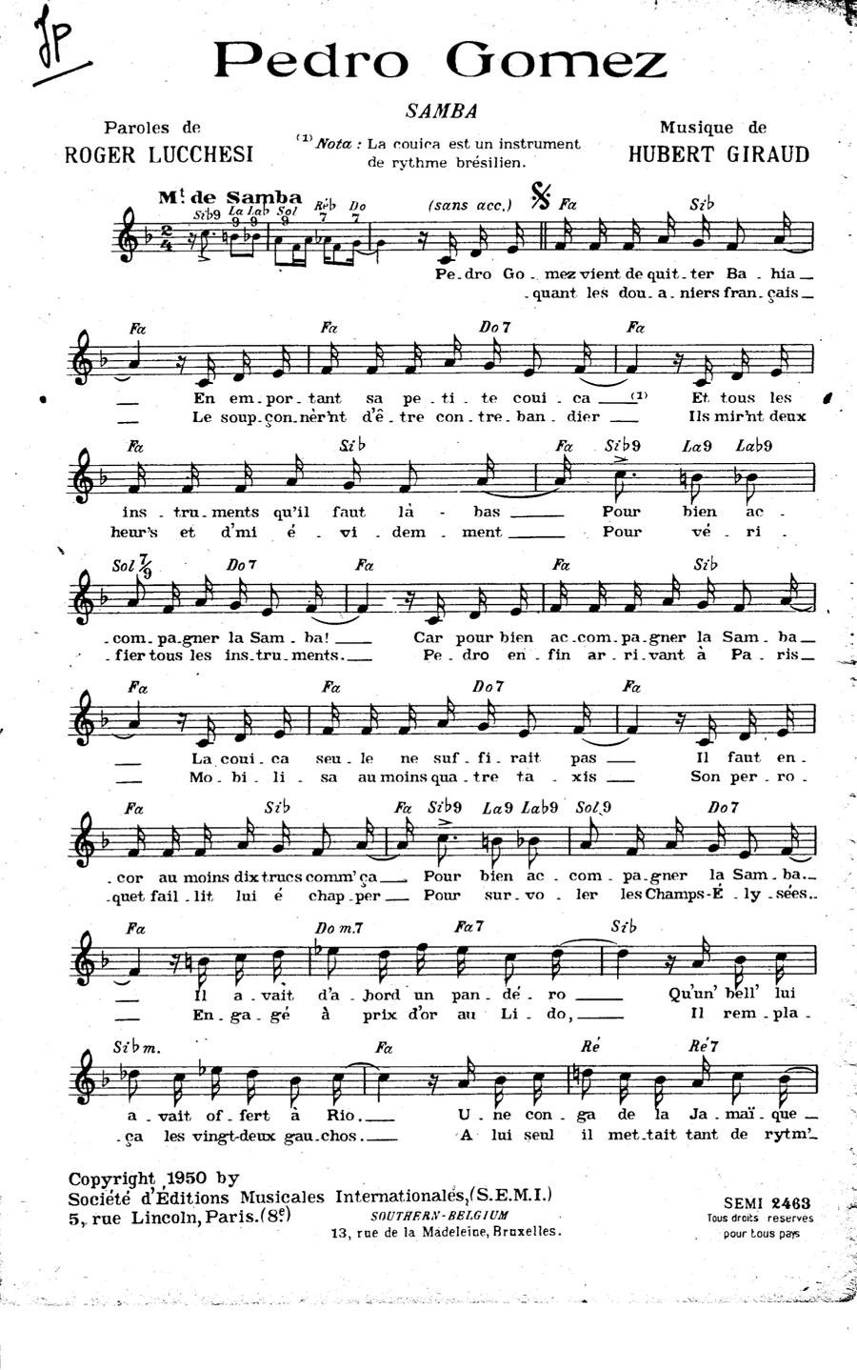
Example 12 and Audio Example 4. “Le petit cireur noir” sheet music, pp. 2 and 3
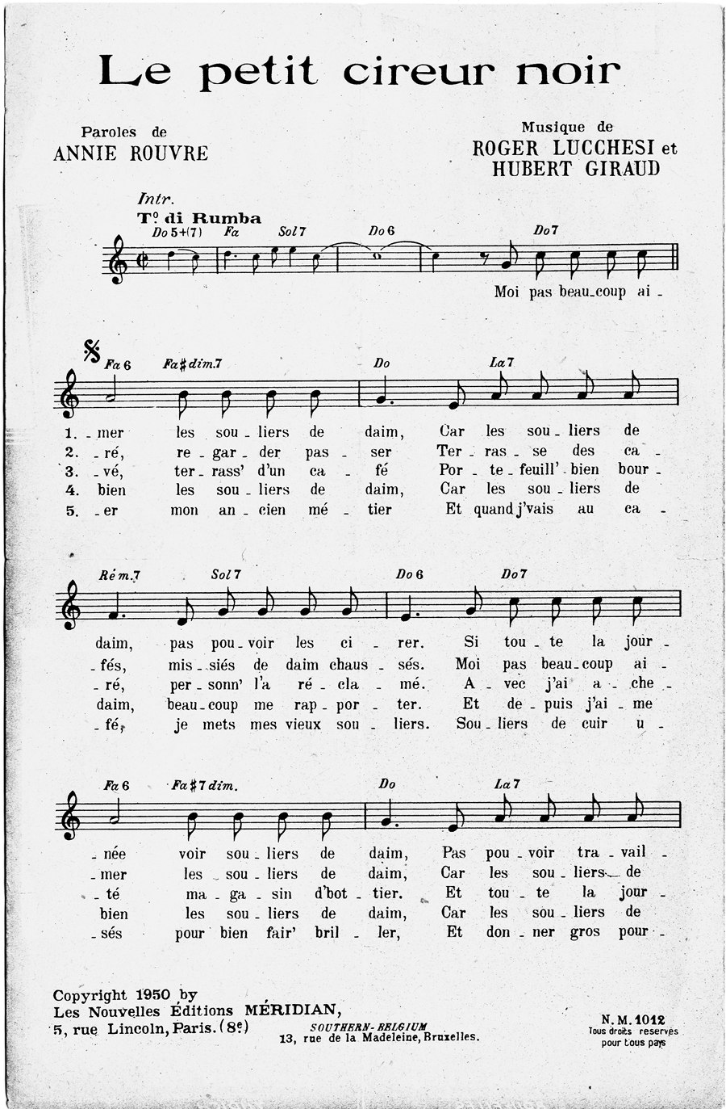
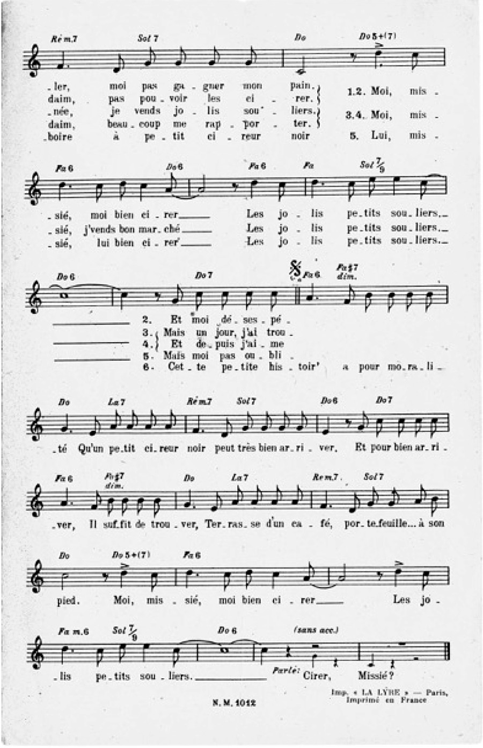
Example 13. “My Little Suede Shoes” A section vs. “Pedro Gomez” A section
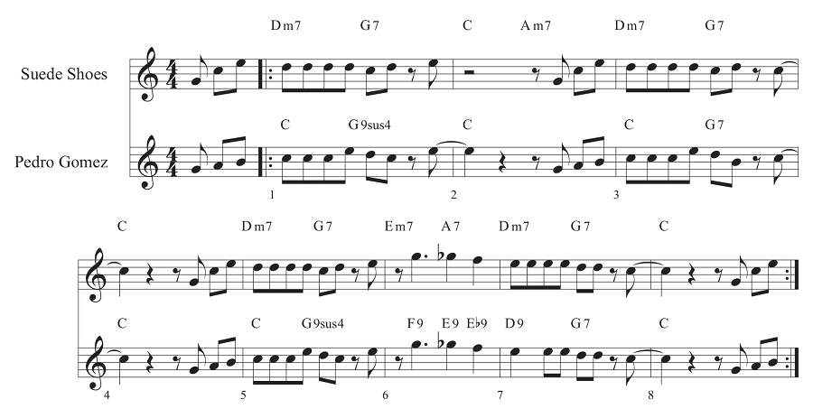

Example 14. “Suede Shoes” vs. “Pedro Gomez” A section voice leading, mm. 1–4
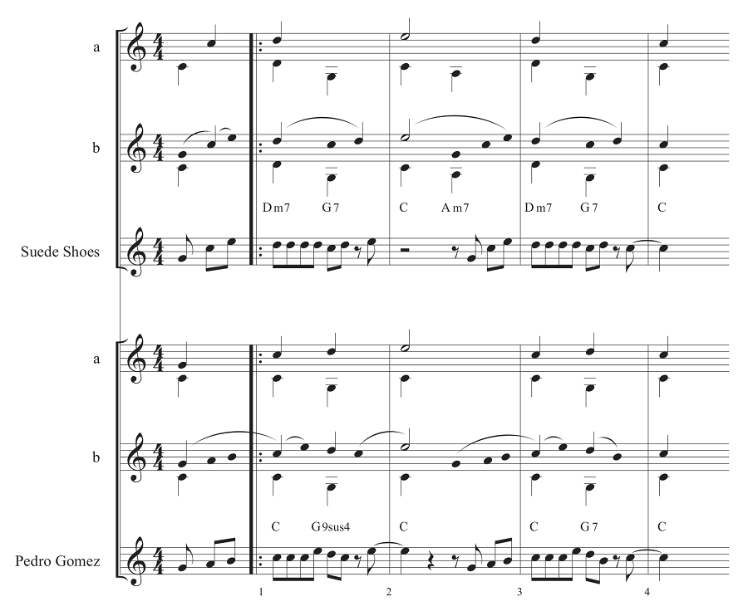

Example 15. “Pedro Gomez” sheet music introduction, in F and C
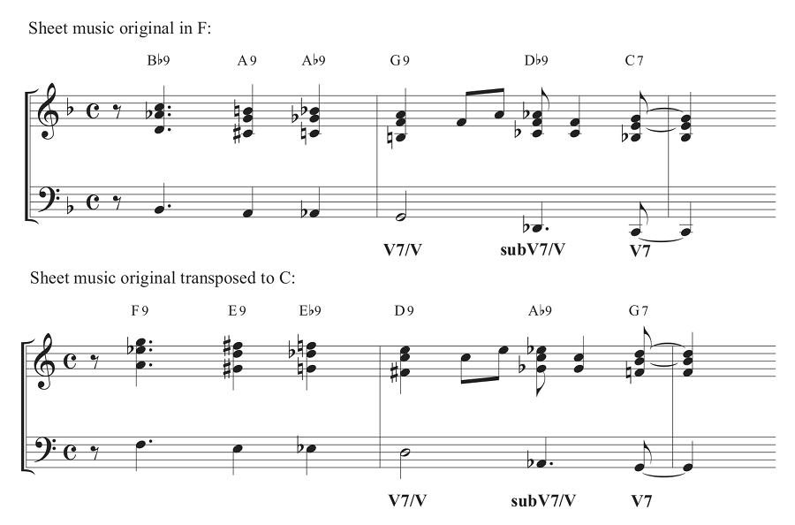

Example 16. “My Little Suede Shoes” B section vs. “Le petit cireur noir” verse
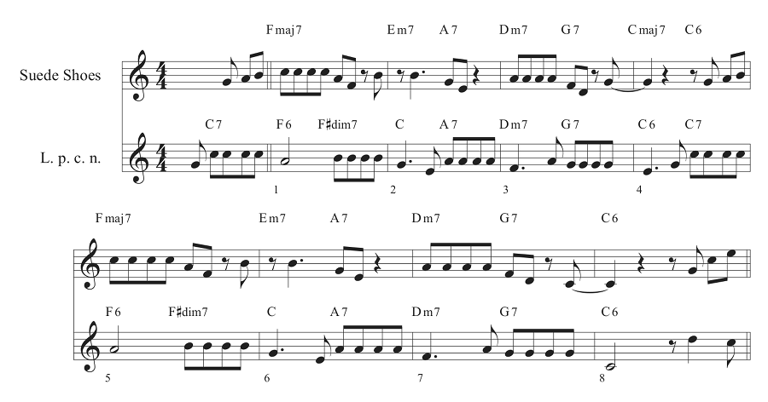

Example 17 and Audio Example 6. “Mop Mop” from “Three Guesses”
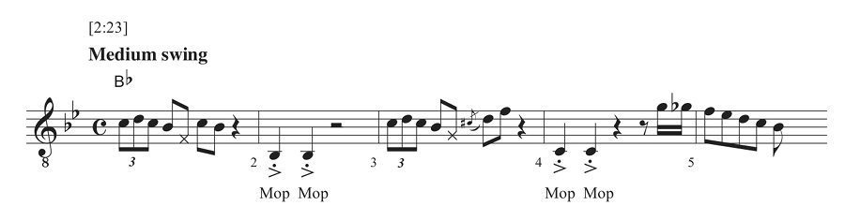

Example 18 and Audio Examples 7–8. “Red Cross”
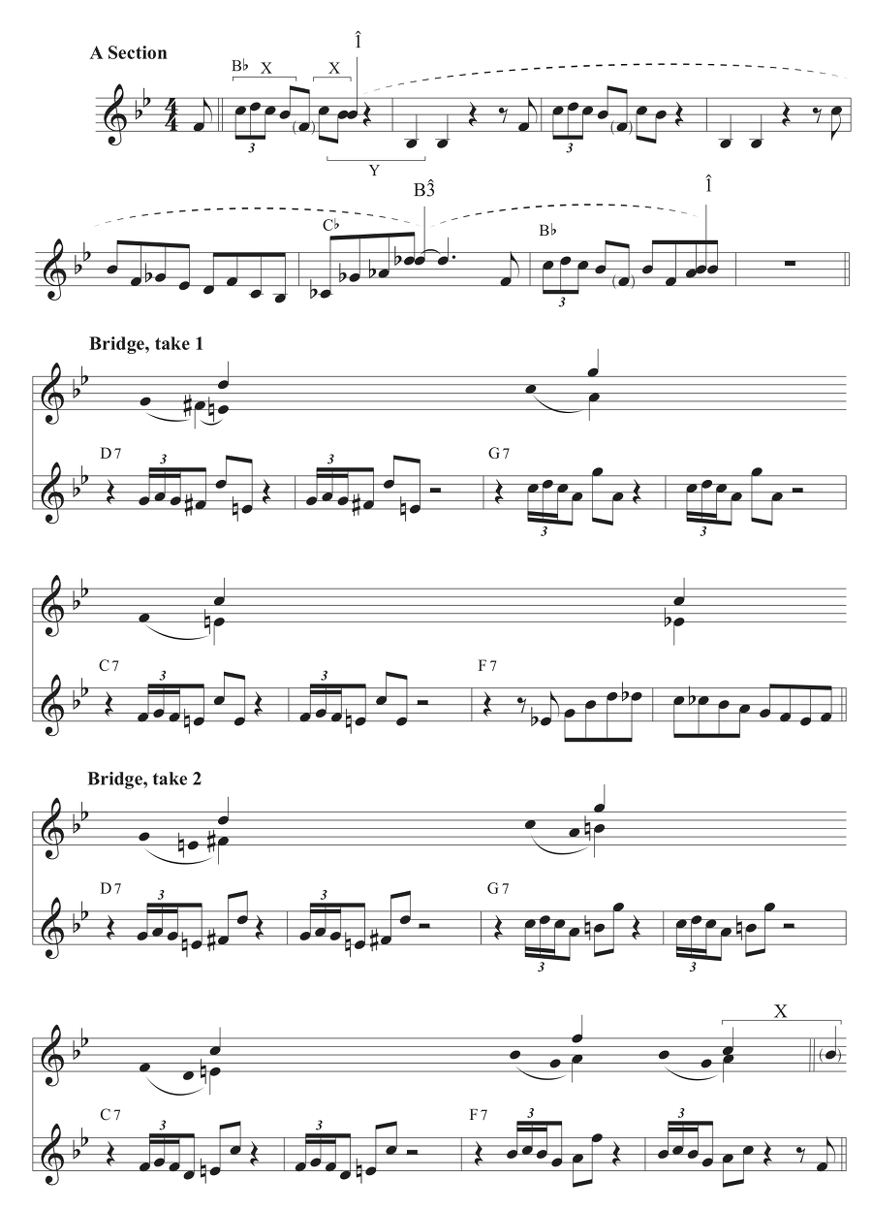

Example 19. “Red Cross” bridge sequences
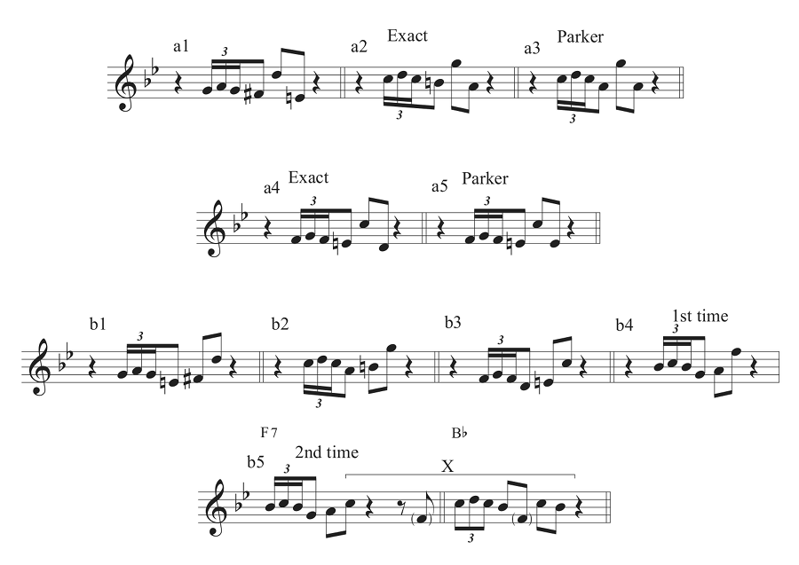

Example 20 and Audio Example 9. “Blues (Fast)” outtakes
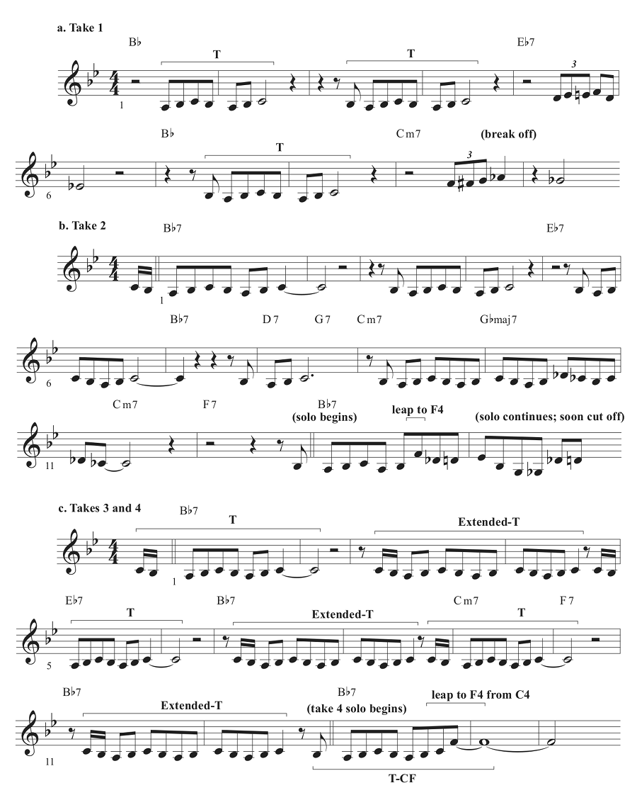
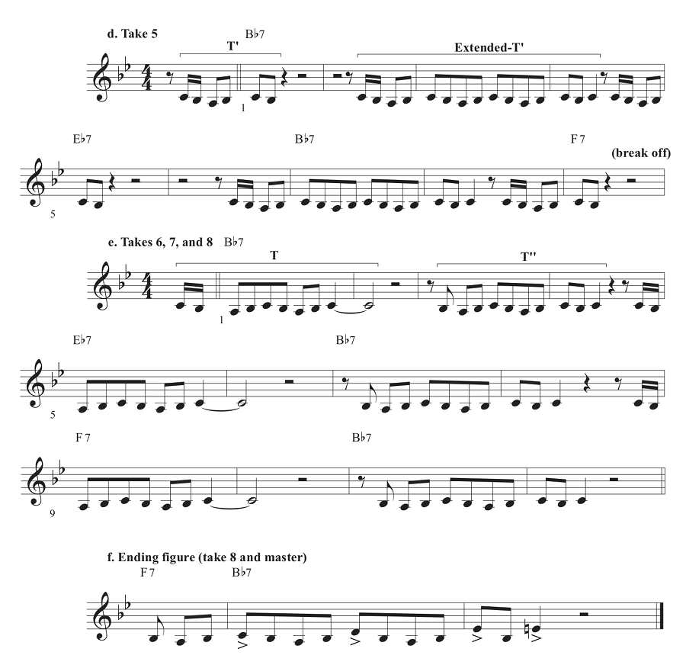

Example 21 and Audio Example 14. “Blues (Fast)” final piece and analysis
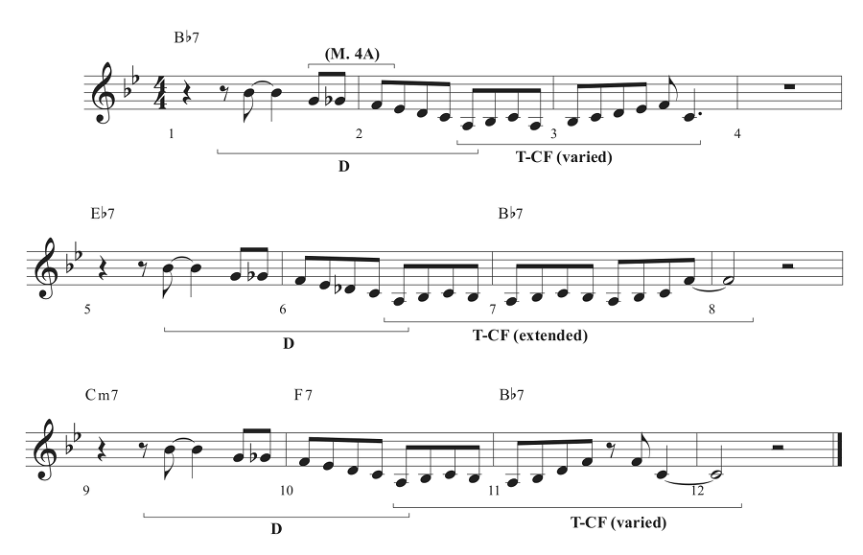
Example 22. Motive T vs. Brahms Clarinet Quintet, op. 115
