
MTO 24.2 Examples: Rifkin, Visualizing Peter: The First Animated Adaptations of Prokofiev’s Peter and the Wolf
(Note: audio, video, and other interactive examples are only available online) http://mtosmt.org/issues/mto.18.24.2/mto.18.24.2.rifkin.html
Example 1. Peter’s Theme from Prokofiev’s Peter and the Wolf, op. 67, mm. 1–8
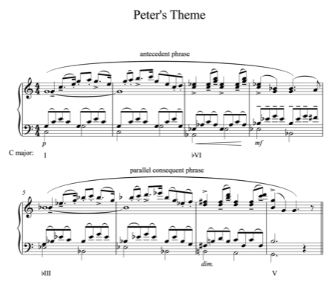

Example 2. Key Areas of Peter’s Theme and Keys Used to Introduce Characters
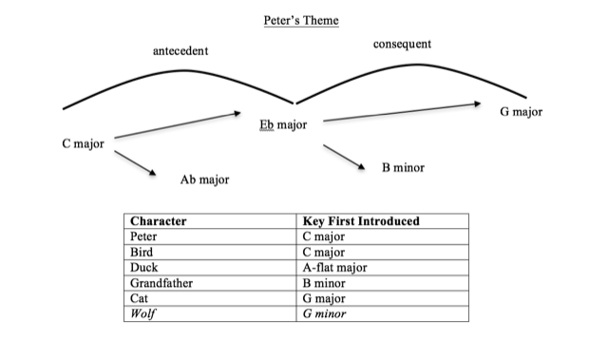

Example 3. Keys of Characters in Prokofiev’s (1936), Disney’s (1946) and Soyuzmultfilm’s (1958) Peter and the Wolf
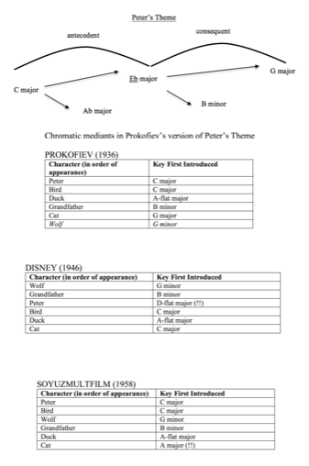

Example 4. Peter’s Theme as a Grand March in the Final Procession of Prokofiev’s Peter and the Wolf, rehearsal 44
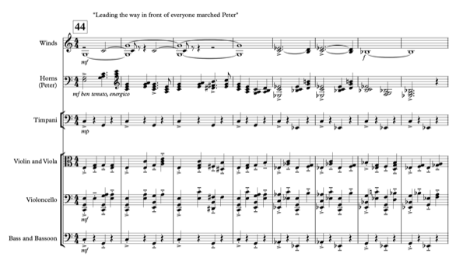

Example 5. Grandfather and Cat Themes in the Final Procession of Prokofiev’s Peter and the Wolf, rehearsal 48
