
MTO 24.2 Examples: Segall, Prokofiev’s Symphony no. 2, Yuri Kholopov, and the Theory of Twelve-Tone Chords
(Note: audio, video, and other interactive examples are only available online) http://mtosmt.org/issues/mto.18.24.2/mto.18.24.2.segall.html
Example 1. Prokofiev, Symphony no. 2, II, m. 134 (strings only)
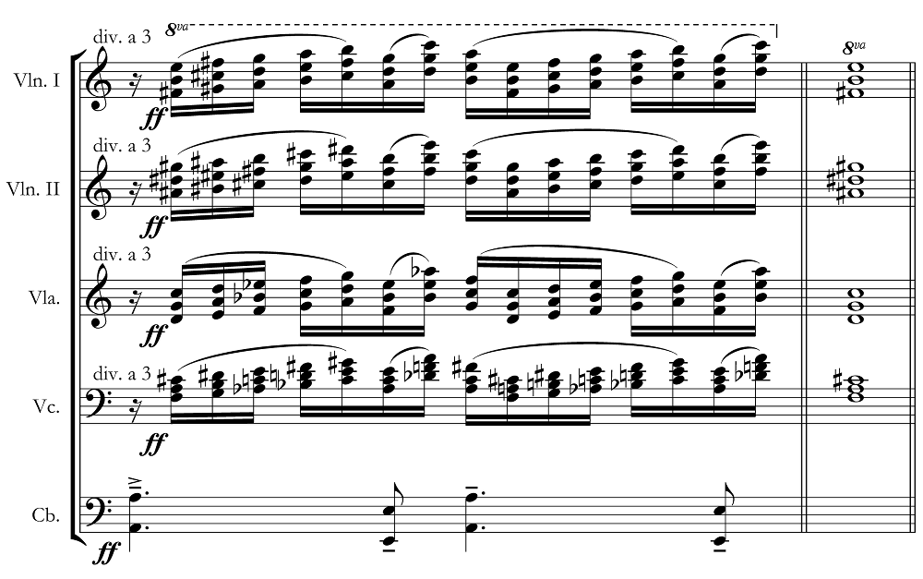

Example 2. Progressions from twelve-tone chords to tertian sonorities (a) Domenico Alaleona, accord dodecafonico, 1911 (Homma 2001). (b) Jean Huré, La Cathédrale, 1910–12 (Lenormand 1940)
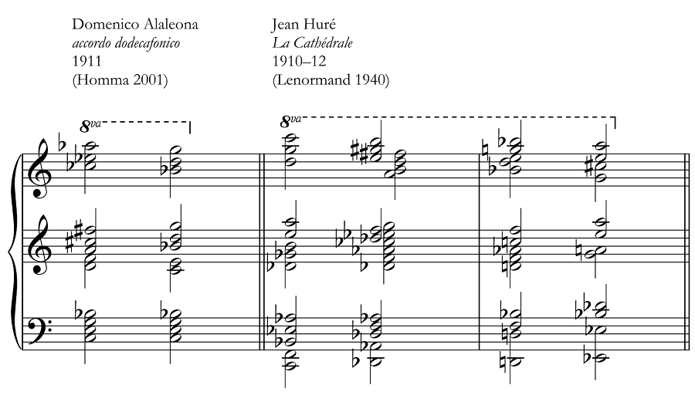

Example 3. Britten, The Turn of the Screw, act I, mm. 39–47 (reduction)
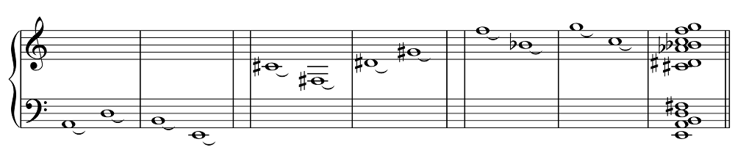

Example 4. Positional twelve-tone chords
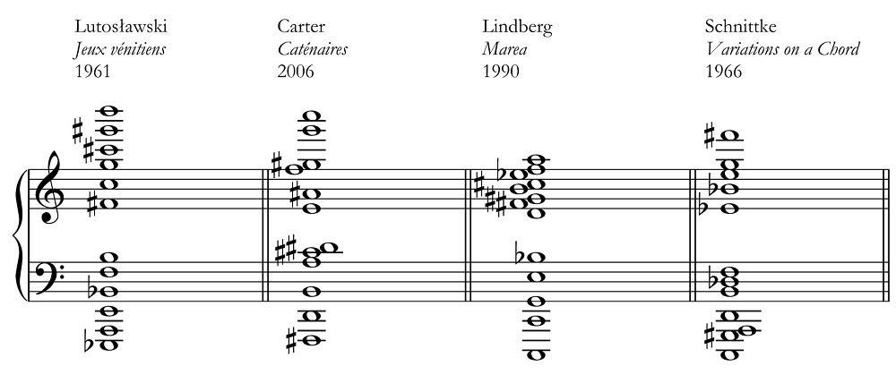

Example 5. Polychords with whole-tone roots
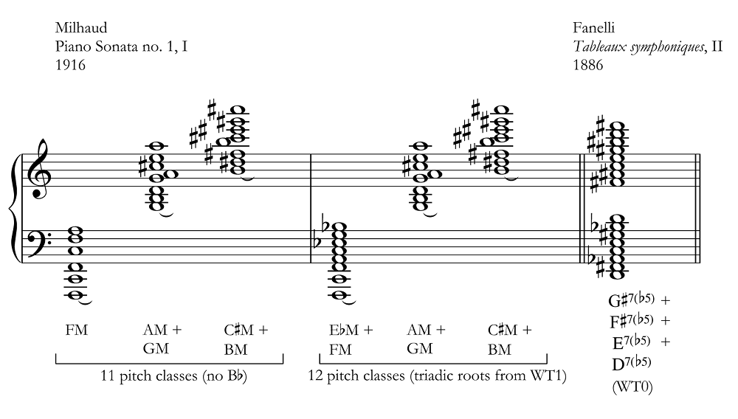

Example 6. Heterogeneous twelve-tone chords without doublings
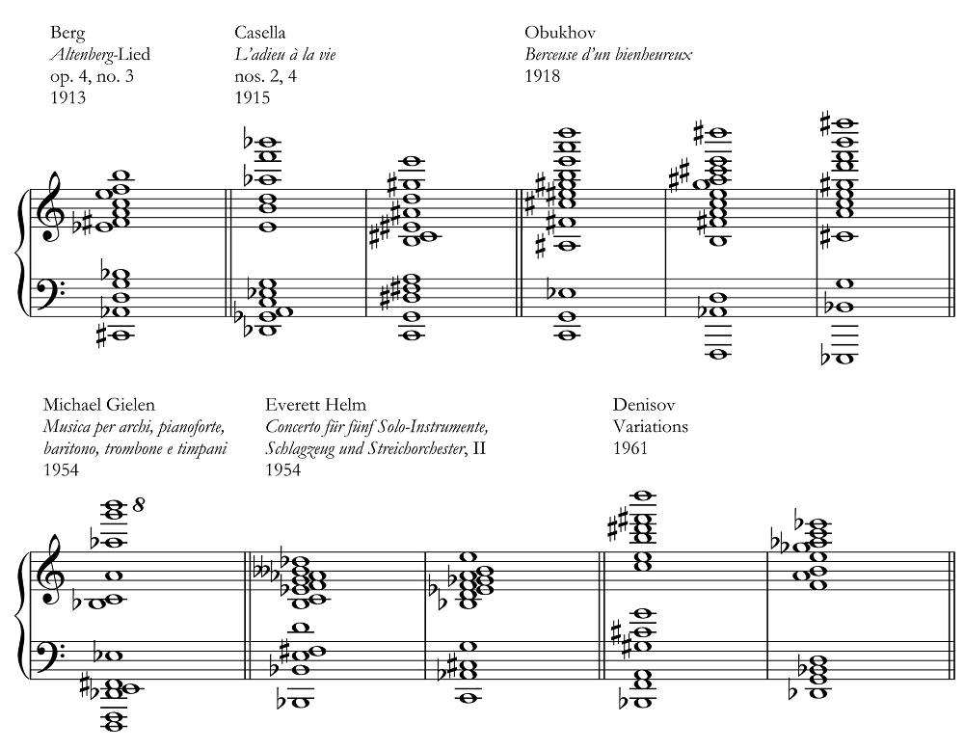

Example 7. Twelve-tone chords with doublings
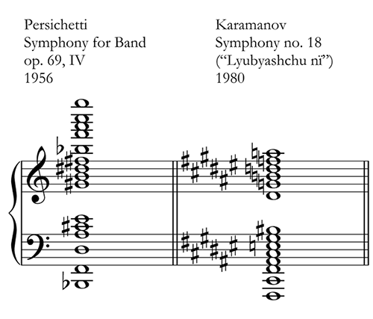

Example 8. Triadic twelve-tone chords
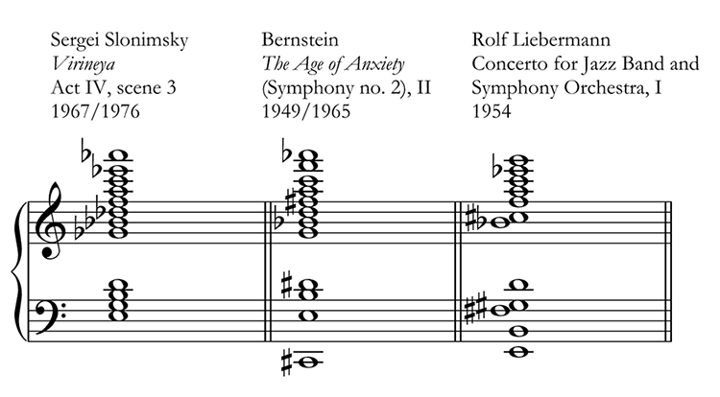

Example 9. Quartal and quintal twelve-tone chords
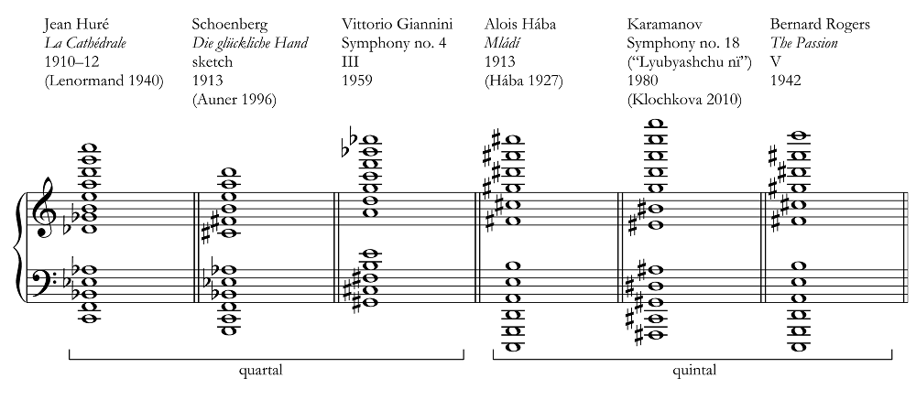

Example 10. Twelve-tone chords with triadic subsets
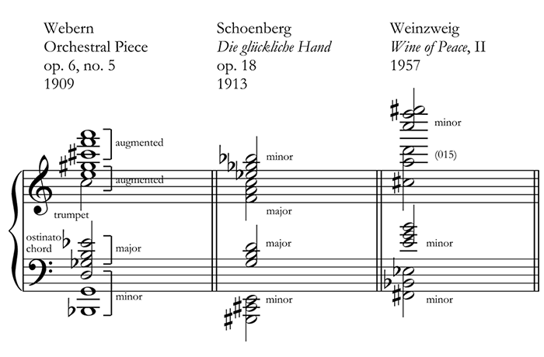

Example 11. Twelve-tone chord with superimposed diminished seventh chords
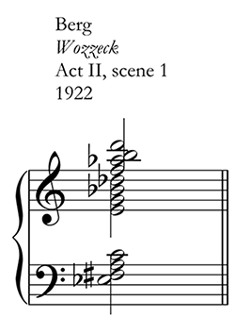

Example 12. Twelve-tone chords with superimposed quartal subsets
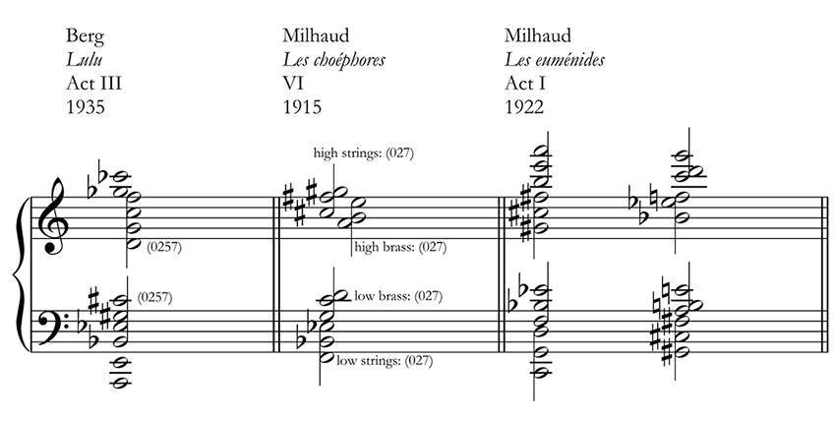

Example 13. Twelve-tone chord with superimposed seventh chords
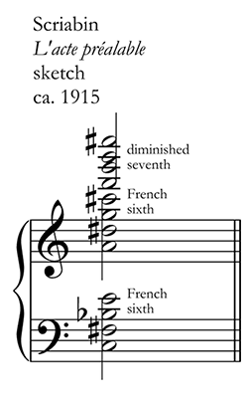

Example 14. Twelve-tone chords as rearranged “grandmother chords”
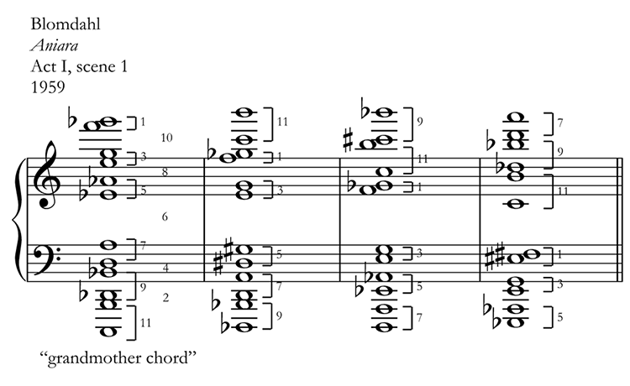

Example 15. Twelve-tone chords with rearrangable quartal subsets
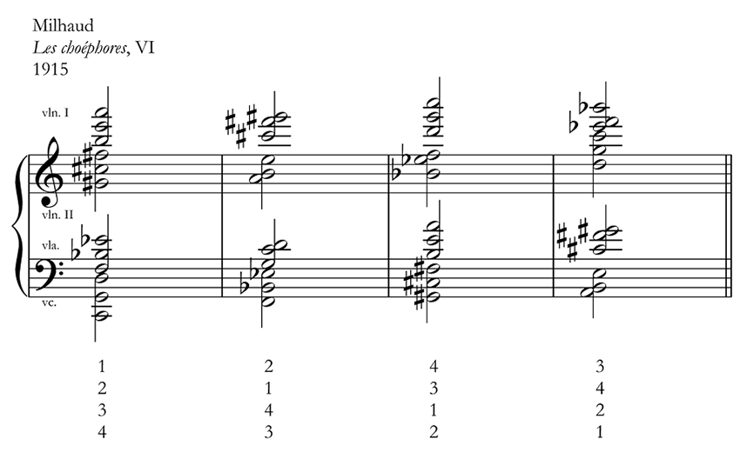

Example 16. Prokofiev, Symphony no. 2, II, m. 134 (twelve-tone string chord and winds)
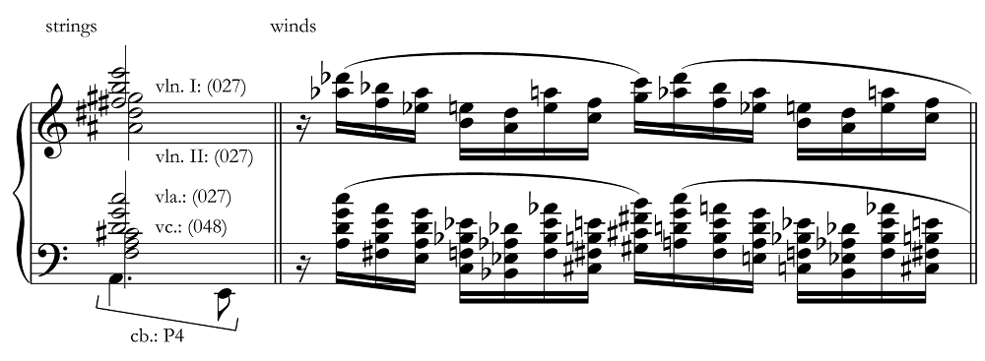

Example 17. Alternative parsing of Prokofiev’s twelve-tone chord
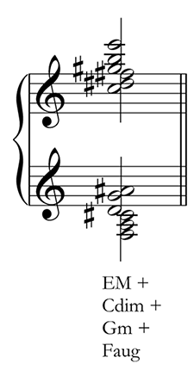

Example 18. Prokofiev, Symphony no. 2, mm. 21–23 (cadential tag)
