
MTO 24.2 Examples: White, Feedback and Feedforward Models of Musical Key
(Note: audio, video, and other interactive examples are only available online) http://mtosmt.org/issues/mto.18.24.2/mto.18.24.2.white.html
Example 1a and b. Feedforward and Feedback ways of schematizing how key interacts with other musical parameters
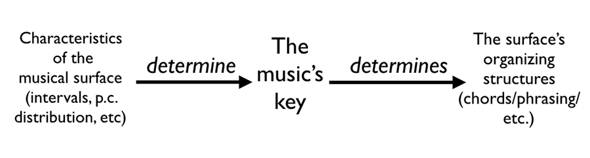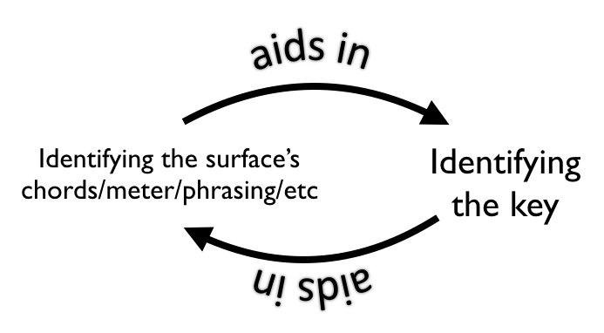

Example 2. Mozart, Piano Sonata, K. 284, iii, mm. 1–8 (slurring from Breitkopf edition)
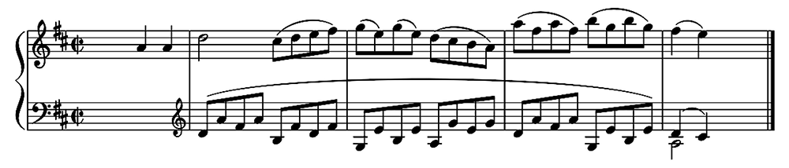

Example 3. Grieg, “The Mountain Maid,” op. 67, no. 2, mm. 4–7, along with tonal analyses provided by two computational models
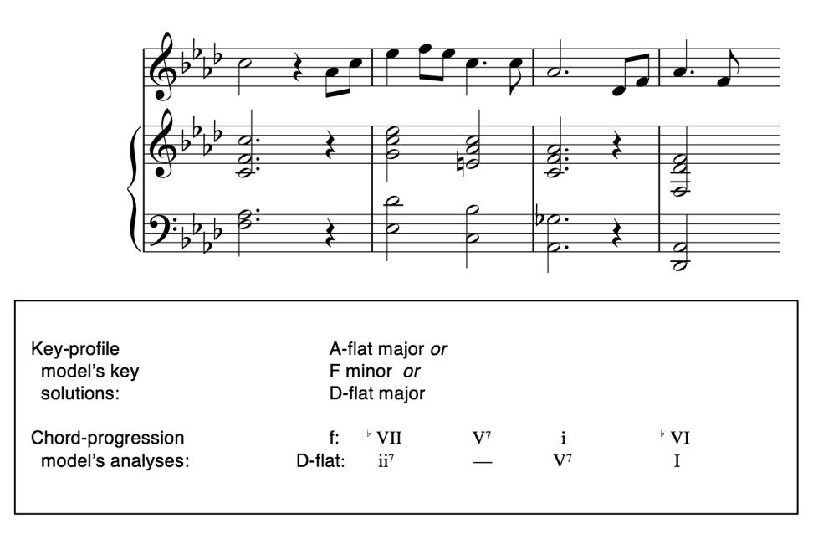

Example 4. A feedback loop between key and chord grouping
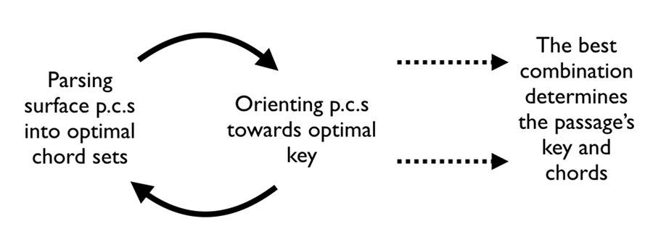

Example 5. A hypothetical toy chord-progression model, with arrows representing the most probable between-chord successions
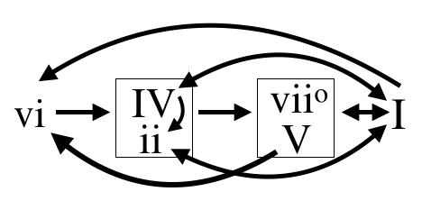

Example 6. A probabilistic analysis of Mozart K. 284, iii, mm. 1–8, using the syntax of Example 5
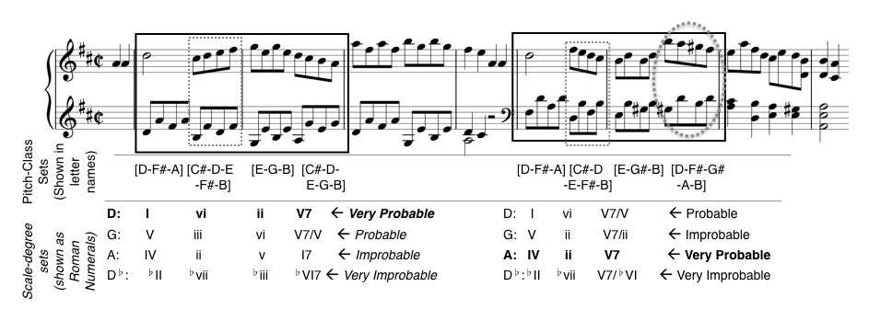

Example 7. The percentage of key assessments on the Kostka-Payne corpus that agreed with the instructor’s edition, divided by model
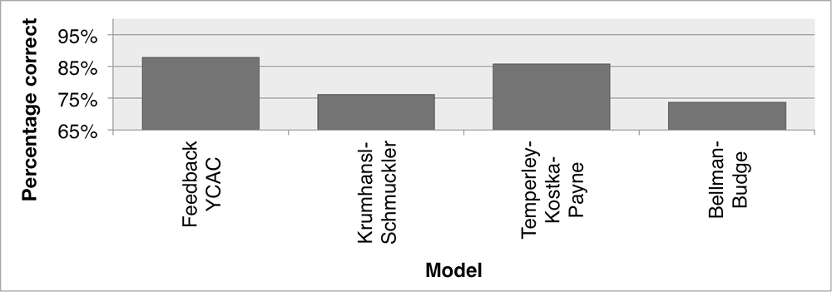

Example 8. Cross entropy results for each corpus-based model
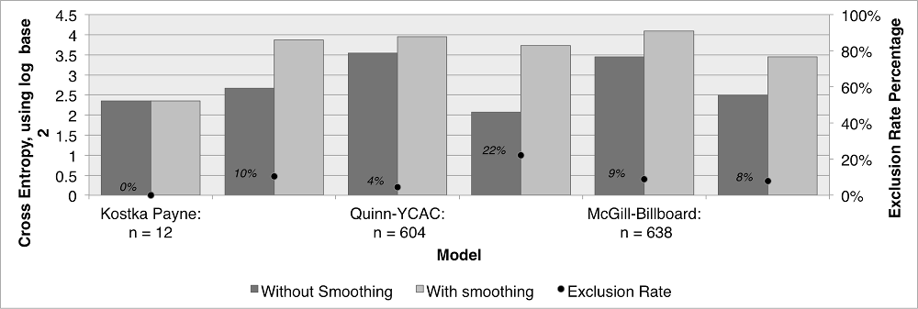

Example 9. Comparing graders’s assessments of both groups of analyses
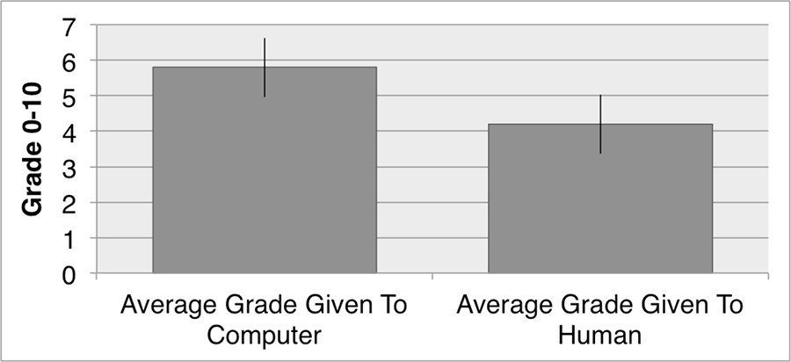

Example 10. Percent of participants who correctly distinguish the human/computer analysis (dotted lines show the 95% confidence window for a p < 0.05 binomial distribution)
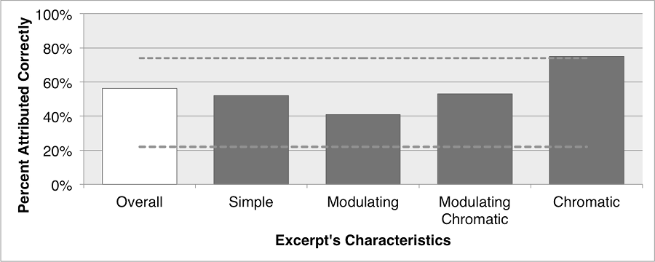

Example 11. Human (left) and computer (right) analyses of mm. 29–37 of Brahms’ “Und gehst du über den Kirchhof” op. 44, no. 10
